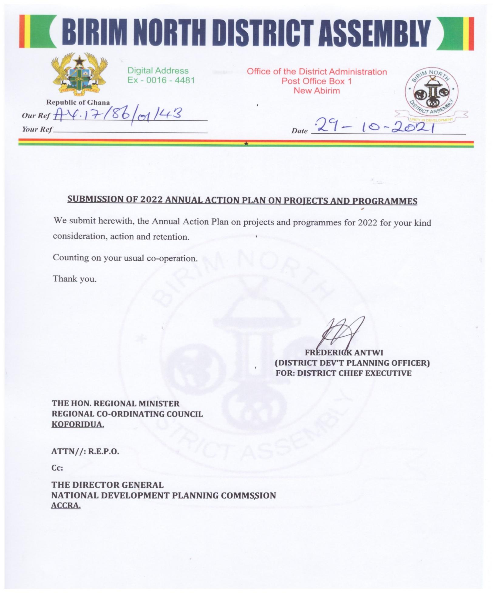
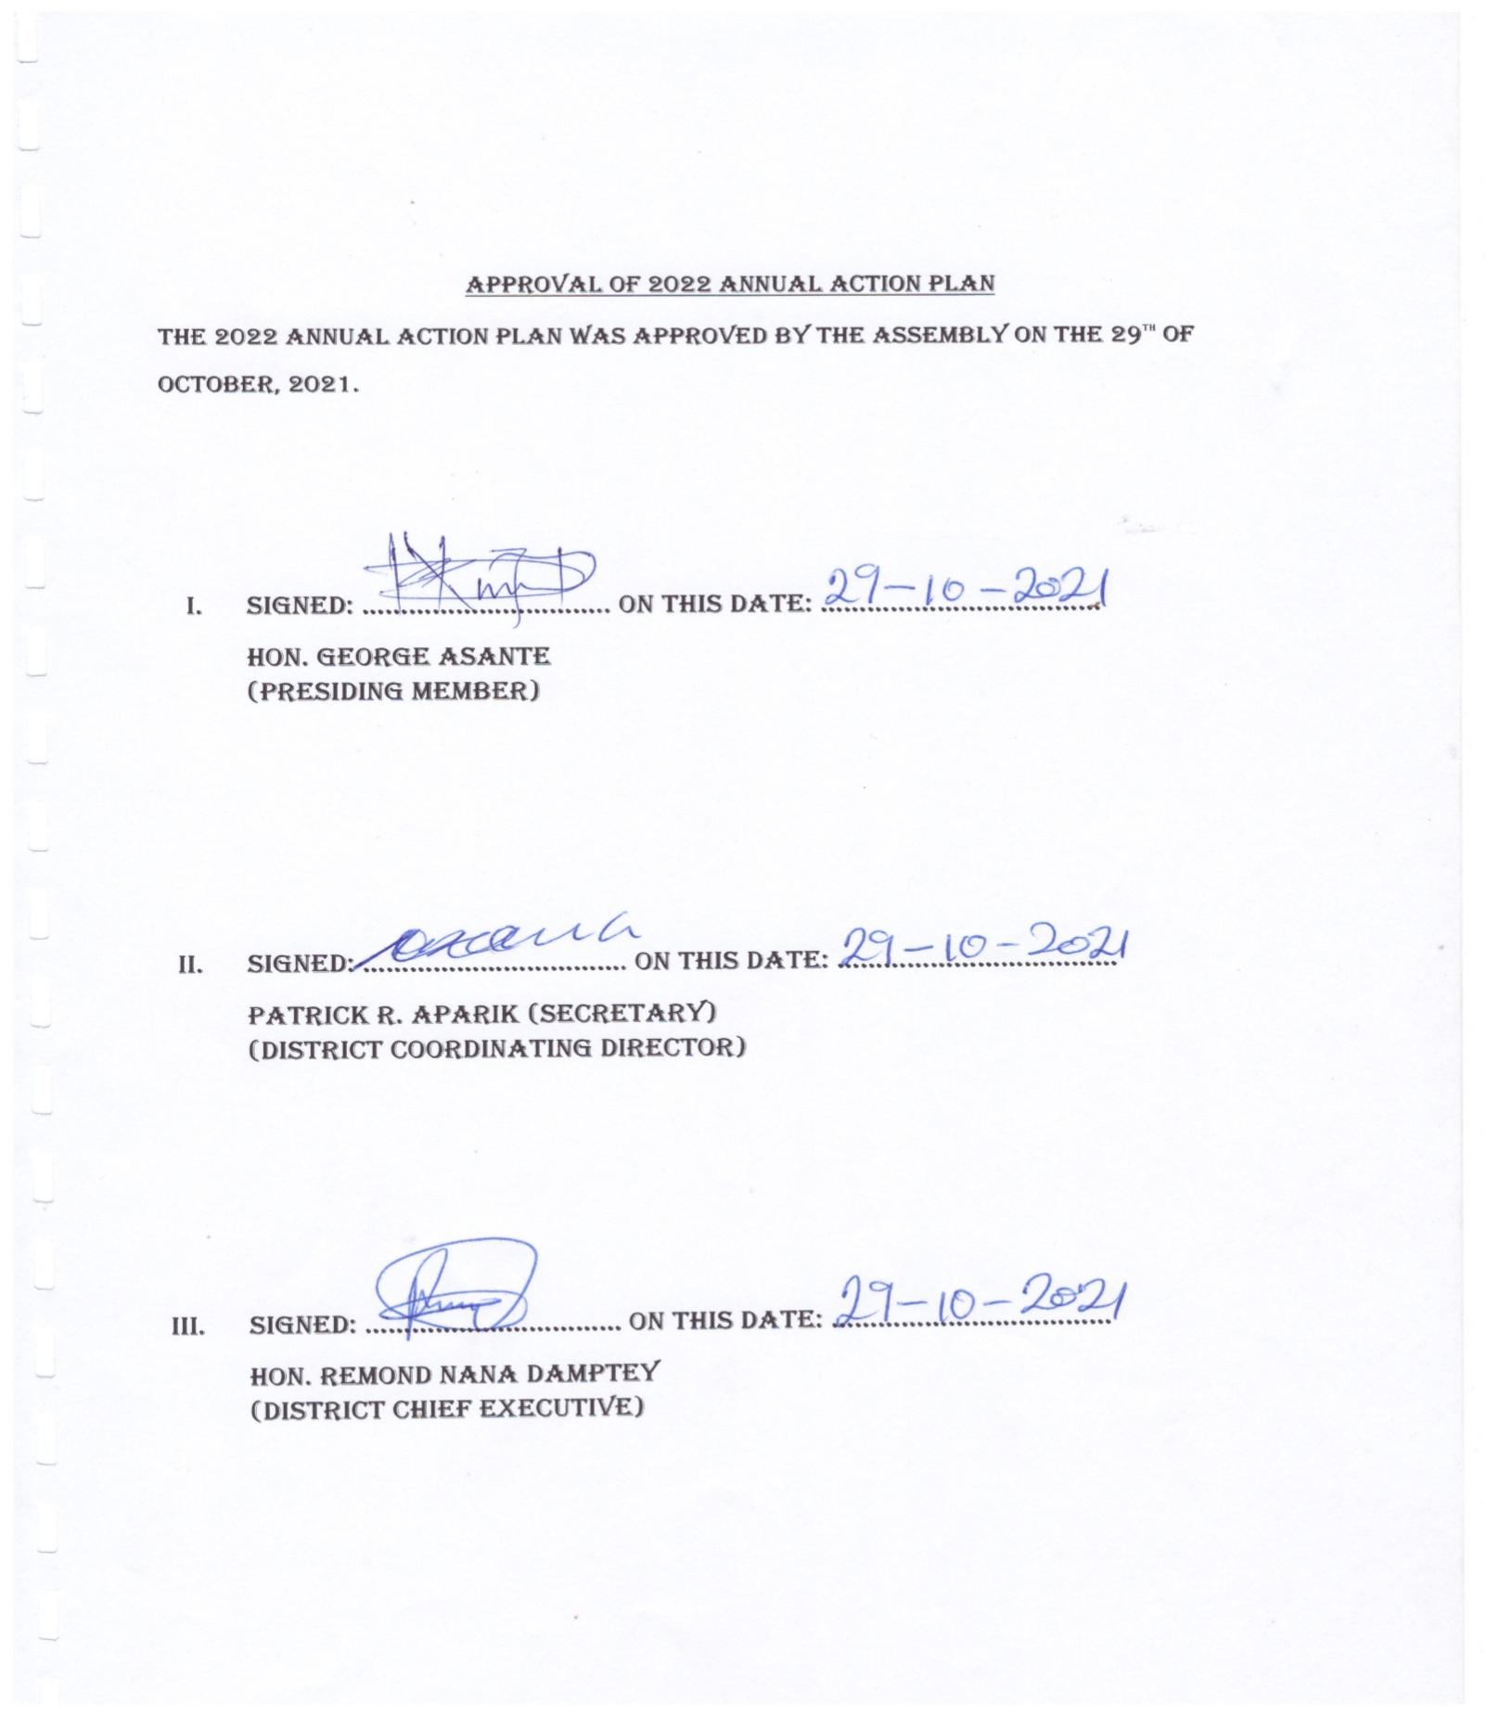

REPUBLIC OF GHANA

MINISTRY OF LOCAL GOVERNMENT AND RURAL DEVELOPMENT

BIRIM NORTH DISTRICT ASSEMBLY

2022 ANNUAL ACTION PLAN

NOVEMBER, 2021

INTRODUCTION

1.0 Location and Size
The Birim North District was carved out of the former Birim District Council in 1987 as part of the government’s decentralization programme to promote effective decentralized governance and speed up the development of the area. After Akyemansa District was carved out of the Birim North District, its estimated total land area reduced significantly from 1270 square kilometers to 550 square kilometers. It has 78 settlements within its jurisdiction. The District is bounded to the North by Kwahu West Municipal, to the South by Akyemansa District, to the East by Atiwa East District and Kwaebibiriem Municipal and to the West by Asante Akyem South and Adansi South District both in the Ashanti Region.
  - Vision Statement:
The Birim North District Assembly is to be environmentally sustainable mining and agrarian district.
  - Mission Statement
The Birim North District Assembly exists to ensure improvement in the quality of life of its citizens by mobilizing human, material and financial resourecs in the district to promote local economic development.
  - Objective
To enhance the quality of life of its people through the provision of basic infrastructure and sustainable use of natural resources
2.0 Compactness of the District Capital
It has one compact town, New Abirem, a well-known commercial town as the District capital. The District capital is located about 241kilometres North–West of Accra with a population of about 6,123 people. It is the third largest urban center in the District after Akoase and Afosu (GSS, 2010 PHC) and a projected population of 101,522 in 2022.
3.0 Population Growth and Density
The 2010 National Population and Housing Census put the District population at 78,907 representing 3 percent of the region population with an intercensal growth rate of about 2.1%. The in and out flow of population to the district especially its capital on a daily basis is estimated to be 2,000. The projected population is therefore considered rather low considering the inflow of people into the district capital on daily basis. The male population is 50,964 (50.2%) and that of female is 50,558(49.8%), indicating that there are slightly more males than females in the district. The projected population for 2022 is 101,522 using a growth rate of 2.1%.
Furthermore, with the projected 2022 population figure of 101,522, the density would be 184.6 persons per sq km which is one of the highest in the region. The increase in population has a direct effect on the density. This indicates a great pressure of population on land, resources and social services especially in the District capital town –New Abirem.

3.1 Rural-Urban Split
According to the 2010 National Population Census projected for 2022, only 26.8 percent of the population lived in urban areas and the rest (73.2%) lived in rural areas. This shows that the District is essentially a rural district with majority of its population living in the rural areas compared with urban areas.

Figure 1: Map of Birim North in National Context

Figure 2: Map of Birim North District
4.0 Economic Potential of the District.
The strategic location of the District capital town couple with a high population growth rate makes New Abirem one of the fastest growing and a vibrant commercial town in the region. Apart from serving as a strong marketing center for her border districts, it is the main marketing center for goods coming from Kade, Nkawkaw and Akim Oda. The presence of good roads therefore has a potential of promoting strong economic linkages with a number of Districts’ to promote economic growth through trade and investment.
5.0 GOVERNANCE
a) Establishment
The Birim North District was carved out of the former Birim District Council in 1987 with L.I 1422 as part of the government’s decentralization programme to promote effective decentralized governance and speed up the development of the area. It has deliberative, legislative and executive powers.
b) Structure of the Assembly
The District consists of 26 electoral areas and represented in the general Assembly by elected and appointed Assembly members. The composition of the Assembly is made up of 26 elected members, 12 appointed members, one Member of Parliament and the District Chief Executive.
The General Assembly is headed by an elected Presiding Member with the District Coordinating Director as the Secretary. The Assembly has two committees i.e. Executive committee and Public Relations and Complaints Committee (PRCC). The Executive committee has six sub-committees which facilitate the performance of its statutory functions. The sub-committees are as follows.
i) Sub-committees
- Development Planning Sub-committee
- Works Sub-Committee
- Finance and Administration Sub-committee
- Justice and Security Sub-committee
- Social Services Sub-committee
- Agric and Environment Sub-committee
Further, we have in the District all the decentralized departments and other quasi government organizations like the National Commission on Civic Education, Commission on Human Rights and Administrative Justice, Ghana Ambulance Service, National Board for Small Scale Industries (NBSSI), Fire Service, Immigration Service, Electoral Commission, Stool lands, Electricity Company of Ghana among others. The established Decentralized Departments are as follows:
- Centralized Administration Department
- Works Department
- Physical Planning Department
- Department of Trade and Industry
- Department of Agriculture
- Department of Social Welfare and Community Development
- Finance Department
- Education, Youth and Sports Department
- Disaster Prevention and Management Department
- Natural Resources Conservation Department of Forestry, Game and Wildlife Division
- District Health Department
- Department of Statistics
- Department of Human Resource

C) Sub-District structures (Urban/Town and Area Councils)
The District has four (4) sub-structures namely:
- New Abirem /Afosu Area Council
- Akoase Town Council
- Praman Area Council
- Pankese Area Council
The Area Councils are well established and are supporting the Assembly in its development efforts. All the Area Councils have the full complement of staff to work with.
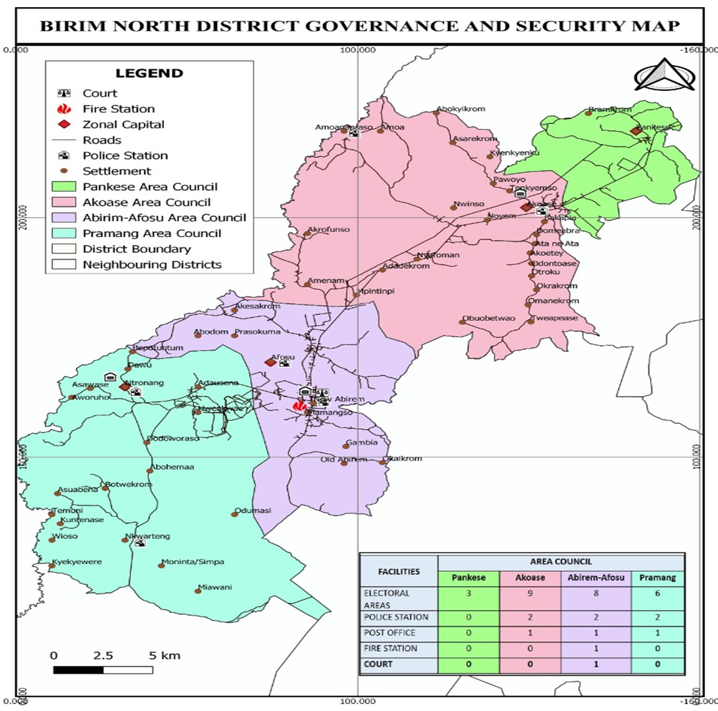
6.0 SOCIAL SERVICES
6.1 Education
Educationally, the district has been demarcated into seven (7) Circuits headed by School Improvement support officers (SISOs) to make supervision and monitoring of schools effective and efficient. The circuits are: Afosu, Akoase, Amuana Praso, New Abirem, Nkwateng, Ntronang and Pankese. There are 70 Public Basic Schools, 29 Private and 3 SHS – New Abirem/ Afosu SHS, Akoase St. Michael’s SHS and Amuana Praso SHS. The overall Student population in the district is 25,430 consisting of 12,969 boys and 12,461 girls giving the Gender Parity Index (GPI) of 0.96. The overall Teacher population is 1,360 with 840 males and 520 females giving the District Pupil Teachers Ration (PTR) of 1: 19. The map below presents the state of educational infrastructure in the district.
The survey in Birim North District covered the educational characteristics and its implications for development. The District currently has both Basic and Second Cycle Schools.
- Enrolment Levels

Table 1: Educational facilities and pupil’s enrolment in the district as at 31st December, 2021
Schools | Enrolment
 | Public | Enrolment |  |  | Private | Enrolment
 | Public | Total | M | F |  | Total | M | F
K.G | 63 | 2,241 | 1,100 | 1,141 | 29 | 1,829 | 985 | 844
Primary | 63 | 10,555 | 5,467 | 5,088 | 29 | 2,261 | 1,143 | 1,118
J.H.S | 61 | 5,340 | 2,746 | 2,594 | 16 | 411 | 212 | 199
S.H.S | 3 | 2,162 | 1,071 | 1,,091
Total | 181 | 22,541 | 10,311 | 12,230 | 90 | 4,549 | 2,307 | 2,242
Source: DED, New Abirem, Dec., 2021
Table 2: Total number of teachers in the district as at 31st Dec., 2021
Schools | Number of teachers
 | Public |  |  |  |  | Private
 | Total | Trained | Untrained | Male | Female | Total | Trained | Untrained | Male | Female
K.G | 144 | 136 | 8 | 15 | 129 | 44 | 3 | 41 | 9 | 40
Primary | 357 | 342 | 15 | 218 | 139 | 86 | 15 | 121 | 118 | 55
J.H.S | 398 | 395 | 5 | 316 | 82 | 50 | 18 | 32 | 42 | 08
S.H.S | 175 | 152 | 23 | 135 | 40
Total | 1,074 | 1,025 | 51 | 684 | 390 | 180 | 36 | 194 | 169 | 103
Source: GES, EMIS, New Abirem, Dec, 2021
Analysis of the above table indicates that the district has One Thousand and Seventy-Four (1,074) teachers. Out of which 95% are trained whiles 5% are untrained. The male female teacher ratio is 1:0.68 approximately 2:1.
Analysis of BECE performance for the District for the past three years is presented in the table below. Table.3.
Year | Both Public and Private
Year | Male | Female
2018 | 82.84% | 82.11%
2019 | 67.56% | 72.65%
2020 | 72.43% | 72.63%
Source: GES, BNDA-2021

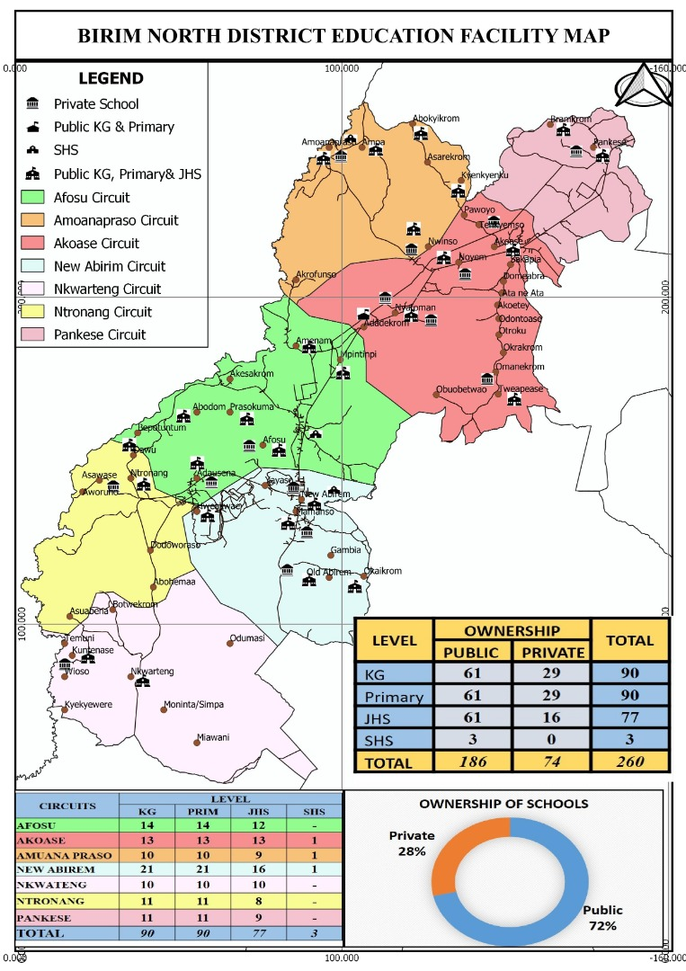
  - Health Service Delivery

6.2.1 Health
The infrastructure of health delivery system of the District consists of 1 government hospital at New Abirem, 3 private clinics, one in Afosu and 2 in New Abirem and 5 Reproductive and Child Health Centers at Nkwarteng, Adausena, Afosu, Amuana Praso and Tweapease. The District can boost of 26 demarcated CHPS centers. 15 of the demarcated CHPS centres are operational with 27 herbalists and spiritual healers in the entire District.
The District’s government hospital located at New Abirem has a 69-bed ward including Emergency Ward, Theatre, Medical laboratory, Pharmacy Department, Dental clinic, Out-Patients Department and Eye Clinic. The hospital lacks an X-Ray Department and a Mortuary. However, most cases beyond the hospital are referred to Nkawkaw, Atibie, Akim Oda, Koforidua or Accra.

The hospital has only 3 doctors with 3 medical assistants, 1 Dental Surgeon, 1 Ophthalmic Nurse (ENT), 2 Biomedical Scientist, 2 Laboratory Technicians and 2 Pharmacist with 2 Dispensary Assistants. The District has a Doctor – Population ratio of 1:29,795 as against national average of 1: 25,000 and WHO standard of 1: 10,000.

The Nurse Population ratio is also 1: 1,625 as against the national figure of 1:900.
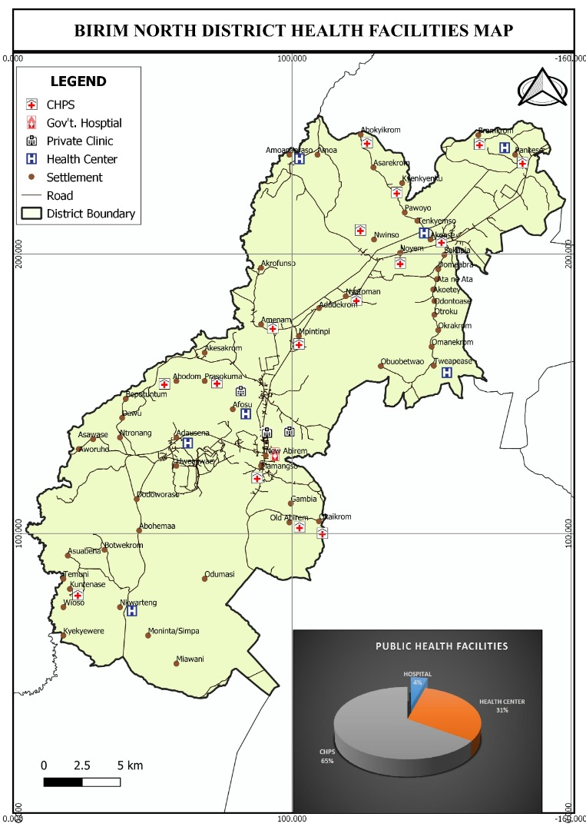

7.0 POLICE SERVICE

The Birim North is under the Akim Oda and Nkawkaw Division interms of police administration. The District police headquarters is at New Abirem with 3 sub districts at Ntronang, Akoase(Akim Oda Division) and Amuana Praso(Nkawkaw Division). The assembly has constructed a new police station at Nkwarteng and a new one is being constructed for Ntronang. This is been done to improve the security situation in the district whilst effort are been made to bring policing in the district under one division.

8.0 WASTE MANAGEMENT
8.1 Solid Waste / Garbage

The rate of waste generation and management in the District is a matter of concern to the Assembly. With the increasing influx of people and the rapid urbanization, huge amounts of waste are generated at an alarming rate. It is estimated that about 950 tonnes of solid waste is generated monthly out of which 480 tonnes are collected which represents about 51%. This leaves a substantial amount of backlog that creates various kinds of inconveniences including health hazard to the people in the District.
Most communities in the District have designated sanitary sites –open dumping at the outskirts of the settlement. Zoomlion Ghana Limited is responsible for emptying the containers to the final disposal site in the Newmont catchment areas. Zoomlion is also responsible for house-to-house garbage collection in those areas. Waste landfills company limited in collaboration with the Assembly also level refuse heaps in the communities on quarterly basis thus all year round and also responsible for the management of the final disposal site. The situation is under control as the Assembly in collaboration with Newmont Golden Ridge Limited (Newmont Akyem Mines) has developed an engineered landfill for final disposal of solid waste.
8.2 Liquid Waste
Apart from settlements in the District lacking improved toilet facilities, most of the existing public toilets are not well constructed. The main types of toilet facilities in the District are K.V.I.P, pit, Aqua Privy and septic. The stench, associated with pit latrine pollutes the air and this presupposes that it should be distanced from the communities, taking due cognizance of the prevailing wind direction.
Some communities do not have any toilet facilities and this makes indiscriminate defecation the normal practice. This poses health hazards to the inhabitants of the settlements since run-offs wash the human excreta into streams, thus contaminating them.
8.3 Liquid Household Waste and Storm-Water Disposal
Wastewater from houses is normally dislodged into open earths, which are not maintained in most of the urban settlements. The odour and stench emanating from such areas pollute the air and is very much abominable.
In smaller communities’ household waste water and run-offs are not considered in any way as they drain on to the narrow lanes to create gullies, and unto lower areas in the bush to create ponds.

9.0 TOURISM DEVELOPMENT
Even though tourism has become one of the main sources of income and employment generation in the country, the Birim North District Assembly is yet to reap its full benefits. There are a number of tourist sites that has the potential of rivaling some of the well-known tourist sites in the country. Though largely undeveloped, these sites hold the key to the area’s development if steps are taken to tap the large potential they present.
The District is endowed with as many as 5 efficiently managed forest reserves that are well resourced with some of the most beautiful flora and fauna which are basic to the development of attractive wild life sanctuaries or parks. Near Otwereso is a picturesque site of the confluence of the Birim and Pra rivers. At Akrofunso, near Afosu are Ashanti antique War Bells and a grove that marks the spot where the great Ashanti King, Osei Tutu, was killed.
The District has a number of hotels and guesthouses which has help to ease the burden of accommodation for visitors to the district. This includes 3 four star hotels namely; Obaa’s golden Plaza(Afosu), Miners Inn(New Abirem), Beige Village Golf Resort and Spa(Afosu), and Candle light hotel and Restaurant(Afosu), Paradis Hotel(Nyafoman). In addition, there are seven guest houses at varous locations within the district; Ma Home(Afosu), Royal Hill(New Abirem), Ritheous(New Abirem), Naagyei(Afosu), Ofori(Afosu), Manna Lodge(Akoase), Nketia(Akoase) and Amadu Guest House at Akoase.
10.0 MARKETS
The Districts traditional market pattern has been in New Abirem, Ntronang, Amuana Praso and Akoase. The New Abirem market functions daily with Tuesdays and Fridays as major market days, whilst that of Ntronang is every Wednesdays. New Abirem is a nodal town but because of the bad road network from Nkawkaw to Kade through New Abirem and New Abirem to Oda, it does not make the market functional as a characteristic of a nodal town.
11.0 ROADS
Road is the only form of transport in the District. This implies that, the overall improvement of the road network, maintenance and rehabilitation will facilitate and lower transportation cost and integrates the Districts rural economy with the urban economy to reduce poverty. The completion of the lorry park at the New Abirem market has help to reduce the traffic situation in the district. Again, the 36.3km road from Nkawkaw to New Abirem is under construction.So is t that of New Abirem-Kade and New Abirem –Oda.
12.0 REVENUE BASE OF THE ASSEMBLY
Revenue and Expenditure Performance of the District Assembly
This section examines the revenue and expenditure pattern of the District Assembly for the 2020 to 2021 fiscal year. This is to aid improve the Assembly’s financial management practices in order to generate and manage funds for the effective implementation of the District’s Medium Term Development Plan.

A. Revenue Pattern of the District Assembly
There are two main sources of revenue for the District Assembly. These consist of Internally Generated Funds (IGF) and Externally Generated Revenue.

  - Internally Generated Fund (IGF)
The Internally Generated Fund (IGF) is mainly made up of revenue collected from; lands, fees and fines, rates, license, rent, investment and miscellaneous. The internally generated funds are purposely used in funding recurrent expenditure incurred by the District Assembly since its amount is normally not substantial to be used to fund capital expenditure. However, in the case of Birim North, the presence of Newmont has aided the assembly to generate enough IGF to help in financing capital projects far in excess of what is required by law.

  - Externally Generated Revenue/Funds (EGF)
The EGF is accrued from both governmental and private (non-governmental) sources including; the District Assemblies Common Fund (DACF), Government of Ghana (GoG) and Donor Grants which are mostly based on some specific criteria. The Assembly only gets to benefit from this Donor Grant such as District Development Facility (DDF) upon meeting the criteria specified. However, this Donor Grant (DDF) has now been changed to District Performance Assessment Tool (DPAT) or DACF-RFG(Responsive Factor Grant). This revenue source has been the major contributor to the Assembly’s total revenue base.

Table 4: Revenue Pattern of the District Assembly
Revenue item | Baseline 2020 | Target 2021 | Actual 2021
Revenue item | GH¢ | GH¢ | GH¢
IGF | 5,815,729.43 | 6,643,557.62 | 5,606,619.86
GOG-COMPENSATION | 1,929,183.36 | 2,550,268.00 | 2,000,434.52
DACF | 2,163,727.70 | 3,713,374.23 | 817,617.73
MP’s CF | 321,412.27 | 350,000.00 | 180,442.64
PWDs CF | 180,725.92 | 280,000.00 | 105,033.83
MSHAP | 8,134.12 | 18,880.31 | 2,049.12
DDF | 512,475.31 | 931,016.58 | 865,662.00
OTHERS | 245,486.48 | 322,830.46 | 388,401.66
LEAP | 122,928.00 | 122,928.00 | 101,748.00
Total | 11,299,829.59 | 14,932,855.20 | 10,122,009.36
Source: BNDA Finance Office, Jan. 2022

B. Expenditure Pattern of the District Assembly
Expenses here are in two forms namely; recurrent and capital expenses. The recurrent expenses are made of; administration, service and miscellaneous items. The capital expenses are made as and when the need arises. These expenses mostly include construction works and other physical projects.

Table 5: Update on expenditure
Expenditure item | Baseline 2020 | Target 2021 | Actual 2021
Expenditure item | GH¢ | GH¢ | GH¢
Compensation | 2,393,111.23 | 3,821,619.00 | 2,488,711.44
Goods & services | 2,424,503.19 | 2,325,400.00 | 3,159,128.01
Investment / Assets | 7,071,670.75 | 7,573,495.03 | 4,588,834.23
Others (MAG & SIP) | 301,364.20 | 206,508.00 | 639,109.99
Total | 12,199,649.37 | 13,927,022.03 | 10,875,783.67S
Source: BNDA Finance Office, Jan. 2022

13.0 DISTRICT ECONOMY
The economic activities carried out in the District include primary (crops) production, animal husbandry, small scale industrial activities, mining and commerce. The Birim North District is predominantly agrarian because about 73.5 percent of the entire labour force is into agriculture and its related activities. The population in commerce and services forms about 15.2 percent and 3.8 percent of the labour force respectively. The District is home to Seven (7) forest reserves i.e. kwekaru, Kajeasi, Ajenjua, Kwasi Anyinima, Jade Bepo, Mamang River and Auro River. The rapid expansion of the cocoa and oil palm farming in the District coupled with the activities of the illegal mining and chain saw operators are changing the original forest into a secondary type. The map below gives a pictorial evidence of the district economy.

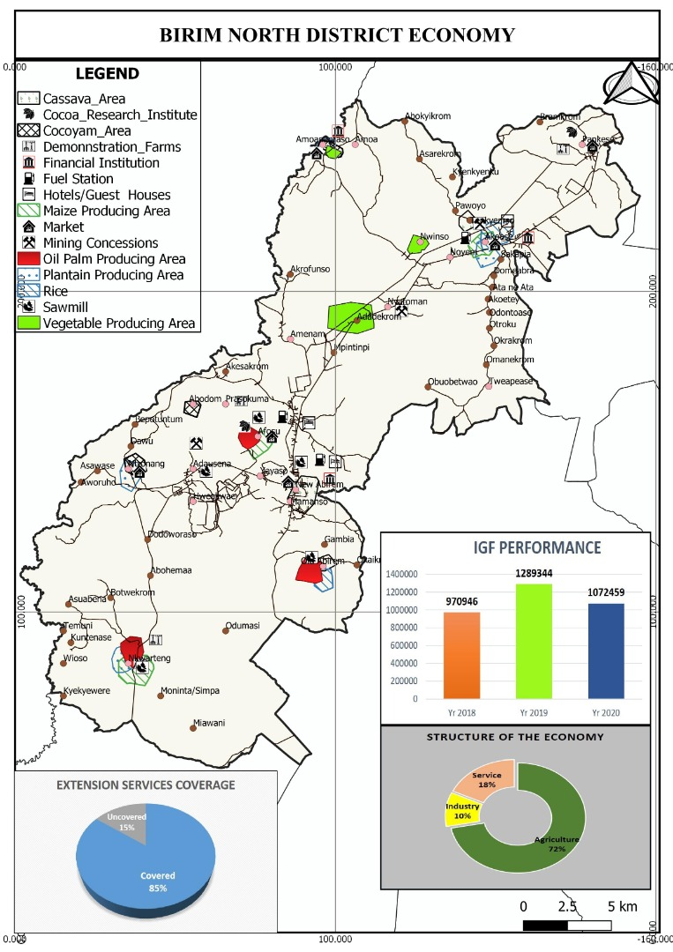
13.1 Mining
Various minerals occur within the District. However, Gold is the largest mineral deposit which is found in both rocks and alluvial. The alluvial gold is obtained from the eroded and weathered Birimian rocks, Tarkwaian rocks and also from the mineralized eroded granites where the River Pra flows. River Pra, its valleys and plains are the good source of the alluvial gold. There are about seven small scale miners in the district with one multinational company operating in the district (Newmont Golden Ridge Limited-Akyem).
Newmont Golden Ridge Limited activities’ can be found mainly in Southern part of the district around Ajenjua Bepo surrounded by Ntronang, Afosu, Adausena, New Abirem, New Amanfrom, Hweakwae, Old Abirem, Mamanso, Adjenua, Yaw Tano & Hamlet communities.
It is expected that a lot of revenue will come to the District Assembly by way of royalties. However, the inflows for Mineral Royalties, Ground Rent and Concessions as at 2020 amounted to GH¢ 9,210,236.82. In terms of Property Rate, Newmont Akyem Mines from 2016 to date has paid a total of GH¢ 2,315,000.00 to the Assembly. This revenue is assisting the Assembly in its development efforts by way of providing social infrastructure such as schools, water and sanitation facilities, health, roads, market among others.
Another major advantage which the mining activities have brought to the District is the creation of employment avenues for both skilled and unskilled labour. This has helped reduced unemployment in the district especially among the youth.
One major challenge with the mining activities is the influx of people from all walks of life into the district to look for employment opportunities in the mining company. However, the District Assembly in collaboration with the mining company has put in place measures to minimize the various social vices such as prostitution, armed robbery among others associated with mining communities. The map on the next page present the natural resource that the district is endowed with.

Figure 2.
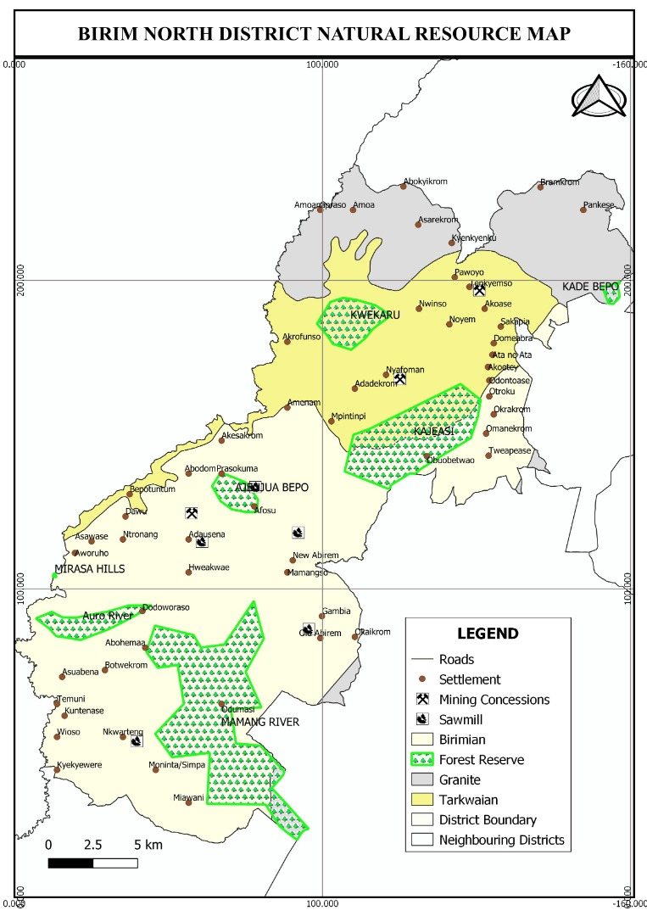

14.0 The Agricultural Sector
14.1 Overview
Agriculture is the mainstay of the economy of the Birim North District. About 85.5 percent of the labour force in the District is engaged in one form of agricultural enterprise or the other. The major crops cultivated in the District include cocoa, oil palm, citrus, rice, maize, plantain, cassava, cocoyam and vegetables. The following areas are considered under the Agricultural sector; Land tenure - availability and acquisition, farm sizes and holdings, farming systems, farm labour, area under cultivation and type of crops cultivated as well as their estimated yields, sources of finance to the Agricultural sector, extension services, farm tools and equipment, storage and marketing systems.

15.0 SERVICE SECTOR
(i) Postal Service
The District has one Post Office at New Abirem and four Postal Agencies at Ntronang, Afosu, Akoase and Pankese. Owing to lack of patronage, some of the Postal Agencies are not functional to expectation. Their main functions include delivery of letters to and from the District capital.
(ii) Banking Service
Conventional banking institutions in the District, there are three commercial banks; Absa Bank, Consolidated Bank and Ecobank are located in New Abirem. There are five rural banks operating in the District. These are Mponua Rural Bank, Kwahu Rural Bank, Mumuadu Rural Bank and South Birim banks all located at New Abirem whiles Dumpon Rural Bank is located at Akoase. However, Mponua Rural Bank has its headquarters at Amuana Praso. Ropa microfinance and Vision Workers Cooperative Credit Union is also located at New Abirem. Banking service is therefore skewed towards New Abirem the District capital.
(iii)

16.0 Age and Sex Composition
The structure of the population has about 50.0% female and 50.0% male. The sex ratio is 100 males to 100 females. When the population is divided into broad age groups; 0 – 14 years age cohort constitute about 39.9 percent, whiles the 15 – 64 years age cohort constitute 55 percent. The 65+ year age cohort is 5.1 percent. The District population is youthful with about 39.9 percent between the ages of 0 – 14 years whiles only 5.1 are above the age of 64 years. The proportion of children below 15 years is therefore very high. The de facto composition of the labour force; defined here as the number of people within the age group of 15- 64 years is 55 percent.
The implication is that a greater percentage of the population falls within the vulnerable group. This therefore calls for a positive affirmative action in the distribution, control and benefits of socio-economic policies, programmes and activities of the Assembly.

Figure 3: Age / Sex Structure of Birim North District

16.1 Labour Force and Dependency Ratio
The 2010 Population census put the economically active and working population in the district at 54.6% for males and compares favourably with females who constitute 55.4% while the non-economically active population constitutes 45.4% for males and 44.6% for females. This implies the need for mainstreaming gender in the development programmes of the District.

17.0 Staff Distribution in relation to Gender
Staff distribution in Birim North District is skewed in favor of males with the female: male ratio being 1:3. The total staff strength at the District Administration is 147 comprising of 108 males and 39 females. Meanwhile only nine (9) out of the twenty-eight (28) senior officers are female. This implies that mostly males dominate the District Administration. The situation is not different from the junior officers where we have only 18 females as against 55 males. A conscious effort should be geared towards affirmative action in the subsequent recruitments and appointments. The Assembly should facilitate the appointment of females to management positions to give meaning to the concept of women empowerment. The break down is shown below:
The total staff strength of the Birim North District Assembly as at 30th October, 2021 is One hundred and forty-seven (147).
b) Staff Distribution

- Male - 108
Female - 39
Total - 147

- Snr. Male Officers - 28
Snr. Female Officers - 9
Total - 37

- Jnr. Male Officers - 55
Jnr. Female Officers - 18
Total - 73
- Causal Staff
Male - 22
Female - 12
Total - 34
Commission Collectors-3 Males
Source: BNDA/November, 2021
Resource Utilization
With limited resource, financial, material and human, it is not possible to satisfy the needs of all communities within the 4-Year period.
On the basis of the above, projects should be sited strategically to serve many communities as much as possible. Secondly, projects selected should serve the felt needs of the communities and not political interest.
Institutional linkages
As much as possible, institutional capacity building should be pursued. The District Assembly should assume the overall central coordinating role while outlining institutional responsibilities in conjunction with the various Departments of the Assembly and other government agencies. This is to get them actively involved in implementation on the plan in its totality.
Agencies outside must also be consulted to give assistant to the Assembly’s own implementation and monitoring efforts. Research institutions of the various Universities such as BIRD, BRRI, CSIR, etc. could be of immense help in the areas of planning, training and advise on project implementation, monitoring and evaluation.
In order to achieve some level of integration, planning and project implementation have to be worked out in such a way that the development of one sector is linked to the other sectors of the economy of the District.
This way the development of feeder roads is meant to positively affect agriculture production. Much the same, the provision of potable water is expected to supplement health delivery in the District.
Project Selection Consideration
Pragmatic approach guided in the selection and location of projects. This was to avoid pressure from communities and authorities. The process involved open for communal participation in the needs assessment procedure. Care was also taken to ensure equitable distribution of projects in order to be sure that:
- Selected projects respond to the priority needs of the community.
- Project selected are accessible to the majority of the people in the community.
- Technology choice for implementation is user friendly.
- Resources for implementation is available
- Projects will be sustainable (E.g. a school must have encouraging enrolment rate).
- Projects are aimed at poverty reduction in the District.
Project Financing
The implementation of projects and programmes under the 2022 Annual Action Plan will require huge financial resources. Obviously, such financial resources cannot be generated within the District alone over the planned period. Even with its share of the Common Fund, the District will still need extra funding from central government and other agencies.
The main sources therefore include:
- Internally Generated Fund
- Royalties
- Central Government (GoG)
- GETFUND
- DACF-RFG
- DACF
- Donor

Programme Based Budgeting System
In order to successfully implement programmes and projects as spelt out in the plan. A programme based budgeting system would be followed. This allow for allotment of adequate funding to different areas of the programme. This entails a clear description of the projects involved and matching of specific projects or programme budgeting is linked to specific prioritize projects. Therefore, reduction in allocation from the planned budget can be easily identified with a particular project, which easily leads to corresponding exclusion of specific projects rather than to squeezing all programmes in efficiently.
It must be noted that the effective and successful implementation of programmes of the Birim North District Annual Action Plan will depend heavily on the authority and capacity of the Assembly, and the participation and integration of all the people in all stages of the development process, namely, project planning, implementation, monitoring and evaluation.
The tables that follow show the Annual Action Plan for Birim North District Assembly indicating specific project intervention for the year 2022 as planned.
Table 6. Annual Action Plan (AAP) – 2022
An Agenda for Jobs . Goal: Build a prosperous society
Development Dimension: Economic development
DMTDP Goal: Build an industrialised, inclusive and resilient economy
Programme (PBB) |  | Sub programme (PBB) |  | Broad activities |  | Location | Time frame (Year) |  |  |  |  |  |  |  | Cost (GH¢) |  |  |  |  |  |  |  |  |  | Programme status |  | Implementing institution / department
 |  |  |  |  |  |  | Q1 |  | Q2 |  | Q3 |  | Q4 |  |  |  |  |  |  |  |  |  | Q1 | Q2 | Q3 | Q4
Economic development |  | Agriculture development |  | 1. Train women (WIAD) in income generating activities(soap making and Beekeeping) |  | District wide | √ |  | √ |  | √ |  | √ |  |  |  |  |  | 3,500.00 |  |  |  | 6,000.00 (MAG) |  |  | √ | DDA | BNDA
Economic development |  | Agriculture development |  | 2.Business training/  Education of farmers and actors along the value chain on product standardization |  | District wide | √ |  | √ |  | √ |  | √ |  |  |  |  |  | 3,200.00 |  |  |  |  |  |  | √ | DDA | BNDA
Economic development |  | Agriculture development |  | 3.Promote alternative livelihood,  climate resilient cropping system,  Water system conservation and sustainable land management |  | District wide | √ |  | √ |  | √ |  | √ |  |  |  |  |  |  |  |  |  | 4,300.00 (MAG) |  |  | √ | DDA | BNDA
Economic development |  | Agriculture development |  | 4.On-farm Demonstration of innovation  Agricultural technologies/ Provision of storage facility |  | District wide | √ |  | √ |  | √ |  | √ |  | 4,000.00 |  |  |  |  |  |  |  | 16,500.00 (MAG) |  |  | √ | DDA | BNDA
Economic development | Agriculture development |  | 5.Development of FBO’s (Formation) |  | District wide |  |  | √ |  | √ |  | √ |  | √ |  | 7,800.00 |  |  |  |  |  |  | 5,000.00 (MAG) |  |  | √ | DDA | BNDA

Annual Action Plan (AAP) – 2022
An Agenda for Jobs . Goal: Build a prosperous society
Development Dimension: Economic development
DMTDP Goal: Build an industrialised, inclusive and resilient economy
Programme (PBB) | Sub programme (PBB) | Broad activities | Location | Time frame (Year) |  |  |  | Cost (GH¢) |  |  |  |  |  | Programme status |  | Implementing institution / department
 |  |  |  | Q1 | Q2 | Q3 | Q4 | GoG | IGF | DACF | DACF-RFG | DP | Others | New | Ongoing | Lead | Collaborating
Economic development | Agriculture development | 6.Safe use of Agro-chemicals (Training) | District wide | √ | √ | √ | √ | 4,000.00 |  |  |  | 15,000.00 (MAG) |  |  | √ | DDA | BNDA
Economic development | Agriculture development | 7.Collation and Analysis of Market information(SRID) | District wide | √ | √ | √ | √ |  |  |  |  | 3,850.00 (MAG) |  |  | √ | DDA | BNDA
Economic development | Agriculture development | 8.Effective and efficient extension service delivery | District wide | √ | √ | √ | √ |  |  |  |  | 62,000.00 (MAG) |  |  | √ | DDA | BNDA
Economic development | Agriculture development | 9.Management and Administration | District wide | √ | √ | √ | √ |  |  |  |  | 30,000.00 (MAG) |  |  | √ | DDA | BNDA
Economic development | Agriculture development | 10.Livestock Diseases control | District wide | √ | √ | √ | √ |  |  | 2,500.00 |  | 3,200.00 (MAG) |  |  | √ | DDA | BNDA
Economic development | Agriculture development | 11. Promoting small ruminant’s production among PLWD’s in the district. | District wide | √ | √ | √ | √ |  |  |  |  | 5,450.00 (MAG) |  |  | √ | DDA | BNDA
Economic development | Agriculture development | 12.Sensitization of farmers on disease control | District wide | √ | √ | √ | √ |  |  |  |  | 2,700.00 (MAG) |  |  | √ | DDA | BNDA
Annual Action Plan (AAP) – 2022
An Agenda for Jobs . Goal: Build a prosperous society
Development Dimension: Economic
DMTDP Goal: Build an industrialised, inclusive and resilient economy
Programme (PBB) | Sub programme (PBB) | Broad activities | Location | Time frame (Year) |  |  |  | Cost (GH¢) |  |  |  |  |  | Programme status |  | Implementing institution / department
 |  |  |  | Q1 | Q2 | Q3 | Q4 | GoG | IGF | DACF | DACF-RFG | DP | Others | New | Ongoing | Lead | Collaborating
Economic development | Agriculture development | 13.Livestock pest control (Training) | District wide | √ | √ | √ | √ |  |  |  |  | 2,100.00 (MAG) |  |  | √ | DDA | BNDA
Economic development | Agriculture development | 14.Food safety, Quality & Standardization Education | District wide | √ | √ | √ | √ |  |  |  |  | 2,500.00 (MAG) |  |  | √ | DDA | BNDA
Economic development | Agriculture development | 15.Planting For Food and Jobs | District wide | √ | √ | √ | √ | 8,000.00 |  | 1,000.00 |  | 12,000.00 (MAG) |  |  | √ | DDA | BNDA
Economic development | Agriculture development | 16. Staff Skills development training. | District wide | √ | √ | √ | √ |  |  |  |  | 2,500.00 (MAG) |  |  | √ | DDA | BNDA
Economic development | Agriculture development | 17. Distribution of certified Oil Palm seedlings to farmers from Dept. of Agric. Nursery. | District  wide | √ | √ | √ | √ | 4,000.00 |  | 200,000.00 |  |  |  |  | √ | DDA | BNDA
Economic development | Agriculture development | 18.Promote satellite market development | Okaikrom | √ | √ | √ | √ |  | 7,000.00 | 11,000.00 |  | 3,700.00 |  |  | √ | DDA | BNDA

Annual Action Plan (AAP) – 2022
An Agenda for Jobs . Goal: Build a prosperous society
Development Dimension: Economic development
DMTDP Goal: Build an industrialised, inclusive and resilient economy
Programme (PBB) | Sub programme (PBB) | Broad activities | Location | Time frame (Year) |  |  |  | Cost (GH¢) |  |  |  |  |  | Programme status |  | Implementing institution / department
 |  |  |  | Q1 | Q2 | Q3 | Q4 | GoG | IGF | DACF | DACF-RFG | DP | Others | New | Ongoing | Lead | Collaborating
Economic development | Trade, tourism and industrialised development | 19.Engagement with Trade Associations | District wide | √ | √ | √ | √ | 5,500.00 |  |  |  |  |  |  | √ | BAC | BNDA
Economic development | Trade, tourism and industrialised development | 20.Procure cassava processing facility for Gari Production / palm oil processing machine | Tenkyemso  Okaikrom | √ | √ | √ | √ | 10,000.00 |  |  |  |  |  |  | √ | BAC | BNDA
Economic development | Trade, tourism and industrialised development | 21.Strengthening of Association of Small Scale Industries (ASSI) | New Abirem | √ | √ | √ | √ |  | 3,000.00 |  |  |  |  |  | √ | BAC | BNDA
Economic development | Trade, tourism and industrialised development | 22.Organisation of NVTI examination and purchase of start-up kits | New Abirem | √ | √ | √ | √ | 6,000.00 | 15,000.00 |  |  |  |  |  | √ | BAC | BNDA
Economic development | Trade, tourism and industrialised development | 23.Support for youth and SMEs | New Abirem | √ | √ | √ | √ |  | 60,000.00 |  |  |  |  |  | √ | BAC | BNDA
Economic development | Trade, tourism and industrialised development | 24.Organisation of Start Your Business Workshop (SYBW) | Hweakwae | √ | √ | √ | √ |  | 4,000.00 |  |  |  |  |  | √ | BAC | BNDA

Annual Action Plan (AAP) – 2022
An Agenda for Jobs . Goal: Build a prosperous society
Development Dimension: Economic development
DMTDP Goal: Build an industrialised, inclusive and resilient economy
Programme (PBB) | Sub programme (PBB) | Broad activities | Location | Time frame (Year) |  |  |  | Cost (GH¢) |  |  |  |  |  | Programme status |  | Implementing institution / department
 |  |  |  | Q1 | Q2 | Q3 | Q4 | GoG | IGF | DACF | DACF-RFG | DP | Others | New | Ongoing | Lead | Collaborating
Economic development | Trade, tourism and industrialised development | 25.Organisation of Occupational Safety, Health and Environmental Management (OSHEM) | Afosu & Old Abirem | √ | √ | √ | √ |  | 5,000.00 |  |  |  |  |  | √  546 | BAC | BNDA
Economic development | Trade, tourism and industrialised development | 26.Facilitation of Rural Enterprises Development Fund (REDF) Loan Facility | District wide | √ | √ | √ | √ | 150,000.00 |  |  |  |  |  |  | √ | BAC | BNDA
Economic development | Trade, tourism and industrialised development | 27.Technology training in Palm Oil Production | Mamanso & Adausena | √ | √ | √ | √ |  |  | 6,000.00 |  |  |  |  | √ | BAC | BNDA
Economic development | Trade, tourism and industrialised development | 28.Business counselling and Monitoring Services | District wide | √ | √ | √ | √ |  | 3,000.00 |  |  |  |  |  | √ | BAC | BNDA
Economic development | Trade, tourism and industrialised development | 29.Formation and registration of co-operatives | District wide | √ | √ | √ | √ |  | 3,000.00 |  |  |  |  |  | √ | Co-op. | BNDA
Economic development | Trade, tourism and industrialised development | 30.Training of co-operatives societies members | District wide | √ | √ | √ | √ |  | 5,000.00 |  |  |  |  |  | √ | Co-op. | BNDA
Economic development | Trade, tourism and industrialised development | 31.Auditing of co-operatives societies | District wide | √ | √ | √ | √ |  | 5,000.00 | 4,000.00 |  |  |  |  | √ | Co-op. | BNDA

Annual Action Plan (AAP) – 2022
An Agenda for Jobs . Goal: Create opportunities for all
Development Dimension: Social development
DMTDP Goal: Create equitable, healthy and discipline society
Programme (PBB) | Sub programme (PBB) | Broad activities | Location | Time frame (Year) |  |  |  | Cost (GH¢) |  |  |  |  |  | Programme status |  | Implementing institution / department
 |  |  |  | Q1 | Q2 | Q3 | Q4 | GoG | IGF | DACF | DACF-RFG | DP | Others | New | Ongoing | Lead | Collaborating
Social Services Delivery | Education, youth and sports and library services | 32.Construction of 1No. 3-Unit classroom block with emphasis on women and Children | Okaikrom, | √ | √ | √ | √ |  | 190,000.00 | 95,000.00 | 95,000.00 |  |  |  | √ | DED | BNDA
Social Services Delivery | Education, youth and sports and library services | 33.Construction of 1No. 3-Unit classroom block with emphasis on women and Children | ,Abohema, | √ | √ | √ | √ |  | 190,000.00 | 95,000.00 | 95,000.00 |  |  |  | √ | DED | BNDA
Social Services Delivery | Education, youth and sports and library services | 34.Construction of 1No. 3-Unit classroom block with emphasis on women and Children | Akoase D/A, | √ | √ | √ | √ |  | 190,000.00 | 95,000.00 | 95,000.00 |  |  |  | √ | DED | BNDA
Social Services Delivery | Education, youth and sports and library services | 35.Construction of 1No. 3-Unit classroom block with emphasis on women and Children | Adadekrom, | √ | √ | √ | √ |  | 190,000.00 | 95,000.00 | 95,000.00 |  |  |  | √ | DED | BNDA
Social Services Delivery | Education, youth and sports and library services | 36.Rehabilitation Of 1no. 6-Unit Classroom Block | Amuana Praso Presby | √ | √ | √ | √ |  | 323,735.00 |  |  |  |  |  | √ | DED | BNDA
Social Services Delivery | Education, youth and sports and library services | 37.Rehabilitation Of 1no. 3-Unit Classroom Block | Kuntunase | √ | √ | √ | √ |  | 164,635.99 |  |  |  |  |  | √ | DED | BNDA
Social Services Delivery | Education, youth and sports and library services | 38.Construction of fence wall with emphasis on women | New Abirem/Afosu  SHS | √ | √ | √ | √ |  | 217,039.70 |  |  |  |  |  | √ | DED | BNDA
Social Services Delivery | Education, youth and sports and library services | 39.Construction of 1No. Library with ICT  emphasis on women | Adausena& Hweakwae | √ | √ | √ | √ |  |  |  | 241,124.90 |  |  |  | √ | DED | BNDA
Social Services Delivery | Education, youth and sports and library services | 40.Construction of 1No. 6-Unit classroom block emphasis on women | Odontuase | √ | √ | √ | √ |  | 545,418.72 |  |  |  |  |  | √ | DED | BNDA
Social Services Delivery | Education, youth and sports and library services | 41.Construction of 1No. 2-Unit classroom block, office, store, W/C, sanded play area, paved walk way, fenced, gated, poly tank stand with 5000 capacity litres emphasis on women | Afosu R/C | √ | √ | √ | √ |  |  |  | 350,000.00 |  |  | √ |  | DED | BNDA
Social Services Delivery | Education, youth and sports and library services | 42.Organisation of My First Day at school | District wide | √ | √ | √ | √ |  | 10,000.00 | 5,000.00 |  |  |  |  | √ | DED | BNDA
Social Services Delivery | Education, youth and sports and library services | 43.Organization of STEM Clinics from School Level to Regional Level. | District wide | √ | √ | √ | √ |  | 4,500.00 | 4,500.00 |  |  |  |  | √ | DED | BNDA

Annual Action Plan (AAP) – 2022
An Agenda for Jobs . Goal: Create opportunities for all
Development Dimension: Social development
DMTDP Goal: Create equitable, healthy and discipline society
Programme (PBB) | Sub programme (PBB) | Broad activities | Location | Time frame (Year) |  |  |  | Cost (GH¢) |  |  |  |  |  | Programme status |  | Implementing institution / department
 |  |  |  | Q1 | Q2 | Q3 | Q4 | GoG | IGF | DACF | DACF-RFG | DP | Others | New | Ongoing | Lead | Collaborating
Social Services Delivery | Education, youth and sports and library services | 44.Organization of School, Zonal, District, Sub-Zonal and Regional Cultural Festivals | District wide | √ | √ | √ | √ |  | 2,000.00 | 10,000.00 |  |  |  |  | √ | DED | BNDA
Social Services Delivery | Education, youth and sports and library services | 45.Organise SPAM and performance review Meetings | District wide | √ | √ | √ | √ |  | 4,000.00 | 9,300.00 |  |  |  |  | √ | DED | BNDA
Social Services Delivery | Education, youth and sports and library services | 46.Provide Scholarship, Bursaries & Financial Assistance to Students | District wide | √ | √ | √ | √ |  | 20,000.00 | 70,000.00 |  |  |  |  | √ | DED | BNDA

Annual Action Plan (AAP) – 2022
An Agenda for Jobs . Goal: Create opportunities for all
Development Dimension: Social development
DMTDP Goal: Create equitable, healthy and discipline society
Programme (PBB) | Sub programme (PBB) | Broad activities | Location | Time frame (Year) |  |  |  | Cost (GH¢) |  |  |  |  |  | Programme status |  | Implementing institution / department
 |  |  |  | Q1 | Q2 | Q3 | Q4 | GoG | IGF | DACF | DACF-RFG | DP | Others | New | Ongoing | Lead | Collaborating
Social Services Delivery | Public health services and management | 47.Completion of Health centre emphasis on women | Akoase | √ | √ | √ |  |  | 108,838.10 |  |  |  |  |  | √ | DHD | BNDA
Social Services Delivery | Public health services and management | 48.Completion of Health centre emphasis on women | Pankese | √ | √ | √ |  |  | 70,232.58 |  |  |  |  |  | √ | DHD | BNDA
Social Services Delivery | Public health services and management | 49.Construction of 1No. CHPS Compound and Staff Quarters emphasis on women | Nwinso, | √ | √ | √ | √ |  | 250,000.00 | 125,000.00 |  |  |  | √ |  | DHD | BNDA
Social Services Delivery | Public health services and management | 50.Construction of 1No. CHPS Compound and Staff Quarters emphasis on women | Odontuase, | √ | √ | √ | √ |  | 250,000.00 | 125,000.00 |  |  |  |  |  | DHD | BNDA
Social Services Delivery | Public health services and management | 51.Construction of 1No. CHPS Compound and Staff Quarters emphasis on women | Mpintimpi | √ | √ | √ | √ |  | 250,000.00 | 125,000.00 |  |  |  |  |  | DHD | BNDA
Social Services Delivery | Public health services and management | 52.Construction of 1No. CHPS Compound and Staff Quarters emphasis on women | Mamanso | √ | √ | √ | √ |  | 250,000.00 | 125,000.00 |  |  |  |  |  | DHD | BNDA
Social Services Delivery | Public health services and management | 53.Construction of 4 No. placenta pit | Adausena, Nkwateng, Amuana Praso, Tweapaese | √ | √ | √ | √ |  |  | 42,000.00 |  |  |  | √ |  | DHD | BNDA
Social Services Delivery | Public health services and management | 54.Construction of fence wall | New Abirem Government Hospital | √ | √ | √ | √ |  | 500,000.00 |  |  |  |  | √ |  | DHD | BNDA
Social Services Delivery | Public health services and management | 55.Provide basic equipment: BP apparatus, HB meters and autoclave | Amenam, Praso Kuma, Mpintimpi, Abodom | √ | √ | √ | √ |  | 20,000.00 | 13,250.00 |  |  | √ |  |  | DHD | BNDA
Social Services Delivery | Public health services and management | 56.Increase uptake of Expanded Programme on Immunization (EPI) services through outreach and supportive supervision | District wide | √ | √ | √ | √ |  |  | 4,500.00 |  |  |  |  |  | DHD | BNDA
Social Services Delivery | Public health services and management | 57.Increase access to modern FP services through public education and regular supplies of FP commodities | District wide | √ | √ | √ | √ |  | 5,000.00 |  |  |  |  |  |  | DHD | BNDA
Social Services Delivery | Public health services and management | 58.Strengthen school health programmes | District wide | √ | √ | √ | √ |  | 4,500.00 |  |  |  |  |  |  | DHD | BNDA
Social Services Delivery | Public health services and management | 59.Undertake Mass Drug Administration against Onchocerciasis, Schistosomiasis, Intestinal worms and Yaws | District wide | √ | √ | √ | √ |  | 8,815.00 | 10,000.00 |  |  |  |  |  | DHD | BNDA
Social Services Delivery | Public health services and management | 60.Integrated Disease surveillance and response to epidemic prone diseases and other diseases of public health importance | District wide | √ | √ | √ | √ |  | 3,750.00 |  |  |  |  |  |  | DHD | BNDA

Annual Action Plan (AAP) – 2022
An Agenda for Jobs . Goal: Create opportunities for all
Development Dimension: Social development
DMTDP Goal: Create equitable, healthy and discipline society
Programme (PBB) | Sub programme (PBB) | Broad activities | Location | Time frame (Year) |  |  |  | Cost (GH¢) |  |  |  |  |  | Programme status |  | Implementing institution / department
 |  |  |  | Q1 | Q2 | Q3 | Q4 | GoG | IGF | DACF | DACF-RFG | DP | Others | New | Ongoing | Lead | Collaborating
Social Services Delivery | Public health services and management | 61.Organization of health education and creation of awareness to construct household latrine | District wide | √ | √ | √ | √ |  | 8,400.00 |  |  |  |  |  | √ | DEHU | BNDA
Social Services Delivery | Public health services and management | 62.Leveling of engineered landfill site  Fumigation of refuse dumps  Desilting of choke drains | District wide | √ | √ | √ | √ |  | 85,000.00 | 50,000.00 |  |  |  |  | √ | DEHU | BNDA
Social Services Delivery | Public health services and management | 63.Health screening of food and drink vendors | District wide | √ | √ | √ | √ |  | 3,500.00 |  |  |  |  |  | √ | DEHU | BNDA
Social Services Delivery | Public health services and management | 64.Interment of unknown dead bodies | District wide | √ | √ | √ | √ |  | 4,000.00 |  |  |  |  |  | √ | DEHU | BNDA
Social Services Delivery | Public health services and management | 65.Support for DWST | District wide | √ | √ | √ | √ |  | 4,850.00 |  |  |  |  |  | √ | DEHU | BNDA
Social Services Delivery | Public health services and management | 66.Construction of 1No. 12 Seater WC Toilet with mechanized borehole emphasis on women and children | Amoa, | √ | √ | √ | √ |  |  |  | 237,008.9 |  |  |  | √ | DEHU | BNDA
Social Services Delivery | Public health services and management | 67.Construction of 1No. 12 Seater WC Toilet with mechanized borehole emphasis on women and children | Adausena | √ | √ | √ | √ |  |  |  | 237,008.9 |  |  |  | √ | DEHU | BNDA
Social Services Delivery | Public health services and management | 68.Construction of 3No. 12 Seater WC Toilet with mechanized borehole emphasis on women and children | Nyafoman | √ | √ | √ | √ |  |  | 158,122.00
Social Services Delivery | Public health services and management | 69.Construction Of 1no. 16-Seater W/C Toilet And 4 Bathrooms | New Abirem | √ | √ | √ | √ |  |  | 418,315.17 |  |  |  |  | √ | DEHU | BNDA
Social Services Delivery | Public health services and management | 70.Community Led Total Sanitation (CLTS) / WASH promotion | District wide | √ | √ | √ | √ |  | 25,000.00 |  |  |  |  |  | √ | DEHU | BNDA

Annual Action Plan (AAP) – 2022
An Agenda for Jobs . Goal: Create opportunities for all
Development Dimension: Social development
DMTDP Goal:Create equitable, healthy and discipline society
Programme (PBB) | Sub programme (PBB) | Broad activities | Location | Time frame (Year) |  |  |  | Cost (GH¢) |  |  |  |  |  | Programme status |  | Implementing institution / department
 |  |  |  | Q1 | Q2 | Q3 | Q4 | GoG | IGF | DACF | DACF-RFG | DP | Others | New | Ongoing | Lead | Collaborating
Social Services Delivery | Public health services and management | 71.Purchase of sanitary tools | District wide | √ | √ | √ | √ |  |  | 45,000.00 |  |  |  |  | √ | DEHU | BNDA
Social Services Delivery | Public health services and management | 72.Waste landfills site, Fumigation & Sanitation Improvement Package | District wide | √ | √ | √ | √ | Ss |  | 98,000.00 |  |  |  |  | √ | DEHU | BNDA
Social Services Delivery | Public health services and management | 73.Manage sanitation in the district | District wide | √ | √ | √ | √ |  |  | 27,400.00 |  |  |  |  | √ | DEHU | BNDA
Social Services Delivery | Public health services and management | 74.Clear and maintain refuse dump site | District wide | √ | √ | √ | √ |  |  | 11,900.00 |  |  |  |  | √ | DEHU | BNDA
Social Services Delivery | Public health services and management | 75.Celebration of World Toilet Day / Global Hand washing Day | District wide | √ | √ | √ | √ |  | 4,900.00 |  |  |  |  |  | √ | DEHU | BNDA
Social Services Delivery | Public health services and management | 76.Conduct routine inspection | District wide | √ | √ | √ | √ |  | 3,000.00 | 900.00 |  |  |  |  | √ | DEHU | BNDA
Social Services Delivery | Public health services and management | 77. Covid-19 related activities | District wide | √ | √ | √ | √ |  | 10,000.00 |  |  |  |  |  | √ | DEHU | BNDA
Social Services Delivery | Public health services and management | 78. Extention of water facilities to communities (Drilling of 15No boreholes fitted with hand pumps) | Abenase, Asawase and Nkwateng etc | √ | √ | √ | √ | Improved access to portable water for domestic usage |  | 270,000.00 |  |  |  |  |  | DEHU | BNDA
Social Services Delivery | Public health services and management | 79. Extention of water facilities to communities (Drilling, repairs, mechanization and development of 15No boreholes). | Bramkrom, Dodoworaso, Domebra, Koti-Yeboa, Kyereahantan, Mangoase, Mpintimpi, etc. | √ | √ | √ | √ | Improved access to portable water for domestic usage |  | 377,029.07 |  |  |  |  |  | DEHU | BNDA

Annual Action Plan (AAP) – 2022
An Agenda for Jobs . Goal: Create opportunities for all
Development Dimension: Social development
DMTDP Goal: Create equitable, healthy and discipline society
Programme (PBB) | Sub programme (PBB) | Broad activities | Location | Time frame (Year) |  |  |  | Cost (GH¢) |  |  |  |  |  | Programme status |  | Implementing institution / department
 |  |  |  | Q1 | Q2 | Q3 | Q4 | GoG | IGF | DACF | DACF-RFG | DP | Others | New | Ongoing | Lead | Collabo  Rating
Social services delivery | Social welfare and community services | 80.Facilitate the implementation of LEAP Activities | District Wide | √ | √ | √ | √ |  | 3,000.00 |  |  |  | 7,000.00  (LEAP MGT. Secretariat) |  | √ | DSW&CD | Mponua Rural Bank
Social services delivery | Social welfare and community services | 81.Roll out of the child protection tool kits through community engagement and dialogue | District Wide | √ | √ | √ | √ | 3,000.00 | 12,000.00 |  |  |  |  |  | √ | DSW&CD | GES, GHS, DOVVSU, NCCE
Social services delivery | Social welfare and community services | 82.Organise sensitization on HIV/AIDS | District Wide | √ | √ | √ | √ |  | 5,000.00 | 10,000.00 |  |  |  |  | √ | DSW&CD | GES, GHS, NGO
Social services delivery | Social welfare and community services | 83.Organise sensitization on teenage pregnancy | District Wide | √ | √ | √ | √ | 3,000.00 | 5,000.00 |  |  |  |  |  | √ | DSW&CD | GHS,Girl-Child Co-ord-GES
Social services delivery | Social welfare and community services | 84.Organise workshop for school- based Girl Child Co-ordinators | District Wide | √ | √ | √ | √ |  | 3,000.00 |  |  |  |  |  | √ | DSW&CD | GES, GHS
Social services delivery | Social welfare and community services | 85.Organise training on women empowerment | District Wide | √ | √ | √ | √ | 2,000.00 | 5,000.00 |  |  |  |  |  | √ | DSW&CD | AGRIC, NGO
Social services delivery | Social welfare and community services | 86. Organise sensitization on menstrual hygiene in schools | District Wide | √ | √ | √ | √ |  | 2,000.00 |  |  |  |  |  | √ | DSW&CD | GES,GHS
Social services delivery | Social welfare and community services | 87. Organise sensitization on gender based violence in schools | District Wide | √ | √ | √ | √ |  | 3,000.00 |  |  |  |  |  | √ | DSW&CD | DOVVSU, GES,GHS
Social services delivery | Social welfare and community services | 88.Organise Sensitization programme for farmers on child labour | District Wide | √ | √ | √ | √ |  | 2,000.00 |  |  |  |  |  | √ | DSW&CD | GES,GHS,NGO

Annual Action Plan (AAP) – 2022
An Agenda for Jobs . Goal: Create opportunities for all
Development Dimension: Social development
DMTDP Goal: Create equitable, healthy and discipline society
Programme (PBB) | Sub programme (PBB) | Broad activities | Location | Time frame (Year) |  |  |  | Cost (GH¢) |  |  |  |  |  |  | Programme status |  |  | Implementing  institution /  department
 |  |  |  | Q1 | Q2 | Q3 | Q4 | GoG | IGF | DACF | DACF-RFG | DP | Others | New |  | Ongoing | Lead |  | Collabo  Rating
Social services delivery | Social welfare and community services | 89.Supervise and monitor activities of day care centres in the district | District Wide | √ | √ | √ | √ | 2,000.00 | 8,000.00 |  |  |  |  |  |  | √ | DSW&CD |  | GES,  GHS, NGO
Social services delivery | Social welfare and community services | 90.Assist and conduct social enquiry on juveniles in conflict with the law and submit report to the court | District Wide | √ | √ | √ | √ | 1,000.00 | 5,000.00 |  |  |  |  |  |  | √ | DSW&CD |  | Police, Assembly members, Nananom, community members
Social services delivery | Social welfare and community services | 91.Disbursement of Disability Common Fund | District Wide | √ | √ | √ | √ |  |  | 100,000.00 |  |  |  |  |  | √ | DSW&CD |  | DFMC
Social services delivery | Social welfare and community services | 92.Register, enroll PWDs on NHIS and Monitor the activities of PWDs. | District Wide | √ | √ | √ | √ |  |  | 8,000.00 |  |  |  |  |  | √ | DSW&CD |  | Agric, GHS, DFMC
Social services delivery | Social welfare and community services | 93.Organize business management training for PWDs | District Wide | √ | √ | √ | √ |  |  | 40,000.00 |  |  |  |  |  | √ | DSW&CD |  | BAC, GIZ

Annual Action Plan (AAP) – 2022
An Agenda for Jobs . Goal: Create opportunities for all
Development Dimension: Environment, Infrastructure and human settlement
DMTDP Goal: Build safe and well planned communities whiles protecting the natural environment
Programme (PBB) | Sub programme (PBB) | Broad activities | Location | Time frame (Year) |  |  |  | Cost (GH¢) |  |  |  |  |  |  | Programme status |  |  | Implementing  institution /  department
 |  |  |  | Q1 | Q2 | Q3 | Q4 | GoG | IGF | DACF | DACF-RFG | DP | Others | New |  | Ongoing | Lead |  | Collabo  Rating
Infrastructure delivery and management | Physical and spatial planning | 94.Implement street and property addressing system | New Abirem | √ | √ | √ | √ |  | 30,000.00 |  |  |  |  |  |  | √ | PPD |  | GIZ
Infrastructure delivery and management | Physical and spatial planning | 95.Prepare base maps and local plans for 2 communities | New Abirem & Akoase | √ | √ | √ | √ |  | 15,000.00 |  |  |  |  |  |  | √ | PPD |  | GIZ
Infrastructure delivery and management | Physical and spatial planning | 96.Revision of 2 sector plans | Afosu & New Abirem | √ |  | √ |  |  | 8,000.00 |  |  |  |  |  |  | √ | PPD |  | GIZ
Infrastructure delivery and management | Physical and spatial planning | 97.Conduct weekly site inspection for the processing development application for permitting | District wide | √ | √ | √ | √ |  | 5,000.00 |  |  |  |  |  |  | √ | PPD |  | BNDA
Infrastructure delivery and management | Physical and spatial planning | 98.Landscaping and planting of ornamental plants to beautify the environment | New Abirem |  | √ | √ |  |  | 7.000.00 |  |  |  |  | √ |  |  | PPD |  | BNDA

Annual Action Plan (AAP) – 2022
An Agenda for Jobs . Goal: Create opportunities for all
Development Dimension: Environment, Infrastructure and human settlement
DMTDP Goal: Build safe and well planned communities whiles protecting the natural environment
Programme (PBB) | Sub programme (PBB) | Broad activities | Location | Time frame (Year) |  |  |  | Cost (GH¢) |  |  |  |  |  | Programme status |  | Implementing  institution /  department
 |  |  |  | Q1 | Q2 | Q3 | Q4 | GoG | IGF | DACF | DACF-RFG | DP | Others | New | Ongoing | Lead | Collabo  Rating
Infrastructure delivery and management | Public works, rural housing and water management | 99.Construction of police station. emphasis on women | Ntronang | √ | √ | √ | √ |  |  | 248,829.68 |  |  |  |  | √ | DWD | BNDA
Infrastructure delivery and management | Public works, rural housing and water management | 100.Completion of police quarters emphasis on women | Akoase | √ | √ | √ | √ |  |  | 200,000.00 |  |  |  |  | √ | DWD | BNDA
Infrastructure delivery and management | Public works, rural housing and water management | 101.Construction Of 3no. 12-Unit Market Stalls | Nkwateng | √ | √ | √ | √ |  |  |  | 247,423.05 |  |  |  | √ | DWD | BNDA
Infrastructure delivery and management | Public works, rural housing and water management | 102. Construction Of 1no. 64 Lockable Stores | New Abirem | √ | √ | √ | √ |  | 3,223,871.86 |  |  |  |  |  | √ | DWD | BNDA
Infrastructure delivery and management | Public works, rural housing and water management | 103. Construction Of 1no. 16 Lockable Stores (Phase I) | Akim Afosu | √ | √ | √ | √ |  | 1,100,944.60 |  |  |  |  |  | √ | DWD | BNDA
Infrastructure delivery and management | Public works, rural housing and water management | 104.Provision and maintenance of streetlights & extension of electricity | District wide | √ | √ | √ | √ |  | 400,000.00 |  |  |  |  | √ |  | DWD | BNDA
Infrastructure delivery and management | Public works, rural housing and water management | 105.Contract management | District wide- | √ | √ | √ | √ |  | 60,000.00 | 20,000.00 | 20,000.00 |  |  | √ |  | DWD | BNDA
Infrastructure delivery and management | Public works, rural housing and water management | 106.Conversion of warehouse into meat shop emphasis on women | New Abirem | √ | √ |  |  |  | 40,000.00 |  |  |  |  | √ |  | DWD | BNDA
Infrastructure delivery and management | Public works, rural housing and water management | 107. MPs supported projects | District wide | √ | √ | √ | √ |  |  | 100,000.00 |  |  |  | √ |  | DWD | BNDA
Infrastructure delivery and management | Public works, rural housing and water management | 108.Self-help projects | District wide | √ | √ | √ | √ |  | 100,000.00 | 50,000.00 |  |  |  | √ |  | DWD | BNDA
Infrastructure delivery and management | Public works, rural housing and water management | 109. Embark on Development control activities by the end of dec. 2022. | District wide | √ | √ | √ | √ |  | 20,000.00 | 10,000.00 |  |  |  | √ |  | DWD | BNDA
Infrastructure delivery and management | Public works, rural housing and water management | 110. Reshaping of selected feeder roads | District wide | √ | √ | √ | √ |  | 400,000.00 | 50,000.00 |  |  |  | √ |  | DWD | BNDA
Infrastructure delivery and management | Public works, rural housing and water management | 111.Installation of road signs and speed ramps | District wide | √ | √ | √ | √ |  | 40,000.00 | 50,000.00 |  |  |  | √ |  | DWD | BNDA
Infrastructure delivery and management | Public works, rural housing and water management | 112 Decongestion exercise | District wide | √ | √ | √ | √ |  | 400,000.00 | 50,000.00 |  |  |  | √ |  | DWD | BNDA
Infrastructure delivery and management | Public works, rural housing and water management | 113.Pavement of lorry park. | New Abirem | √ | √ | √ | √ |  |  | 62,006.98 |  |  |  |  | √ | DWD | BNDA

Annual Action Plan (AAP) – 2022
An Agenda for Jobs . Goal: Create opportunities for all
Development Dimension: Environment, Infrastructure and human settlement
DMTDP Goal: Build safe and well planned communities whiles protecting the natural environment
Programme (PBB) | Sub programme (PBB) | Broad activities | Location | Time frame (Year) |  |  |  | Cost (GH¢) |  |  |  |  |  | Programme status |  | Implementing  institution /  department
 |  |  |  | Q1 | Q2 | Q3 | Q4 | GoG | IGF | DACF | DACF-RFG | DP | Others | New | Ongoing | Lead | Collabo  Rating
Environmental management | Disaster prevention and management | 114.Education on domestic/bush fires campaign. | District wide | √ | √ | √ | √ |  | 3,993.00 |  |  |  |  |  | √ | NADMO | GNFS  BNDA
Environmental management | Disaster prevention and management | 115.Public education on disaster prevention-(flooding, rain/windstorm, epidemics, erosion, land degradation and road safety) | District wide | √ | √ | √ | √ |  |  | 7,500.00 |  |  |  |  | √ | NADMO | BNDA  NEWMONT  DONORS
Environmental management | Disaster prevention and management | 116. Assessment and registration of disaster incidents and victims. | District wide | √ | √ | √ | √ |  | 3,250.00 |  |  |  |  |  | √ | NADMO | BNDA
Environmental management | Disaster prevention and management | 117. Distribution of relief items to disaster victims. | District wide | √ | √ | √ | √ |  |  | 10,000.00 |  |  |  |  | √ | Regional NADMO | BNDA

Annual Action Plan (AAP) – 2022
An Agenda for Jobs . Goal: Create opportunities for all
Development Dimension: Environment, Infrastructure and human settlement
DMTDP Goal: Build safe and well planned communities whiles protecting the natural environment
Programme (PBB) | Sub programme (PBB) | Broad activities | Location | Time frame (Year) |  |  |  | Cost (GH¢) |  |  |  |  |  | Programme status |  | Implementing  institution /  department
 |  |  |  | Q1 | Q2 | Q3 | Q4 | GoG | IGF | DACF | DACF-RFG | DP | Others | New | Ongoing | Lead | Collabo  Rating
Environmental management | Disaster prevention and management | 118.Planting of economic trees- (Akesia tree,  Nim tree,  Teak tree)  And embarking on afforestation programmes. | District wide |  | √ | √ |  |  | 3,500.00 |  |  |  |  |  | √ | NADMO | MOFA  BNDA  NEWMONT  FORESTRY.
Environmental management | Disaster prevention and management | 119. Adoption to climate change and environmental protection activities. | District wide | √ | √ | √ | √ |  |  | 6,250.00 |  |  |  |  | √ | NADMO | BNDA  MOFA  NEWMONT
Environmental management | Disaster prevention and management | 120. Formation of Disaster Volunteer Group in communities (DVGs). | District wide | √ | √ | √ | √ |  | 2,500.00 |  |  |  |  |  | √ | NADMO | BNDA

Annual Action Plan (AAP) – 2022
An Agenda for Jobs . Goal: Create opportunities for all
Development Dimension: Governance, Corruption and Public Accountability
DMTDP Goal: Build effective, efficient and dynamic institutions
Programme (PBB) | Sub programme (PBB) | Broad activities | Location | Time frame (Year) |  |  |  | Cost (GH¢) |  |  |  |  |  | Programme status |  | Implementing  institution /  department
 |  |  |  | Q1 | Q2 | Q3 | Q4 | GoG | IGF | DACF | DACF-RFG | DP | Others | New | Ongoing | Lead | Collabo  rating
Management and administration | General administration | 121.Organization of statutory meetings and other ad hoc meetings | District wide | √ | √ | √ | √ |  | 245,993.00 | 100,000.00 |  |  |  |  | √ | C.ADMIN | BNDA
Management and administration | General administration | 122.Oragnisation of stakeholders and Town hall meetings | District wide | √ |  | √ |  |  | 20,000.00 | 20,000.00 |  |  |  |  | √ | DBA/DPO/  ADMIN | BNDA
Management and administration | General administration | 123.Gazetting of Assembly documents i.e By-laws | District wide | √ | √ | √ | √ |  | 10,000.00 |  |  |  |  |  | √ | DBA | BNDA
Management and administration | General administration | 124.Repair of Assembly offices, residential accommodations and equipment (O&M) | District wide | √ | √ | √ | √ |  | 345,000.00 | 40,000.00 |  |  |  |  | √ | DWD | BNDA

Annual Action Plan (AAP) – 2022
An Agenda for Jobs . Goal: Create opportunities for all
Development Dimension: Governance, Corruption and Public Accountability
DMTDP Goal: Build effective, efficient and dynamic institutions
Programme (PBB) | Sub programme (PBB) | Broad activities | Location | Time frame (Year) |  |  |  | Cost (GH¢) |  |  |  |  |  |  | Programme status |  | Implementing  institution /  department
 |  |  |  | Q1 | Q2 | Q3 | Q4 | GoG | IGF | DACF | DACF-RFG | DP | Others | New |  | Ongoing | Lead | Collabo  rating
Management and administration | General administration | 125.Procure office furniture | District wide | √ | √ | √ | √ |  | 40,000.00 | 90,000.00 |  |  |  |  |  | √ | PROC. | BNDA
Management and administration | General administration | 126.Renovate and Furnish Assembly hall | New Abirem | √ | √ | √ | √ |  | 350,000.00 |  |  |  |  | √ |  |  | WORKS | BNDA
Management and administration | General administration | 127.Strengthen sub district structures | District wide | √ | √ | √ | √ |  | 25,000.00 | 7,600.00 |  |  |  |  |  | √ | DPCU | BNDA
Management and administration | General administration | 128.organize National celebration i.e. 6th March & Farmers Day, and international disaster day | District wide | √ |  |  | √ |  | 50,000.00 | 40,000.00 |  |  |  | √ |  | √ | DDE & DAD | BNDA
Management and administration | General administration | 129.Procurement of office supplies and consumable | District wide | √ | √ | √ | √ |  | 100,000.00 |  |  |  |  |  |  | √ | PROC. | BNDA
Management and administration | General administration | 130.Support NALAG activities | District wide | √ | √ | √ | √ | 10,000.00 |  |  |  |  |  |  |  | √ | Administration
Management and administration | General administration | 131.Organize public forum and ensure DCE’s engage communities | District wide | √ | √ | √ | √ | 9,000.00 | 5,500.00 |  |  | 1000.00 |  |  |  | √ | ADMIN/  NCCE | BNDA
Management and administration | Planning, budgeting and coordination | 132.Procurement of office materials and support other departments | District wide | √ | √ | √ | √ | 10,000.00 |  | 125,000.00 |  |  |  |  |  | √ | PROC. | BNDA

Annual Action Plan (AAP) – 2022
An Agenda for Jobs. Goal: Create opportunities for all
Development Dimension: Governance, Corruption and Public Accountability
DMTDP Goal: Build effective, efficient and dynamic institutions
Programme (PBB) | Sub programme (PBB) | Broad activities | Location | Time frame (Year) |  |  |  | Cost (GH¢) |  |  |  |  |  | Programme status |  | Implementing  institution /  department
 |  |  |  | Q1 | Q2 | Q3 | Q4 | GoG | IGF | DACF | DACF-RFG | DP | Others | New | Ongoing | Lead | Collabo  rating
Management and administration | Planning, budgeting and coordination | 133.Monitoring and evaluation | District wide | √ | √ | √ | √ |  | 96,972.00 | 76,569.09 |  |  |  |  | √ | DPO | DPCU
Management and administration | Planning, budgeting and coordination | 134.Preparation of Composite budget, fee fixing / Giz GoviD Partners | District wide | √ | √ | √ | √ |  | 20,000.00 | 60,000.00 |  |  |  |  | √ | DBA | Budget Committee
Management and administration | Planning, budgeting and coordination | 135.Revenue Improvement Action Plan | District wide | √ | √ | √ | √ |  | 32,000.00 |  |  |  |  |  | √ | DBA | Budget Committee
Management and administration | Planning, budgeting and coordination | 136.Preparation of Annual Action Plan | District wide | √ | √ | √ | √ |  | 7,500.00 | 12,000.00 |  |  |  |  | √

Annual Action Plan (AAP) – 2022
An Agenda for Jobs . Goal: Create opportunities for all
Development Dimension: Governance, Corruption and Public Accountability
DMTDP Goal: Build effective, efficient and dynamic institutions
Programme (PBB) | Sub programme (PBB) | Broad activities | Location | Time frame (Year) |  |  |  | Cost (GH¢) |  |  |  |  |  |  | Programme status |  |  | Implementing  institution /  department
 |  |  |  | Q1 | Q2 | Q3 | Q4 | GoG | IGF | DACF | DACF-RFG | DP | Others | New |  | Ongoing | Lead |  | Collabo  rating
Management and administration | Human resource management | 137.Capacity building for staff & Assembly members | New Abirem | √ | √ | √ | √ |  | 16,500.00 | 18,000.00 |  |  |  |  |  | √ | HRM |  | BNDA  GIZ
Management and administration | Human resource management | 138.Capacity building for revenue collectors | New Abirem | √ | √ | √ | √ |  | 15,000.00 | 15,000.00 | 15,000.00 |  |  |  |  | √ | DFO |  | BNDA
Management and administration | Human resource management | 139.Pay consultancy fees and commissions | New Abirem | √ | √ | √ | √ |  | 1,000.00 |  |  |  |  |  |  | √ | DFO |  | BNDA
Management and administration | Human resource management | 140.Upgrading internet facility to improve GIFMIS operations | New Abirem | √ | √ | √ | √ |  | 5,500.00 |  |  |  |  |  |  | √ | DFO |  | BNDA
Management and administration | Human resource management | 141. Organize 4No. Audit/ Budget committee meetings | New Abirem | √ | √ | √ | √ |  | 67,500.00 |  |  |  |  |  |  | √ | DBA/IA |  | BNDA
Management and administration | Human resource management | 142.Conduct field survey on businesses | District wide | √ | √ | √ | √ |  | 5,000.00 |  |  |  |  |  |  |  | District statistician |  | BNDA
Management and administration | Human resource management | 143.Update and extend the scope of data hub for BNDA | District  Wide | √ | √ | √ | √ |  | 50,000.00 | 30,000.00 |  |  |  |  |  | √ | District statistician |  | DBA, DFO, DIA
Management and administration | Human resource management | 144. Train Casual Workers on Local Gov’t Protocols and Retirement Planning | District wide | √ | √ | √ | √ |  | 7,500.00 |  |  |  |  |  |  |  | HR |  | BNDA  GIZ

