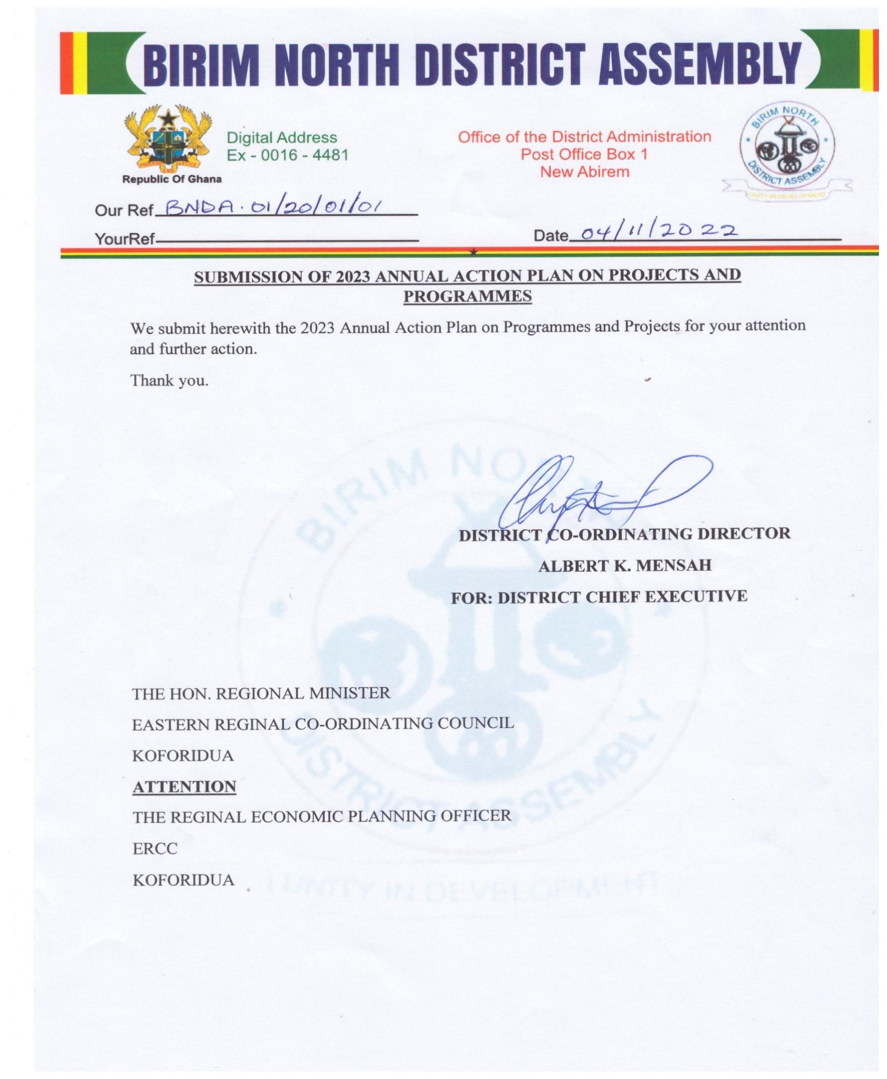
Republic of ghana
Ministry of local government, decentralization and rural development

Birim north District Assembly

ANNUAL ACTION PLAN (AAP) FOR 2023

October, 202
Approval of 2023 annual action plan

the 2023 annual action plan was approved by the general assembly on the 28th of october 2022.
- Signed………………………………………on this date…………………………………………
Hon. Isaac acheampong
(Presiding member)

- Signed………………………………………on this date…………………………………………
Albert k. Mensah
(District coordinating director)

- Signed………………………………………on this date…………………………………………
Hon. Remond nana damptey
(District chief executive)

1.0 Location and Size
The Birim North District was carved out of the former Birim District Council in 1987 as part of the government’s decentralization programme to promote effective decentralized governance and speed up the development of the area. After Akyemansa District was carved out of the Birim North District, its estimated total land area reduced significantly from 1270 square kilometers to 550 square kilometers. It has 78 settlements within its jurisdiction. It is bordered to the north by Kwahu West Municipal, to the South by Akyemansa District, to the East by Atiwa East District and Kwaebibiriem Municipal and to the West by Asante Akyem South and Adansi South District both in the Ashanti Region.
  - Vision Statement
The Birim North District Assembly is to be environmentally sustainable mining and agrarian district.
  - Mission Statement
The Birim North District Assembly exists to ensure improvement in the quality of life of its citizens by mobilizing human, material and financial resources’ in the district to promote local economic development.
  - Objective
To enhance the quality of life of its people through the provision of basic infrastructure and sustainable use of natural resources
2.0 Compactness of the District Capital
It has one compact town, New Abirem, a well-known commercial town as the District capital. The District capital is located about 241kilometres North West of Accra. It is the third largest urban center in the District after Akoase and Afosu.
3.0 Population Growth and Density
The 2021 National Population and Housing Census put the District population at 82,669 representing 2.8 percent of the region population with an intercensal growth rate of about 2.1%. The in and out flow of population to the district especially its capital on a daily basis is estimated to be 2,000. The projected population is therefore considered rather low considering the inflow of people into the district capital on daily basis. The male population is 41,343 (50.01%) and that of female is 41,326(49.99%), indicating that there are slightly more males than females in the district. The projected population for 2023 is 103,676 using a growth rate of 2.1%.
Furthermore, with the projected 2023 population figure of 103,676, the density would be 188.5 persons per sq km, which is one of the highest in the region. The increase in population has a direct effect on the density. This indicates a great pressure of population on land, resources and social services especially in the District capital town –New Abirem.

3.1 Rural-Urban Split
According to the 2021 National Population Census projected for 2023, only 32.2 percent of the population lived in urban areas and the rest (67.8%) lived in rural areas. This shows that the District is essentially a rural district with majority of its population living in the rural areas compared with urban areas.

Figure 1: Map of Birim North in National Context

Figure 2: Map of Birim North District
4.0 Economic Potential of the District.
The strategic location of the District capital town couple with a high population growth rate makes New Abirem one of the fastest growing and a vibrant commercial town in the region. Apart from serving as a strong marketing center for her border districts, it is the main marketing center for goods coming from Kade, Nkawkaw and Akim Oda. The presence of good roads therefore has a potential of promoting strong economic linkages with a number of Districts’ to promote economic growth through trade and investment.
5.0 GOVERNANCE
a) Establishment
The Birim North District was carved out of the former Birim District Council in 1987 with L.I 1422 as part of the government’s decentralization programme to promote effective decentralized governance and speed up the development of the area. It has deliberative, legislative and executive powers.
b) Structure of the Assembly
The District consists of 26 electoral areas and represented in the general Assembly by elected and appointed Assembly members. The composition of the Assembly is made up of 26 elected members, 12 appointed members, one Member of Parliament and the District Chief Executive.
An elected Presiding Member with the District Coordinating Director as the Secretary heads the General Assembly. The Assembly has two committees i.e. Executive committee and Public Relations and Complaints Committee (PRCC). The Executive committee has six sub-committees, which facilitate the performance of its statutory functions. The sub-committees are as follows.
- Development Planning Sub-committee
- Works Sub-Committee
- Finance and Administration Sub-committee
- Justice and Security Sub-committee
- Social Services Sub-committee
- Agric and Environment Sub-committee
Further, we have in the District all the decentralized departments and other quasi government organizations like the National Commission for Civic Education, Commission on Human Rights and Administrative Justice, Ghana Ambulance Service, National Board for Small Scale Industries (NBSSI), Fire Service, Immigration Service, Electoral Commission, Stool lands, Electricity Company of Ghana among others. The established Decentralized Departments are as follows:
- Centralized Administration Department
- Works Department
- Physical Planning Department
- Department of Trade and Industry
- Department of Agriculture
- Department of Social Welfare and Community Development
- Finance Department
- Education, Youth and Sports Department
- Disaster Prevention and Management Department
- Natural Resources Conservation Department of Forestry, Game and Wildlife Division
- District Health Department
- Department of Statistics
- Department of Human Resource

C) Sub-District structures (Urban/Town and Area Councils)
The District has four (4) sub-structures namely:
- New Abirem /Afosu Area Council
- Akoase Town Council
- Praman Area Council
- Pankese Area Council
The Area Councils are well established and are supporting the Assembly in its development efforts. All the Area Councils have the full complement of staff to work with.
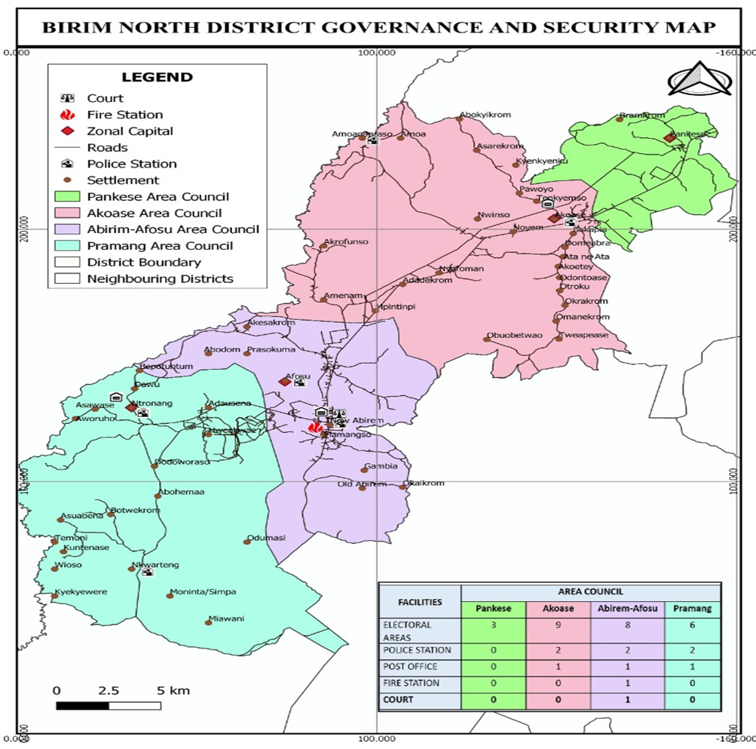
6.0 SOCIAL SERVICES
6.1 Education
Educationally, the district has been demarcated into seven (7) Circuits headed by School Improvement support officers (SISOs) to make supervision and monitoring of schools effective and efficient. The circuits are: Afosu, Akoase, Amuana Praso, New Abirem, Nkwateng, Ntronang and Pankese. There are 189 Public Basic Schools, 62 Private and 3 SHS – New Abirem/ Afosu SHS, Akoase St. Michael’s SHS and Amuana Praso SHS. The overall Student population in the district is 24,737 consisting of 12,745 boys and 11,965 girls giving the Gender Parity Index (GPI) of 1.07. The overall Teacher population is 1,298 with 810 males and 488 females giving the District Pupil Teachers Ration (PTR) of 1: 19. The map below presents the state of educational infrastructure in the district.
The survey in Birim North District covered the educational characteristics and its implications for development. The District currently has both Basic and Second Cycle Schools.
- Enrolment Levels

Table 1: Educational facilities and pupil’s enrolment in the district as at June, 2022
Schools | Enrolment
 | Public | Enrolment |  |  | Private | Enrolment
 | Public | Total | M | F |  | Total | M | F
K.G | 63 | 3656 | 1,885 | 1,771 | 25 | 1,090 | 560 | 530
Primary | 63 | 10,171 | 5,278 | 4,893 | 25 | 2,314 | 1,171 | 1,143
J.H.S | 62 | 4933 | 2,535 | 2,398 | 12 | 411 | 212 | 199
S.H.S | 3 | 2,162 | 1,071 | 1,091
Total | 191 | 20,922 | 10,802 | 10,093 | 62 | 3,815 | 1,943 | 1,872
Source: DED, New Abirem, June, 2022
Table 2: Total number of teachers in the district as at June, 2022
Schools | Number of teachers
 | Public |  |  |  |  |  | Private
 | Total | Trained | Untrained | Male | Female | Total |  | Trained | Untrained | Male | Female
K.G | 125 | 123 | 2 | 11 | 114 | 49 |  | 6 | 43 | 9 | 40
Primary | 362 | 359 | 3 | 221 | 141 | 173 |  | 32 | 141 | 118 | 55
J.H.S | 364 | 361 | 3 | 274 | 90 | 50 |  | 18 | 32 | 42 | 8
S.H.S | 175 | 152 | 23 | 135 | 40
Total | 1,026 | 995 | 31 | 641 | 385 | 272 |  | 56 | 216 | 169 | 103
Source: GES, EMIS, New Abirem, June, 2022
Analysis of the above table indicates that the district has One Thousand Two Hundred and Ninety-Eight (1,298) teachers. Out of which 81% are trained whiles 19% are untrained. The male female teacher ratio is 1:0.60 approximately 1:1.
Analysis of BECE performance for the District for the past three years is presented in the table below.
Table.3.
Year | Both Public and Private
Year | Male | Female
2018 | 82.84% | 82.11%
2019 | 67.56% | 72.65%
2020 | 72.43% | 72.63%
Source: GES, BNDA-2021

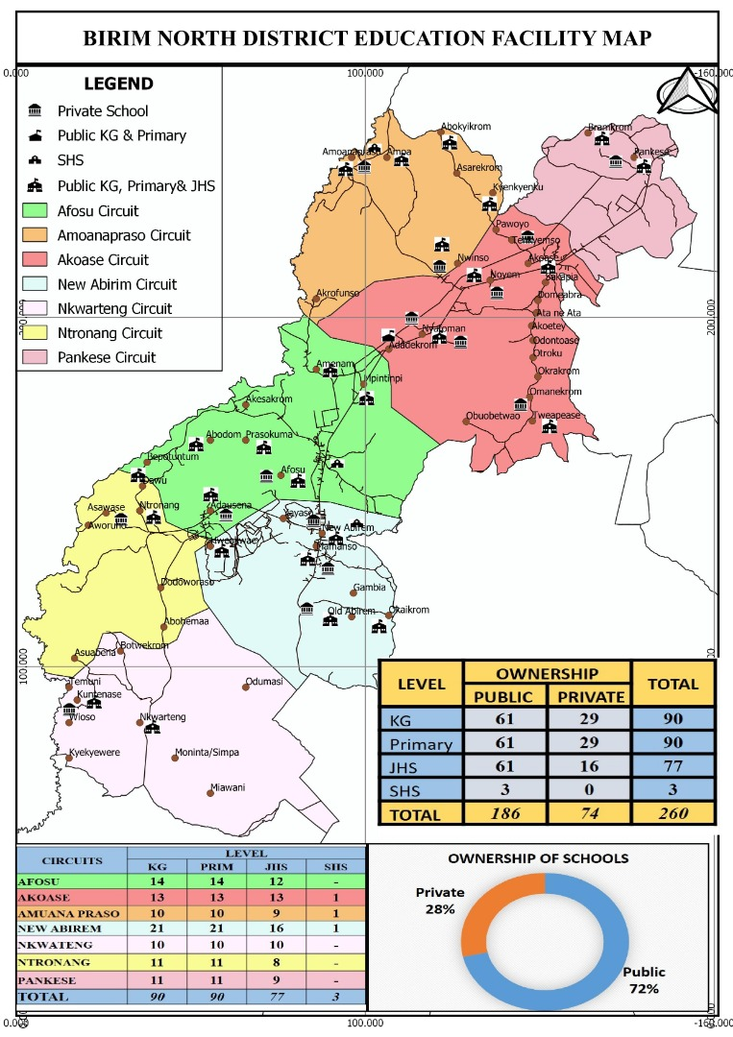
  - Health Service Delivery

6.2.1 Health
The infrastructure of health delivery system of the District consists of one (1) government hospital at New Abirem, 1 private hospital at Afosu, 3 private clinics, one at Afosu and 2 at New Abirem and 5 Reproductive and Child Health Centers at Nkwarteng, Adausena, Afosu, Amuana Praso and Tweapease. The District can boost of 26 demarcated CHPS centers. Fifteen (15) of the demarcated CHPS centres are operational with 27 herbalists and spiritual healers in the entire District.
The District’s government hospital located at New Abirem has a 69-bed ward including Emergency Ward, Theatre, Medical laboratory, Pharmacy Department, Dental clinic, Out-Patients Department ,an X-Ray Department and Eye Clinic; the hospital however, has no Mortuary. However, most cases beyond the hospital are referred to Nkawkaw, Atibie, Akim Oda, Koforidua or Accra.

The hospital has only 3 doctors with 6 medical assistants, 1 Dental Surgeon, 1 Ophthalmic Nurse (ENT), 2 Biomedical Scientist, 2 Laboratory Technicians, 254 Nurses, 63Midwives and 6 Pharmacist with 2 Dispensary Assistants. As at June 2022, the District has a Doctor – Population ratio of 1:33,840.67 as against national average of 1: 25,000 and WHO standard of 1: 1,000.

The Nurse Population ratio is also 1: 399.69 as against the national figure of 1:900.
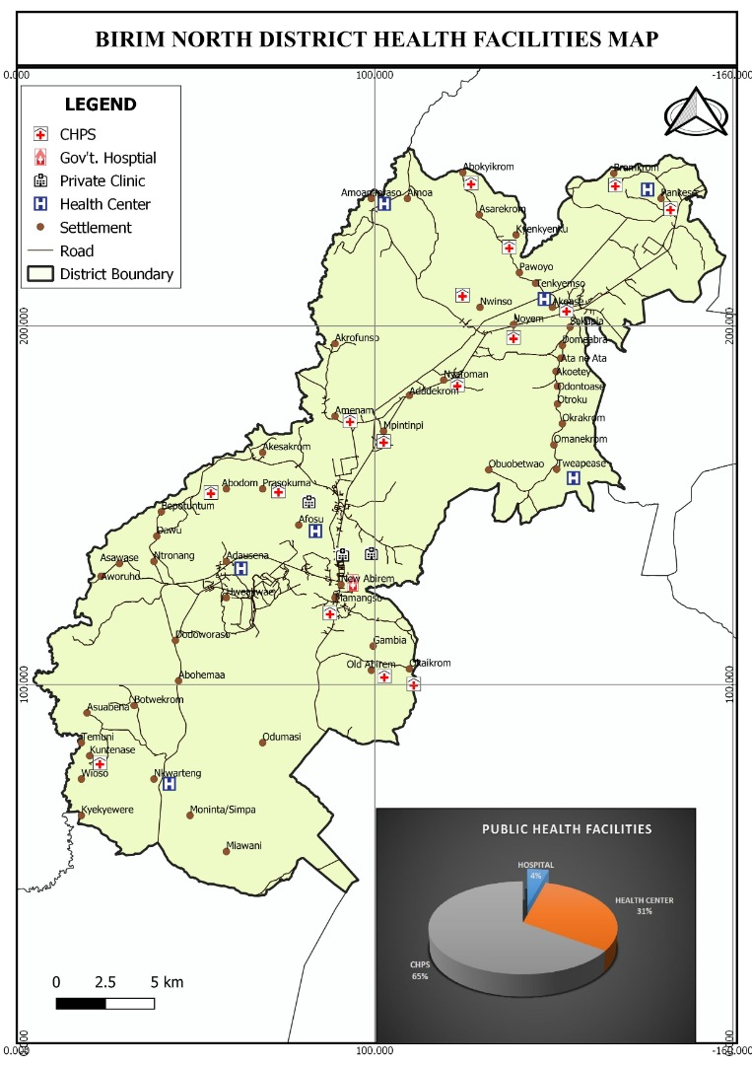

7.0 POLICE SERVICE

The Birim North is under the Akim Oda and Nkawkaw Division in terms of police administration. The District police headquarters is at New Abirem with three (3) sub districts at Ntronang, Akoase (Akim Oda Division) and Amuana Praso (Nkawkaw Division). The Assembly has constructed a new police station at Nkwarteng and Ntronang. This is been done to improve the security situation in the district whilst effort are been made to bring policing in the district under one division.

8.0 WASTE MANAGEMENT
8.1 Solid Waste / Garbage

The rate of waste generation and management in the District is a matter of concern to the Assembly. With the increasing influx of people and the rapid urbanization, huge amounts of waste are generated at an alarming rate. It is estimated that about 950 tonnes of solid waste is generated monthly out of which 480 tonnes are collected which represents about 51%. This leaves a substantial amount of backlog that creates various kinds of inconveniences including health hazard to the people in the District.
Most communities in the District have designated sanitary sites –open dumping at the outskirts of the settlement. Zoomlion Ghana Limited is responsible for emptying the containers to the final disposal site in the Newmont catchment areas. Zoomlion is also responsible for house-to-house garbage collection in those areas. Waste landfills company limited in collaboration with the Assembly also level refuse heaps in the communities on quarterly basis thus all year round and also responsible for the management of the final disposal site. The situation is under control as the Assembly in collaboration with Newmont Golden Ridge Limited (Newmont Akyem Mines) has developed an engineered landfill for final disposal of solid waste.
8.2 Liquid Waste
Apart from settlements in the District lacking improved toilet facilities, most of the existing public toilets are not well constructed. The main types of toilet facilities in the District are K.V.I.P, pit, Aqua Privy and septic. The stench, associated with pit latrine pollutes the air and this presupposes that it should be distanced from the communities, taking due cognizance of the prevailing wind direction.
Some communities do not have any toilet facilities and this makes indiscriminate defecation the normal practice. This poses health hazards to the inhabitants of the settlements since run-offs wash the human excreta into streams, thus contaminating them.
8.3 Liquid Household Waste and Storm-Water Disposal
Wastewater from houses is normally dislodged into open earths, which are not maintained in most of the urban settlements. The odor and stench emanating from such areas pollute the air and is very much abominable.
In smaller communities’ household waste water and run-offs are not considered in any way as they drain on to the narrow lanes to create gullies, and unto lower areas in the bush to create ponds

9.0 TOURISM DEVELOPMENT
Even though tourism has become one of the main sources of income and employment generation in the country, the Birim North District Assembly is yet to reap its full benefits. A number of tourist sites has the potential of rivaling some of the well-known tourist sites in the country. Though largely undeveloped, these sites hold the key to the area’s development if steps are taken to tap the large potential they present.
The District is endowed with as many as five efficiently managed forest reserves that are well resourced with some of the most beautiful flora and fauna, which are basic to the development of attractive wild life sanctuaries or parks. Near Otwereso is a picturesque site of the confluence of the Birim and Pra rivers. At Akrofunso, near Afosu are Ashanti antique War Bells and a grove that marks the spot where the great Ashanti King, Osei Tutu, is believed to have been killed.
The District has a number of hotels and guesthouses, which has help to ease the burden of accommodation for visitors to the district. This includes 3 four star hotels namely; Obaa’s golden Plaza (Afosu), Miners Inn(New Abirem), Beige Village Golf Resort and Spa(Afosu), and Candle light hotel and Restaurant(Afosu), Paradis Hotel(Nyafoman). In addition, there are seven guest houses at varous locations within the district; Ma Home(Afosu), Royal Hill(New Abirem), Ritheous(New Abirem), Naagyei(Afosu), Ofori(Afosu), Manna Lodge(Akoase), Nketia(Akoase) and Amadu Guest House at Akoase.

10.0 MARKETS
The Districts traditional market pattern has been in New Abirem, Ntronang, Amuana Praso and Akoase. The New Abirem market functions daily with Tuesdays and Fridays as major market days, whilst that of Ntronang is every Wednesdays. New Abirem is a nodal town but because of the bad road network from Nkawkaw to Kade through New Abirem and New Abirem to Oda, it does not make the market functional as a characteristic of a nodal town.
11.0 ROADS
Road is the only form of transport in the District. This implies that, the overall improvement of the road network, maintenance and rehabilitation will facilitate and lower transportation cost and integrates the Districts rural economy with the urban economy to reduce poverty. The completion of the lorry park at the New Abirem market has help to reduce the traffic situation in the district. Again, the 36.3km road from Nkawkaw to New Abirem has been constructed. New Abirem-Kade and New Abirem – Oda is under construction.
12.0 REVENUE BASE OF THE ASSEMBLY
Revenue and Expenditure Performance of the District Assembly
This section examines the revenue and expenditure pattern of the District Assembly for the 2021 to 2022 fiscal year. This is to improve the Assembly’s financial management practices in order to generate and manage funds for the effective implementation of the District’s Medium Term Development Plan.
A. Revenue Pattern of the District Assembly
There are two main sources of revenue for the District Assembly. These consist of Internally Generated Funds (IGF) and Externally Generated Revenue.

  - Internally Generated Fund (IGF)
The Internally Generated Fund (IGF) is mainly made up of revenue collected from; lands, fees and fines, rates, license, rent, investment and miscellaneous. The internally generated funds are purposely used in funding recurrent expenditure incurred by the District Assembly since its amount is normally not substantial to be used to fund capital expenditure. However, in the case of Birim North, the presence of Newmont has aided the Assembly to generate enough IGF to help in financing capital projects far in excess of what is required by law.
  - Externally Generated Revenue/Funds (EGF)
The EGF is accrued from both governmental and private (non-governmental) sources including; the District Assemblies Common Fund (DACF), Government of Ghana (GoG) and Donor Grants which are mostly based on some specific criteria. The Assembly only gets to benefit from this Donor Grant such as District Development Facility (DDF) upon meeting the criteria specified. However, this Donor Grant (DDF) has now been changed to District Performance Assessment Tool (DPAT) or DACF-RFG(Responsive Factor Grant). This revenue source has been the major contributor to the Assembly’s total revenue base. A look at the table below indicates that the assembly get a lot of its revenue from IGF and the Mineral royalties’.

Table 4: Revenue Pattern of the District Assembly
UPDATE ON RECEIPT | 2021 BASELINE | 2022 TARGET | ACTUALS 2ND QUARTER 2022
GOG-COMPENSATION | 2,000,434.52 | 3,647,300.00 | 1,649,018.48
IGF | 5,606,619.86 | 7,002,386.64 | 3,444,268.98
MINERAL ROYALTIES |  | 2,696,964.40 | 1,076,874.17
DACF | 871,617.73 | 3,819,574.12 | 757,408.30
MP’s CF | 180,442.64 | 400,000.00 | 178,761.93
PWDs CF | 105,033.83 | 280,000.00 | 190,482.70
MSHAP | 20,449.12 | 18,880.32 | 10,245.60
DACF-RFG | 865,662.00 | 548,603.00 | 264,824.00
OTHERS | 388,401.66 | 189,434.80 | 189,434.81
TOTAL | 10,038,661.36 | 18,553,143.28 | 7,761,318.97
Source: BNDA Finance Office, Jun. 2022

B. Expenditure Pattern of the District Assembly
Expenses here are in two forms namely; recurrent and capital expenses. The recurrent expenses are made of; administration, service and miscellaneous items. The capital expenses are made as and when the need arises. These expenses mostly include construction works and other physical projects.
Table 5: Update on expenditure

EXPENDITURE ITEM | 2021 BASELINE | 2022 TARGET | ACTUAL 2nd QUARTER 2022
GOG & IGF COMPENSATION | 2,488.711.44 | 4,168,126.00 | 1,908,619.96
GOODS AND SERVICE | 3,159,128.01 | 2,414,033.36 | 2,107,238.38
INVESTMENT/ASSET | 4,588,834.23 | 9,024,395.28 | 2,579,177.21
OTHERS | 639,109.99 | 322,830.48 | 513,420.92
TOTAL | 10,875,783,67 | 3,982,346.28 | 7,108,456.47
Source: BNDA Finance Office, Jun. 2022

13.0 DISTRICT ECONOMY
The economic activities carried out in the District include primary (crops) production, animal husbandry, small-scale industrial activities, mining and commerce. The Birim North District is predominantly agrarian because about 73.5 percent of the entire labour force is into agriculture and its related activities. The population in commerce and services forms about 15.2 percent and 3.8 percent of the labour force respectively. The District is home to Seven (7) forest reserves i.e. kwekaru, Kajeasi, Ajenjua, Kwasi Anyinima, Jade Bepo, Mamang River and Auro River. The rapid expansion of the cocoa and oil palm farming in the District coupled with the activities of the illegal mining and chain saw operators are changing the original forest into a secondary type. The map below gives a pictorial evidence of the district economy.

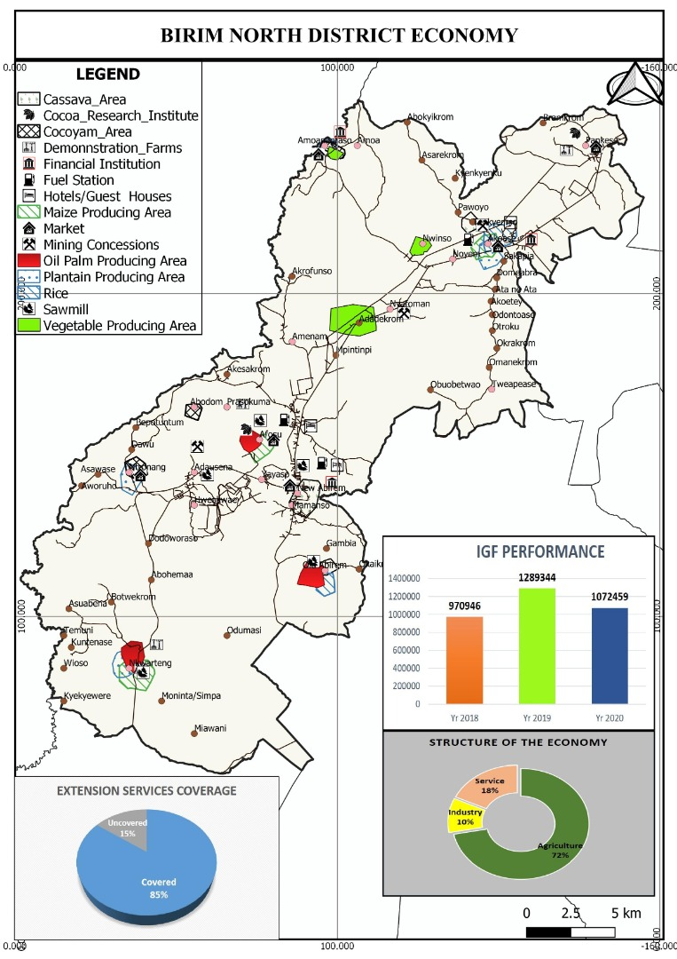
13.1 Mining
Various minerals occur within the District. However, Gold is the largest mineral deposit, which is found in both rocks and alluvial. The alluvial gold is obtained from the eroded and weathered Birimian rocks, Tarkwaian rocks and from the mineralized eroded granites where the River Pra flows. River Pra, its valleys and plains are the good source of the alluvial gold. There are about seven small-scale miners in the district with one multinational company operating in the district (Newmont Golden Ridge Limited-Akyem).
Newmont Golden Ridge Limited activities’ can be found mainly in Southern part of the district around Ajenjua Bepo surrounded by Ntronang, Afosu, Adausena, New Abirem, New Amanfrom, Hweakwae, Old Abirem, Mamanso, Adjenua, Yaw Tano & Hamlet communities.
It is expected that a lot of revenue will come to the District Assembly by way of royalties. However, the inflows for Mineral Royalties, Ground Rent and Concessions as at June 2022 amounted to GH¢ 1,076,874.17
. In terms of Property Rate, Newmont Akyem Mines pays the district assembly on average a total of GH¢ 2,315,000.00 per annum. This revenue is assisting the Assembly in its development efforts by way of providing social infrastructure such as schools, water and sanitation facilities, health, roads, market among others.
Another major advantage, which the mining activities have brought to the District, is the creation of employment avenues for both skilled and unskilled labour. This has helped reduced unemployment in the district especially among the youth.
One major challenge with the mining activities is the influx of people from all lifestyles into the district to look for employment opportunities in the mining company. However, the District Assembly in collaboration with the mining company has put in place measures to minimize the various social vices such as prostitution, armed robbery among others associated with mining communities. The map on the next page present the natural resource that the district is endowed with.

Figure 2.
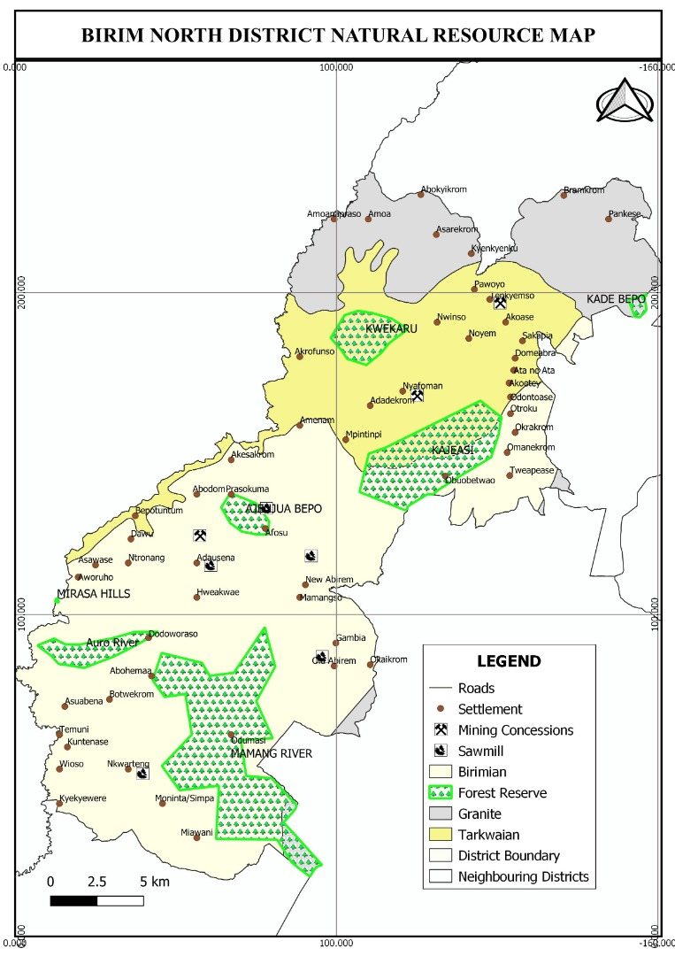

14.0 The Agricultural Sector
14.1 Overview
Agriculture is the main stay of the Birim North District, employing about 72% of the total labour force, while services (hotels, banking etc.) and industry employ 18% and 13% respectively. This invariably makes agriculture the backbone of the district’s economy.
The major crops cultivated are staples; maize, cassava, cocoyam, taro, plantain and vegetables. Tree crops (cash crops); cocoa, rubber, citrus and oil palm (of all, oil palm is cultivated on a large scale in the district).
The major challenges of the sector are climate change, high cost of agro inputs, inadequate numbers of Agricultural Extension Agents (AEAs) and lack of veterinary and engineering staff, poor condition of roads etc. The local businesses in the district include mining, palm and kernel oil processing, gari production, bee keeping among others. However, only a few of these local products are sold in commercial quantities i.e. palm oil, palm fruits, gari and gold. The economic potentials of the district can be seen in the area of; availability of raw material, availability of market, fertile lands, good road network connectivity and suitable environment.
There are three (3) specific area of interest in the development of LED product in the Birim North District i.e. Palm Oil, Gari and Honey. The District has 9,056.2ha of land under oil palm cultivation producing 72,449.6Mt/year. The Minerals Commission and Mineral Development Fund in collaboration with the District Assembly has since 2019 supplied free seedlings to farmers which is expected to increase the area of cultivation by 50% in 2024. The district currently produces palm oil but is unable to link all stakeholder together hence its inability to benefit from the value addition in the commodity.
Additionally, the District has about 1,750ha of farmlands under Cassava cultivation with an average yield of 18mt/ha. The District is currently producing gari and cassava flour (Kokonte) however, the sector has not been adequately resourced to produce and market the cassava in other areas like fortified gari, and cassava fufu mixed flour among others.
The District can boast of a high degree of social development in the area of schools, health facilities, water and sanitation, electricity, communication and technology among others, which can be related to the quality of life of the residents. The employment situation in the district is not different from the national situation, but agriculture mitigates the unemployment situation in the District. However, due to lack of modern machinery and mechanization to modernize Agriculture and reduce drudgery, it becomes an unattractive venture for the youth to explore. There are many economic opportunities for women and youth but the sector has not been given the needed attention to engage these groups in the district to become financially independent.

15.0 SERVICE SECTOR
(i) Postal Service
The District has one Post Office at New Abirem and four Postal Agencies at Ntronang, Afosu, Akoase and Pankese. Owing to lack of patronage, some of the Postal Agencies are not functional to expectation. Their main functions include delivery of letters to and from the District capital.

(ii) Banking Service
Conventional banking institutions in the District, there are three commercial banks; Absa Bank, Consolidated Bank and Ecobank are located in New Abirem. There are five rural banks operating in the District. These are Mponua Rural Bank, Kwahu Rural Bank, Mumuadu Rural Bank and South Birim banks all located at New Abirem whiles Dumpon Rural Bank is located at Akoase. However, Mponua Rural Bank has its headquarters at Amuana Praso. Ropa microfinance and Vision Workers Cooperative Credit Union is also located at New Abirem. Banking service is therefore skewed towards New Abirem the District capital.

16.0 Age and Sex Composition
The structure of the population has about 50.0% female and 50.0% male. The sex ratio is 100 males to 100 females. When the population is divided into broad age groups; 0 – 14 years age cohort constitute about 39.9 percent, whiles the 15 – 64 years age cohort constitute 55 percent. The 65+ year age cohort is 5.1 percent. The District population is youthful with about 39.9 percent between the ages of 0 – 14 years whiles only 5.1 are above the age of 64 years. The proportion of children below 15 years is therefore very high. The de facto composition of the labour force; defined here as the number of people within the age group of 15- 64 years is 55 percent.
The implication is that a greater percentage of the population falls within the vulnerable group. This therefore calls for a positive affirmative action in the distribution, control and benefits of socio-economic policies, programmes and activities of the Assembly.

Figure 3: Age / Sex Structure of Birim North District

16.1 Labour Force and Dependency Ratio
The 2010 Population census put the economically active and working population in the district at 54.6% for males and compares favourably with females who constitute 55.4% while the non-economically active population constitutes 45.4% for males and 44.6% for females. This implies the need for mainstreaming gender in the development programmes of the District.
17.0 Staff Distribution in relation to Gender
Staff distribution in Birim North District is skewed in favour of males with the female: male ratio being 1:3. The total staff strength at the District Administration is 141 comprising of 99 males and 42 females. 15 out of the 28 senior officers are female. This implies that the District Administration is dominated mostly by males. The situation is not different from the junior officers where we have only 15 females as against 49 males. A conscious effort should be geared towards affirmative action in the subsequent recruitments and appointments. The Assembly should facilitate the appointment of females to management positions to give meaning to the concept of women empowerment. The break down is shown below:
The total staff strength of the Birim North District Assembly as at 31st August, 2022 is One hundred and forty-seven (147).
b) Staff Distribution

- Male - 99
Female - 42
Total - 141

- Snr. Male Officers - 28
Snr. Female Officers - 15
Total - 43

- Jnr. Male Officers - 49
Jnr. Female Officers - 15
Total - 64
- Causal Staff
Male - 22
Female - 12
Total - 34
Commission Collectors-3 Males
Source: BNDA/August, 2022

18.0 Resource Utilization
With limited resource, financial, material and human, it is not possible to satisfy the needs of all communities within the 4-Year period.
On the basis of the above, projects should be sited strategically to serve many communities as much as possible. Secondly, projects selected should serve the felt needs of the communities and not political interest.
18.1 Institutional linkages
As much as possible, institutional capacity building should be pursued. The District Assembly should assume the overall central coordinating role while outlining institutional responsibilities in conjunction with the various Departments of the Assembly and other government agencies. This is to get them actively involved in implementation on the plan in its totality.
Agencies outside must also be consulted to give assistant to the Assembly’s own implementation and monitoring efforts. Research institutions of the various Universities such as BIRD, BRRI, CSIR, etc. could be of immense help in the areas of planning, training and advise on project implementation, monitoring and evaluation.
In order to achieve some level of integration, planning and project implementation have to be worked out in such a way that the development of one sector is linked to the other sectors of the economy of the District.
This way the development of feeder roads is meant to positively affect agriculture production. Much the same, the provision of potable water is expected to supplement health delivery in the District.

Annual Action Plan (AAP) – 2023
DMTDP Goal: Build an industrialised, inclusive and resilient economy
Programme (PBB) | Sub programme (PBB) | Broad activities | Location | Time frame (Year) |  |  |  | Expected Output | Cost (GH¢) |  |  |  |  |  | Programme status |  | Implementing institution / department
 |  |  |  | Q1 | Q2 | Q3 | Q4 | Expected Output | GoG | IGF | DACF | DACF-RFG | DP | Others | New | Ongoing | Lead | Collabo  rating
Economic development | Agriculture development | 1. Management and Administration | District wide | √ | √ | √ | √ | Improved management and Administration | 10,000.00 |  |  |  | 30,537.24 |  |  | √ | DDA | BNDA
Economic development | Agriculture development | 2.Promotion of Birim North District Commodity Satellite Market  (Post-harvest loss reduction, product standardization and marketing (Grading, Packaging, Labelling, etc.) by Dec. 2023. | District wide | √ | √ | √ | √ | Satellite market promoted. | 2,000.00 |  |  |  | 7,500.00 |  |  | √ | DDA | BNDA
Economic development | Agriculture development | 3. Alternative livelihood for employment, income generation for women and reduction of malnutrition by Dec. 2023. | District wide | √ | √ | √ | √ | Women empowered through alternative livelihood. |  |  | 5,500.00 |  | 1,500.00 |  |  | √ | DDA | BNDA
Economic development | Agriculture development | 4.Improve livestock housing for higher income generation and promote farm family protein in-take through stock (rabbit, cockerels, turkey) improvement with emphasis on women by Dec. 2023. | District wide | √ | √ | √ | √ | Livestock housing improved for higher income generation |  |  |  |  | 3,000.00 |  |  | √ | DDA | BNDA
Economic development | Agriculture development | 5.Undertake veterinary disease surveillance in Birim North District  (Effective clinical treatment of animals in the district, prevention and control of zoonotic diseases in livestock) by Dec, 2023. | District wide | √ | √ | √ | √ | Controlled incidence of zoonotic diseases in livestock |  |  | 2,000.00 |  | 1,500.00 |  |  | √ | DDA | BNDA
Economic development | Agriculture development | 6.Effective, efficient extension service delivery and staff capacity development by Dec. 2023. | District wide | √ | √ | √ | √ | Improved extension service delivery by December 2023 |  |  |  |  | 50,160.00 |  |  | √ | DDA | BNDA
Economic development | Agriculture development | 7.Facilitate agricultural planning and policy implementation  (RELC, PBB, PERD, etc.) by Dec. 2023. | District wide | √ | √ | √ | √ | Improved Agricultural Planning and policy implementation. |  |  |  |  | 8,500.00 |  |  | √ | DDA | BNDA
Economic development | Agriculture development | 8.Stakeholder capacity building in crop disease and pest control (Improved crop varieties by Dec. 2023. | District wide | √ | √ | √ | √ | Improved crop variety and pest control in the District. |  |  |  |  | 3,000.00 |  |  | √ | DDA | BNDA
Economic development | Agriculture development | 9.Development of FBO’s (Promote agricultural innovation / technology through demonstrations, collaboration with partner institution) by Dec. 2023. | District wide | √ | √ | √ | √ | Agricultural innovation/  technology promoted through demonstrations. |  |  |  |  | 4,000.00 |  |  | √ | DDA | BNDA
Economic development | Agriculture development | 10.Promote safe use of Agro chemicals and Fall Army Worm control by Dec. 2023. | District wide | √ | √ | √ | √ | Controlled incidence of Fall Army worm infestation in the District. |  |  | 2,000.00 |  | 1,500.00 |  |  | √ | DDA | BNDA
Economic development | Agriculture development | 11.Promote sustainable  climate resilient agricultural production systems (Home gardening with emphasis on women) by Dec. 2023. | District wide | √ | √ | √ | √ | Improved climate resilient agricultural production systems. |  |  |  |  | 3,000.00 |  |  | √ | DDA | BNDA
Economic development | Agriculture development | 12.Promote agricultural data collection and analysis by Dec. 2023 | District wide | √ | √ | √ | √ | Improved Agricultural data collection and analysis. |  |  | 5,500 |  | 4,000.00 |  |  | √ | DDA | BNDA
Annual Action Plan (AAP) – 2023
DMTDP Goal: Build an industrialised, inclusive and resilient economy
Programme (PBB) | Sub programme (PBB) | Broad activities | Location | Time frame (Year) |  |  |  | Expected Output | Cost (GH¢) |  |  |  |  |  | Programme status |  | Implementing institution / department
 |  |  |  | Q1 | Q2 | Q3 | Q4 | Expected Output | GoG | IGF | DACF | DACF-RFG | DP | Oth  ers | New | On  going | Lead | Collabo  rating
Economic development | Trade, tourism and industrialised development | 13.Palm oil production activities conducted by Dec. 2023. | Nkwateng |  | √ | √ |  | Enhanced Palm Oil Production in the district. |  |  | 6,500.00 |  |  |  | √ |  | BAC | BNDA, DDA
Economic development | Trade, tourism and industrialised development | 14.Fashion designing and production by Dec. 2023. | New Abirem | √ | √ | √ | √ | Enhanced job creation through fashion designing and production. |  |  | 5,000.00 |  |  |  |  | √ | BAC | BNDA
Economic development | Trade, tourism and industrialised development | 15. Training in Bee keeping done by Dec. 2023. | Ntronang | √ | √ | √ | √ | Improved honey production and job creation |  |  | 6,000.00 |  |  |  | √ |  | BAC | BNDA
Economic development | Trade, tourism and industrialised development | 16.Formation of Farmer Based Organisation (FBO) by Dec. 2023. | District Wide | √ | √ | √ | √ | Farmer Based organisation formed. |  |  | 1,000.00  (MAG) |  |  |  | √ |  | BAC | BNDA
Economic development | Trade, tourism and industrialised development | 17.Occupational Safety, Health and Environmental Management (OSHEM) by Dec. 2023. | Mpintimpi / Afosu | √ | √ | √ | √ | Enhanced Environmental Health and Occupational safety |  |  | 5,000.00  (MAG) |  |  |  | √ |  | BAC | BNDA,  DEHO
Economic development | Trade, tourism and industrialised development | 18.Provision of start-up kits for graduate apprentices by Dec. 2023. | District wide | √ | √ | √ | √ | Enhanced job creation and reduced incidence of unemployment | 10,000.00 |  | 25,000.00  (MAG) |  |  |  |  | √ | BAC | BNDA
Economic development | Trade, tourism and industrialised development | 19.Organisation of NVTI examination | New Abirem | √ | √ | √ | √ | Increased knowledge and job creation. |  | 5,000.00 |  |  |  |  |  | √ | BAC | BNDA
Economic development | Trade, tourism and industrialised development | 20.Facilitation of Rural Enterprises Development Fund (REDF) loan facility done by Dec. 2023. | District wide | √ | √ | √ | √ | Promote local economic development through job creation. |  | 10,000.00 |  |  |  |  |  | √ | BAC | BNDA
Economic development | Trade, tourism and industrialised development | 21.General business financial management conducted by Dec. 2023. | Nkwateng / Mamanso | √ | √ | √ | √ | Improved business management in the District |  | 4,000.00 |  |  |  |  | √ |  | BAC | BNDA
Economic development | Trade, tourism and industrialised development | 22. Identification and Development of tourist sites in the District done by Dec. 2023 | District wide | √ | √ | √ | √ | Promote tourism in the District . |  | 10,000.00 | 20,000.00 |  |  |  | √ |  | DPO | BNDA, CULTURE
Economic development | Trade, tourism and industrialised development | 23.Business counselling and minority services conducted by Dec. 2023. | Akoase | √ | √ | √ | √ | Improved business and minority services. |  | 3,000.00 |  |  |  |  | √ |  | BAC | BNDA
Annual Action Plan (AAP) – 2023
 | DMTDP Goal: Build an industrialised, inclusive and resilient economy
Programme (PBB) |  | Sub programme (PBB) | Broad activities | Location | Time frame (Year) |  |  |  | Expected Output | Cost (GH¢) |  |  |  |  |  |  | Programme status |  |  | Implementing institution / department
 |  |  |  |  | Q1 | Q2 | Q3 | Q4 | Expected Output | GoG | IGF | DACF | DACF-RFG | DP | Oth  ers | New |  | On  going | Lead |  | Collabo  rating
Economic development |  | Trade, tourism and industrialised development | 24.Formation and registration of co-operatives societies. By Dec. 2023. | District wide | √ | √ | √ | √ | Cooperative society formed and registered. |  | 2,000.00 |  |  |  |  |  |  | √ | Co-op. |  | BNDA
Economic development |  | Trade, tourism and industrialised development | 25.Training of co-operatives society members by Dec. 2023 | District wide | √ | √ | √ | √ | Improved cooperative service delivery. |  | 5,000.00 |  |  |  |  |  |  | √ | Co-op. |  | BNDA
Economic development |  | Trade, tourism and industrialised development | 26.Auditing of co-operatives societies by Dec. 2023. | District wide | √ | √ | √ | √ | Enhanced cooperative activities. |  |  | 4,000.00 |  |  |  |  |  | √ | Co-op. |  | BNDA
Annual Action Plan (AAP) – 2023
 | DMTDP Goal: Create equitable, healthy and discipline society
Programme (PBB) |  | Sub programme (PBB) | Broad activities | Location | Time frame (Year) |  |  |  | Expected Output | Cost (GH¢) |  |  |  |  |  |  | Programme status |  | Implementing institution / department
 |  |  |  |  | Q1 | Q2 | Q3 | Q4 | Expected Output | GoG | IGF | DACF | DACF-RFG | DP | Oth  ers | New |  | On  going | Lead | Collaborating
Social Services Delivery |  | Education, youth and sports and library services | 27.Construction of 5No. 3-Unit classroom block by Dec. 2023. | Akoase R/C, Afosu,Tweapease, Ntronang Presby, Domeabra | √ | √ | √ | √ | Improved educational infrastructure |  | 299,000.00 | 348,500.00 |  |  |  | √ |  |  | DED | BNDA
Social Services Delivery |  | Education, youth and sports and library services | 28.Rehabilitation Of 1no. 3-Unit Classroom Block by Dec. 2023 | Kuntunase | √ | √ | √ | √ | Improved educational infrastructure |  | 164,635.99 |  |  |  |  |  |  | √ | DED | BNDA
Social Services Delivery |  | Education, youth and sports and library services | 29.Construction of 4No. 3-Unit classroom block with emphasis on women and Children by Dec. 2023 | Okaikrom, Abohema, Akoase D/A, Adadekrom, | √ | √ | √ | √ | Improved educational infrastructure |  | 250,000.00 |  |  |  |  | √ |  |  | DED | BNDA
Social Services Delivery |  | Education, youth and sports and library services | 30.Rehabilitation Of 1no. 6-Unit Classroom Block by Dec. 2023. | Amoana Praso Presby | √ | √ | √ | √ | Improved educational infrastructure |  | 323,735.00 |  |  |  |  |  |  | √ | DED | BNDA
Social Services Delivery |  | Education, youth and sports and library services | 31.Completion of fence wall Phase II. By Dec. 2023 | New Abirem/Afosu  SHS | √ | √ | √ | √ | Improved educational infrastructure |  | 355,215.00 |  |  |  |  |  |  | √ | DED | BNDA
Social Services Delivery |  | Education, youth and sports and library services | 32.Construction of 1No. Library with ICT equipment by Dec. 2023. | Adausena& Hweakwae | √ | √ | √ | √ | Improved educational infrastructure |  |  |  | 40,000.00 |  |  |  |  | √ | DED | BNDA
Social Services Delivery |  | Education, youth and sports and library services | 33.Completion of 1No. 6-Unit classroom block emphasis on women and children by Dec. 2023 | Odontuase | √ | √ | √ | √ | Improved educational infrastructure |  | 100,000.00 |  |  |  |  |  |  | √ | DED | BNDA
Social Services Delivery |  | Education, youth and sports and library services | 34.Construction of 2No. 6-Unit classroom block with emphasis on women and children by Dec. 2023. | Afosu R/C, Akoase Experimental | √ | √ | √ | √ | Improved educational infrastructure |  | 150,000.00 | 400,000.00 |  |  |  | √ |  |  | DED | BNDA
Social Services Delivery |  | Education, youth and sports and library services | 35.Construction of 1No. 2-Unit classroom block, office, store, W/C, sanded play area, paved walk way, fenced, gated, poly tank stand with 5000 capacity litres emphasis on women and children by Dec. 2023 | Afosu R/C | √ | √ | √ | √ | Improved educational infrastructure |  |  |  | 251,179.95 |  |  | √ |  |  | DED | BNDA
Social Services Delivery |  | Education, youth and sports and library services | 36.Construction of teachers quarters with emphasis on women by Dec. 2023. | Kuntenase, Asawase, Oworomra, | √ | √ | √ | √ | Improved educational infrastructure |  | 200,000.00 |  |  |  |  | √ |  |  | DED | BNDA
Social Services Delivery |  | Education, youth and sports and library services | 37.Renovation of 1No. 3-Unit classroom block with emphasis on women and children by Dec. 2023. | Nkwateng D/A | √ | √ | √ | √ | Improved educational infrastructure |  | 124,059.20 |  |  |  |  | √ |  |  | DED | BNDA
Social Services Delivery |  | Education, youth and sports and library services | 38.Renovation of 2No. 6-Unit classroom block with emphasis on women and children by Dec. 2023 | Akrofonso, Nkwateng SDA | √ | √ | √ | √ | Improved educational infrastructure |  | 200,000.00 |  |  |  |  | √ |  |  | DED | BNDA
Social Services Delivery |  | Education, youth and sports and library services | 39.Renovation of 1No. 2-Unit classroom block with emphasis on women children by Dec. 2023. | Amenam D/A | √ | √ | √ | √ | Improved educational infrastructure |  | 100,000.00 |  |  |  |  | √ |  |  | DED | BNDA
Social Services Delivery |  | Education, youth and sports and library services | 40.Organisation of My First Day at school by Dec. 2023 | District wide | √ | √ | √ | √ | My first day at school organized |  |  | 10,000.00 | 20,000.00 |  |  |  |  | √ | DED | BNDA
Social Services Delivery |  | Education, youth and sports and library services | 41.Provide scholarship, Bursaries & Financial Assistance to Students by Dec. 2023. | District wide | √ | √ | √ | √ | Needy but brilliant students supported |  | 10,000.00 | 20,000.00 | 80,000.00 |  |  |  |  | √ | DED | BNDA
Annual Action Plan (AAP) – 2023
 | DMTDP Goal: Create equitable, healthy and discipline society
Programme (PBB) |  | Sub programme (PBB) | Broad activities | Location | Time frame (Year) |  |  |  | Expected Outcome | Cost (GH¢) |  |  |  |  |  | Programme status |  | Implementing institution / department
 |  |  |  |  | Q1 | Q2 | Q3 | Q4 | Expected Outcome | GoG | IGF | DACF | DACF-RFG | DP | Others | New | Ong  oing | Lead | Collabo  rating
Social Services Delivery |  | Education, youth and sports and library services | 42. Organize STEM Clinics from School Level to Regional Level by Dec. 2023 | District wide | √ | √ | √ | √ | STEM Clinics organized |  |  | 10,200.00 |  |  |  |  | √ | DED | BNDA
Social Services Delivery |  | Education, youth and sports and library services | 43.Organize School, Zonal, District, Sub-Zonal and Regional Cultural Festivals | District wide | √ | √ | √ | √ | School, Zonal, District, Sub-Zonal and Regional Cultural Festivals organized |  | 13,000.00 |  |  |  |  |  | √ | DED | BNDA
Social Services Delivery |  | Education, youth and sports and library services | 44.Organize SPAM and performance review Meetings by the end of July 2023. | District wide | √ | √ | √ | √ | SPAM and performance review Meetings organized. |  |  | 14,300.00 |  |  |  |  | √ | DED | BNDA
Annual Action Plan (AAP) – 2023
 | DMTDP Goal: Create equitable, healthy and discipline society
Programme (PBB) |  | Sub programme (PBB) | Broad activities | Location | Time frame (Year) |  |  |  | Expected Outcome | Cost (GH¢) |  |  |  |  |  | Programme status |  | Implementing institution / department
 |  |  |  |  | Q1 | Q2 | Q3 | Q4 | Expected Outcome | GoG | IGF | DACF | DACF-RFG | DP | Oth  ers | New | On  going | Lead | Collabo  rating
Social Services Delivery |  | Public health services and management | 45.Construct nurses quarters by the end of December 2023. | Ntronang,  Abodom | √ | √ | √ | √ | Improved health service deliver |  | 500,000.00 | 500,000.00 |  |  |  | √ |  | DHD | BNDA
Social Services Delivery |  | Public health services and management | 46.Complete Health centre with emphasis on women by the end of the third quarter 2023. | Akoase | √ | √ | √ |  | Improved health service deliver |  | 108,838.10 |  |  |  |  |  | √ | DHD | BNDA
Social Services Delivery |  | Public health services and management | 47.Complete Health centre with emphasis on women by the end of the third quarter 2023. | Pankese | √ | √ | √ |  | Improved health service deliver |  | 70,232.58 |  |  |  |  |  | √ | DHD | BNDA
Social Services Delivery |  | Public health services and management | 48. Construct 3No. CHPS Compound and Staff Quarters with emphasis on women, vulnerable groups by the end of Dec. 2023. | Mpintimpi Nwinso,  Odontuase | √ | √ | √ | √ | Improved health service deliver |  | 500,000.00 |  |  |  |  | √ |  | DHD | BNDA
Social Services Delivery |  | Public health services and management | 49.Construct bungalow (Nurses quarters) by the end of Dec. 2023. | Akoase | √ | √ | √ | √ | Improved health service deliver |  | 193,750.00 |  |  |  |  | √ |  | DHD | BNDA
Social Services Delivery |  | Public health services and management | 50.Construct bungalow (Nurses quarters) by Dec. 2023 | Pankese, | √ | √ | √ | √ | Improved health service deliver |  | 193,750.00 |  |  |  |  | √ |  | DHD | BNDA
Social Services Delivery |  | Public health services and management | 51.Construct 5 No. placenta pit by Dec. 2023. | Nwinso, Noyem, Old Abirem, Akoase, Nyafoman and Pankese | √ | √ | √ | √ | Improved health service deliver |  |  | 84,000.00 |  |  |  | √ |  | DHD | BNDA
Social Services Delivery |  | Public health services and management | 52.Complete fence wall phase I by the end of Dec. 2023. | New Abirem Government Hospital | √ | √ | √ | √ | Improvement in health infrastructure |  | 22,547.68 |  |  |  |  | √ |  | DHD | BNDA
Social Services Delivery |  | Public health services and management | 53. Complete 3No. 12 Seater WC Toilet with emphasis on women and children. | Ntronang, Oworomera & Adadekrom | √ | √ | √ | √ | Improved sanitation in the District |  |  | 219,600.00 |  |  |  |  | √ | DEHU | BNDA
Social Services Delivery |  | Public health services and management | 54. Construct 1No. 16-Seater W/C Toilet And 4 Bathrooms by the end of Dec. 2023. | New Abirem | √ | √ | √ | √ | Improved sanitation in the District |  |  | 418,315.17 |  |  |  |  | √ | DEHU | BNDA
Social Services Delivery |  | Public health services and management | 55.Drill 15No boreholes fitted with hand pumps | Abenase, Asawase and Nkwateng etc | √ | √ | √ | √ | Improved access to portable water for domestic usage |  | 270,000.00 |  |  |  |  |  |  | DEHU
Social Services Delivery |  | Public health services and management | 56.Drill, repairs, mechanize and develop 15No boreholes at Bramkrom, Dodoworaso, Domebra, Kofi-Yeboa, Kyereahahantan, Mangoase, Mpintimpi, etc. | at Bramkrom, Dodoworaso, Domebra, Kofi-Yeboa, Kyereahahantan, Mangoase, Mpintimpi, etc. | √ | √ | √ | √ | Improved access to portable water for domestic usage |  | 377,029.07
Social Services Delivery |  | Public health services and management | 57.Improve upon Expanded Programme on Immunization (EPI) services through outreach and supportive supervision | District wide | √ | √ | √ | √ | Improved Expanded Programme on Immunization (EPI) services |  |  | 4,500.00 |  |  |  |  | √ | DHD | BNDA
Social Services Delivery |  | Public health services and management | 58.Create awareness on communicable and non-communicable diseases, FP, mental health etc by Dec. 2023 | District wide | √ | √ | √ | √ | Reduced cases of communicable and non-communicable diseases and metal helath |  | 5,000.00 |  |  |  |  |  | √ | DHD | BNDA
Social Services Delivery |  | Public health services and management | 59. Strengthen school health programmes, screening of non-communicable diseases by the end of Dec. 2023. | District wide | √ | √ | √ | √ | School health programmes strengthened |  | 5,000.00 |  |  |  |  |  | √ | DHD | BNDA
Social Services Delivery |  | Public health services and management | 60.Provide basic equipment: BP apparatus, HB meters and autoclave by Dec. 2023. | Noyem, Nwinso, Nyafoman, Akoase | √ | √ | √ | √ | Enhanced health service delivery through the provision of basic equipment: BP apparatus, HB meters and autoclave |  |  | 21,000.00 |  |  |  | √ |  | DHD | BNDA
Social Services Delivery |  | Public health services and management | 61.Undertake Mass Drug Administration against Schistosomiasis, Intestinal worms and Yaws by Dec. 2023. | District wide | √ | √ | √ | √ | Mass drug Administration organized. |  | 8,000.00 | 10,000.00 |  |  |  |  | √ | DHD | BNDA
Social Services Delivery |  | Public health services and management | 62. Support Integrated Disease surveillance and response to epidemic prone diseases and other diseases of public health importance by Dec.2023. | District wide | √ | √ | √ | √ | Support Integrated Disease surveillance and response to epidemic prone diseases and other diseases supported |  | 4,000.00 |  |  |  |  |  | √ | DHD | BNDA
Annual Action Plan (AAP) – 2023
 | DMTDP Goal: Create equitable, healthy and discipline society
Programme (PBB) |  | Sub programme (PBB) | Broad activities | Location | Time frame (Year) |  |  |  | Expected Output | Cost (GH¢) |  |  |  |  |  | Programme status |  | Implementing institution / department
 |  |  |  |  | Q1 | Q2 | Q3 | Q4 | Expected Output | GoG | IGF | DACF | DACF-RFG | DP | Oth  ers | New | On  going | Lead | Collabo  rating
Social Services Delivery |  | Public health services and management | 63.Purchase of sanitary tools by the end of Dec. 2023. | District wide | √ | √ | √ | √ | Improved Environmental Health Services. |  | 20,000.00 | 45,118.71 |  |  |  |  | √ | DEHU | BNDA
Social Services Delivery |  | Public health services and management | 64.Support Sanitation Improvement Package and Manage sanitation in the district by the end of Dec. 2023 | District wide | √ | √ | √ | √ | Improved sanitation in the District. |  |  | 130,000.00 |  |  |  |  | √ | DEHU | Zoomlion
Social Services Delivery |  | Public health services and management | 65.Clear and maintain refuse dump by the end of Dec. 2023. | District wide | √ | √ | √ | √ | Improved Sanitation in the District. |  | 20,000.00 | 12,740.00 |  |  |  |  | √ | DEHU | Zoomlion
Social Services Delivery |  | Public health services and management | 66.Conduct routine inspection by the end of Dec. 2023. | District wide | √ | √ | √ | √ | Routine inspection conducted. |  | 5,000.00 | 2,000.00 |  |  |  |  | √ | DEHU | BNDA
Social Services Delivery |  | Public health services and management | 67.Support Covid-19 related activities by the end of Dec. 2023. | District wide | √ | √ | √ | √ | Covid-19 activities supported |  | 10,000.00
Social Services Delivery |  | Public health services and management | 68.Organize health education and creation of awareness to construct household latrine/ Community Led Total Sanitation (CLTS) / WASH by the end of Dec. 2023. | District wide | √ | √ | √ | √ | Health education and awareness creation on household latrines organized |  | 20,000.00 |  |  |  |  |  | √ | DEHU | BNDA
Social Services Delivery |  | Public health services and management | 69.Organize Health screening of food and drink vendors by the end of Dec. 2023. | District wide | √ | √ | √ | √ | Enhanced food hygiene in the District. |  | 10,000.00 |  |  |  |  |  | √ | DEHU | BNDA
Social Services Delivery |  | Public health services and management | 70.Leveling of engineered landfill site  Fumigation of refuse dumps  Desilting of choke drains by the end of Dec. 2023. | District wide | √ | √ | √ | √ | Landfill sites leveled and fumigated. |  | 50,000.00 | 55,000.00 |  |  |  |  | √ | DEHU | Zoomlion
Social Services Delivery |  | Public health services and management | 71.Waste landfills sites, fumigation & sanitation improvement | District wide | √ | √ | √ | √ | Waste Landfill sites fumigated |  | 100,000.00 |  |  |  |  |  | √ | DEHU | Zoomlion
Social Services Delivery |  | Public health services and management | 72.Interment of unknown dead bodies | District wide | √ | √ | √ | √ | Unknown dead bodies interred |  | 5,000.00 |  |  |  |  |  | √ | DEHU | BNDA
Social Services Delivery |  | Public health services and management | 73.Support for DWST | District wide | √ | √ | √ | √ | DWST activities support |  | 5,000.00 |  |  |  |  |  | √ | DEHU | BNDA

Annual Action Plan (AAP) – 2023
DMTDP Goal: Create equitable, healthy and discipline society
Programme (PBB) | Sub programme (PBB) | Broad activities | Location | Time frame (Year) |  |  |  | Expected Outcome | Cost (GH¢) |  |  |  |  |  | Programme status |  | Implementing institution / department
 |  |  |  | Q1 | Q2 | Q3 | Q4 | Expected Outcome | GoG | IGF | DACF | DACF-RFG | DP | Others | New | Ong  oing | Lead | Collabo  rating
Social service delivery | Social Protection Programmes | 74.Train SW&CD staff on sign language communication by Dec 2023 | New | √ | √ | √ | √ | Improved sign language communication |  | 5,000.00 |  |  |  |  | √ |  | DSW | BNDA
Social services delivery | Social Protection Programmes | 75.Prepare gender strategic plan and support to specific gender programmes/ Giz GoviD by Dec 2023 | District Wide | √ | √ | √ | √ | Strategic gender plan prepared by December 2023 |  | 10,000.00 |  |  |  |  | √ |  | DSW&  CD | DPO
Social services delivery | Social Protection Programmes | 76.Support PWDs in their income generating activities, educational support and capacity building for their organizations and Govid Partners by Dec 2023 | New Abirem | √ | √ | √ | √ | PWDs supports in income generating activities |  |  | 280,000.00 |  |  |  | √ |  | DSW&  CD | BNDA
Social services delivery | Social Protection Programmes | 77.Train enumerators to collect data on Vulnerability and Marginalization by Dec. 2023 | District Wide | √ | √ | √ | √ | Improved vulnerability data collection | 1,000.00 | 8,000.00 |  |  |  | √ |  |  | DSW&  CD | GIZ
Social services delivery | Social Protection Programmes | 78.Collect data, supervise and monitor activities of day care centers in the district by Dec. 2023 | District Wide | √ | √ | √ | √ | Availability of data for quality for effective Daycare supervision | 3,000.00 | 2,000.00
Social service delivery | Social Protection Programmes | 79.Community sensitization on HIV/AIDS and teenage pregnancy by December 2023 | District Wide | √ | √ | √ | √ | Sensitization on HIV/AIDS and teenage pregnancy organized | 2,000.00 | 5,000.00 | 10,000.00 |  |  |  |  | √ | DSW&  CD | GHS, GES, NGO
Social services delivery | Social Protection Programmes | 80.Train SW&CD staff and Probation Officers on Juvenile case management and Standard Operating Procedures by Dec. 2023 | District Wide | √ | √ | √ | √ | Capacity of staff built in Juvenile case management |  | 6,000.00 |  |  |  |  | √ |  | DSW&CD | GIZ
Social services delivery | Social welfare and community services | 81.Assist children in conflict with the law and  Conduct social enquiries/ investigations Dec. 2023 | District Wide | √ | √ | √ | √ | Children Assisted and social enquiries/investigations conducted | 6,000.00 | 1,000.00 |  |  |  |  |  | √ | DSW&CD | Police Assembly members, Nananom
Social service delivery | Social welfare and community services | 82.Monitor LEAP implementation activities | District Wide | √ | √ | √ | √ | Monitoring conducted on LEAP activities in the District |  |  | 9,000.00 |  |  |  |  | √ | DSW&CD | Agric, GHS
Social service delivery | Social welfare and community services | 83.Roll out of the child protection through community engagement and dialogue by Dec 2023 | District Wide | √ | √ | √ | √ | Sensitization organized on child protection in the District | 3,000.00 | 10,000.00 |  |  |  |  |  | √ | DSW&CD | GES, GHS
Annual Action Plan (AAP) – 2023
 | DMTDP Goal: Build safe and well planned communities whiles protecting the natural environment
Programme (PBB) |  | Sub programme (PBB) | Broad activities | Location | Time frame (Year) |  |  |  | Expected Outcome | Cost (GH¢) |  |  |  |  |  |  | Programme status |  | Implementing  institution /  department
 |  |  |  |  | Q1 | Q2 | Q3 | Q4 | Expected Outcome | GoG | IGF | DACF | DACF-RFG | DP | Others | New |  | Ong  oing | Lead | Collabo  rating
Infrastructure delivery and management |  | Physical and spatial planning | 84.Implement street naming and property addressing system, Digitize satellite images, Ground- Trothing, Upgrade address maps and revise existing local plans/Giz GoviD by Dec. | District wide | √ | √ | √ | √ | Existing local plans updated, Digital satellite images prepared and streets named in the District |  | 95,000.00 |  |  |  |  |  |  | √ | PPD | GIZ
Infrastructure delivery and management |  | Physical and spatial planning | 85.Prepare base maps and local plans for 2 communities by Dec. 2023 | Hweakwae & Amuana Praso | √ | √ | √ | √ | Base maps prepared in the District. |  | 10,000.00 |  |  |  |  |  |  | √ | PPD | BNDA
Infrastructure delivery and management |  | Physical and spatial planning | 86.Training of PPD staff to upgrading address maps into approved local plans by Dec. 2023 | District wide | √ |  |  |  | PPD staff trained on address maps upgrading into approved local plans |  | 25,000.00 |  |  |  |  |  |  | √ | PPO | GIZ
Infrastructure delivery and management |  | Physical and spatial planning | 87.Refresher trainings for PPD Staff on SNPA | District wide | √ |  |  |  | Refresher trainings organized on SNPA for PPD staff |  | 15,000.00 |  |  |  |  |  |  | √ | PPO | GIZ
Infrastructure delivery and management |  | Physical and spatial planning | 88.Organize quarterly technical sup/ SAT & spatial planning committee meeting | Assembly hall | √ | √ | √ | √ |  |  | 22,000.00 |  |  |  |  |  |  | √ | PPD | GIZ
Infrastructure delivery and management |  | Physical and spatial planning | 89.Revision of 2 sector plans for 2 communities by Dec. 2023 | Mamanso & New Abirem | √ |  | √ |  | 2 plans revised for 2 comminities |  | 4,000.00 |  |  |  |  |  |  | √ | PPD | BNDA
Infrastructure delivery and management |  | Physical and spatial planning | 90.Facilitate the documentation of assembly’s lands by Dec. 2023 | District wide | √ | √ | √ | √ | Assembly lands documented |  | 15,000.00 |  |  |  |  |  |  | √ | PPD | BNDA
Infrastructure delivery and management |  | Physical and spatial planning | 91.Conduct weekly site inspection for the processing development application for permitting by Dec | District wide | √ | √ | √ | √ | Weekly site inspections conducted for processing of development applications |  | 5,000.00 |  |  |  |  |  |  | √ | PPD | BNDA
Infrastructure delivery and management |  | Physical and spatial planning | 92.Landscaping and planting of ornamental plants to beautify the environment by Dec. 2023 | District wide |  | √ | √ |  | Land scaped and ornamental plants planted |  | 6,000.00 |  |  |  |  | √ |  |  | PPD | BNDA
Annual Action Plan (AAP) – 2023
 | DMTDP Goal: Build safe and well planned communities whiles protecting the natural environment
Programme (PBB) |  | Sub programme (PBB) | Broad activities | Location | Time frame (Year) |  |  |  | Expected Output | Cost (GH¢) |  |  |  |  |  | Programme status |  | Implementing  institution /  department
 |  |  |  |  | Q1 | Q2 | Q3 | Q4 | Expected Output | GoG | IGF | DACF | DACF-RFG | DP | Oth  ers | New | Ong  oing | Lead | Collabo  rating
Infrastructure delivery and management |  | Public works, rural housing and water management | 93.Support Contract management / Development control by Dec. 2023 | District wide | √ | √ | √ | √ | Improved contract management and Development controll |  | 30,000.00 | 15,000.00 | 10,000.00 |  |  | √ |  | DWD | BNDA
Infrastructure delivery and management |  | Public works, rural housing and water management | 94.Support MPs projects | District wide | √ | √ | √ | √ | PMs Projects Supported |  |  | 312,000.00 |  |  |  | √ |  | DWD | BNDA
Infrastructure delivery and management |  | Public works, rural housing and water management | 95.Support Self-help projects | District wide | √ | √ | √ | √ | Self-help projects supported |  | 50,000.00 | 30,000.00 | 190,000.00 |  |  | √ |  | DWD | BNDA
Infrastructure delivery and management |  | Public works, rural housing and water management | 96.Construct 3No. 12-Unit Market Stalls by Dec. 2023 | Nkwateng | √ | √ | √ | √ | Improved Economic Infrastructure |  |  |  | 247,423.05 |  |  |  | √ | DWD | BNDA
Infrastructure delivery and management |  | Public works, rural housing and water management | 97.Extension of market stalls by Dec. 2023 | Amuana Praso | √ | √ | √ | √ | Improved Economic Infrastructure |  |  |  | 100,000.00 |  |  |  | √ | DWD | BNDA
Infrastructure delivery and management |  | Public works, rural housing and water management | 98. Extension of market stores by Dec. 2023 | New Abirem | √ | √ | √ | √ | Improved Economic Infrastructure |  | 150,000.00 |  |  |  |  |  | √ | DWD | BNDA
Infrastructure delivery and management |  | Public works, rural housing and water management | 99.Construct 1No. 64 Lockable Stores by Dec. 2023 | New Abirem | √ | √ | √ | √ | Improved Economic Infrastructure |  | 1,000,000.00 |  |  |  |  |  | √ | DWD | BNDA
Infrastructure delivery and management |  | Public works, rural housing and water management | 100.Construct 1No. 16 Lockable Stores (Phase I) By Dec. 2023 | Akim Afosu | √ | √ | √ | √ | Improved Economic Infrastructure |  | 400,000.00 |  |  |  |  |  | √ | DWD | BNDA
Infrastructure delivery and management |  | Public works, rural housing and water management | 101.Reshap selected feeder roads | District wide | √ | √ | √ | √ | Improved road network and accessibility |  | 100,000.00 | 50,000.00 |  |  |  | √ |  | DWD | BNDA
Infrastructure delivery and management |  | Public works, rural housing and water management | 102.Construct “U” Drain | Afosu | √ | √ | √ | √ | Improved drainage systems in the District |  | 30,000.00 |  |  |  |  | √ |  | DWD | BNDA
Infrastructure delivery and management |  | Public works, rural housing and water management | 103. Installation of road signs and speed ramps | District wide | √ | √ | √ | √ | Improved road network and accessibility |  | 40,000.00 | 50,000.00 |  |  |  |  | √ | DWD | BNDA
Infrastructure delivery and management |  | Public works, rural housing and water management | 103.Construct police station. emphasis on women by Dec. 2023 | Ntronang | √ | √ | √ | √ | Improve security services |  |  | 27,943.44 |  |  |  |  | √ | DWD | BNDA
Infrastructure delivery and management |  | Public works, rural housing and water management | 104.Complete police quarters emphasis on women by Dec. 2023 | Akoase | √ | √ | √ | √ | Improve security services by |  |  | 149,668.00 |  |  |  |  | √ | DWD | BNDA
Infrastructure delivery and management |  | Public works, rural housing and water management | 105.Convert warehouse into meat shop emphasis on women | New Abirem | √ | √ |  |  | Improved food hygiene in the District |  | 25,000.00 |  |  |  |  | √ |  | DWD | BNDA
Annual Action Plan (AAP) – 2023
 | DMTDP Goal: Build safe and well planned communities whiles protecting the natural environment
Programme (PBB) |  | Sub programme (PBB) | Broad activities | Location | Time frame (Year) |  |  |  | Expected Output | Cost (GH¢) |  |  |  |  |  | Programme status |  | Implementing  institution /  department
 |  |  |  |  | Q1 | Q2 | Q3 | Q4 | Expected Output | GoG | IGF | DACF | DACF-RFG | DP | Oth  ers | New | Ong  oing | Lead | Collabo  Rating
Environmental management |  | Disaster prevention and management | 106.Organize education on domestic/bush fires campaign by Dec 2023 |  | √ | √ | √ | √ | Reduced incidence of domestic/bush fire in the District |  | 4,000.00 |  |  |  |  |  | √ | NADMO | GNFS  BNDA
Environmental management |  | Disaster prevention and management | 107.Organize public education on disaster prevention-(flooding, rain/windstorm, epidemics, erosion and land degradation) by December 2023 |  | √ | √ | √ | √ | Reduced incidence of flooding, rain/windstorm, epidemics, erosion and land degradation in the District |  |  | 8,000.0 |  |  |  |  | √ | NADMO | BNDA  NEWMONT  DONORS
Environmental management |  | Disaster prevention and management | 108. Assess and register disaster incidents and victims. |  | √ | √ | √ | √ | International day for disaster reduction |  | 4,000.00 |  |  |  |  |  | √ | NADMO | BNDA
Environmental management |  | Disaster prevention and management | 109.Distribute relief items. | District wide | √ | √ | √ | √ | Relief items distributed |  |  | 12,000.00 |  |  |  |  | √ | Regional NADMO | BNDA
Environmental management |  | Disaster prevention and management | 110.Plant economic trees- (Akesia tree,  Nim tree,  Teak tree) by Dec. 2023 | District wide | √ | √ | √ | √ | Economic and ornamental plants planted |  | 4,500.00 |  |  |  |  |  | √ | NADMO | MOFA  BNDA  NEWMONT  FORESTRY.
Environmental management |  | Disaster prevention and management | 111.Support climate change and environmental protection activities by Dec. 2023 | District wide | √ | √ | √ | √ | Awareness created on Environmental and Climate change activities |  |  | 7,500.00 |  |  |  |  | √ | NADMO | BNDA  MOFA  NEWMONT
Environmental management |  | Disaster prevention and management | 112.Train Disaster Volunteer Group in communities (DVGs) by Dec. 2023 | District wide | √ | √ | √ | √ | Disaster Volunteer Groups equipped with Knowledge and Skills |  | 2,500.00 |  |  |  |  |  | √ | NADMO | BNDA
Annual Action Plan (AAP) – 2023
 | DMTDP Goal: Build effective, efficient and dynamic institutions
Programme (PBB) |  | Sub programme (PBB) | Broad activities | Location | Time frame (Year) |  |  |  | Expected Output | Cost (GH¢) |  |  |  |  |  | Programme status |  | Implementing  institution /  department
 |  |  |  |  | Q1 | Q2 | Q3 | Q4 | Expected Output | GoG | IGF | DACF | DACF-RFG | DP | Oth  ers | New | Ong  oing |  | Lead | Collabo  rating
Management and administration |  | General administration | 113.Organization of statutory meetings, General Assembly and other ad hoc meetings | District wide | √ | √ | √ | √ | Statutory meetings, General Assembly and other ad hoc meetings organized |  | 330,600.00 | 105,000.00 |  |  |  |  | √ |  | C.ADMIN, PPD | BNDA  GIZ
Management and administration |  | General administration | 114.Promote Community Participation at the regional level for stakeholders in the Accountability value chain. | District wide | √ | √ | √ |  | Improved stakeholder engagement and Accountability along the value chain. |  | 10,000.00 | 5,000.00 |  |  |  | √ |  |  | IA | GIZ
Management and administration |  | General administration | 115.Support Internal Audit and Social Audit committee in their meetings and dissesmination of their reports, conduct field Audits/monitoring of projects | District wide | √ | √ | √ |  | Improved Internal Auditing of the Assembly |  | 40,000.00 | 5,000.00 |  |  |  |  | √ |  | IA | GIZ
Management and administration |  | General administration | 116.Support the audit committee of the 3% disability fund to scrutiny | District wide | √ | √ |  |  | Audit Committee activities supports |  | 7,000.00 | 2,000.00 |  |  |  |  | √ |  | IA | GIZ
Management and administration |  | General administration | 117.Support and promote District Accountability and PFM. | District wide | √ |  |  |  | Improved District Accountability and PFM. |  | 10,000.00 | 5,000.00 |  |  |  | √ |  |  | IA, CDD | GIZ, CDD
Management and administration |  | General administration | 118.Rollout of Citizens Eye App which would be used by Citizens to Rate services and to report issues by Dec. 2023 | District wide | √ |  |  |  | Enhanced citizenship participation at the local level | 3,000.00 | 10,000.00 |  |  |  |  | √ |  |  | IA | GIZ
Management and administration |  | General administration | 119.Support to Social Audit Committees through capacity building and peer-to-peer learning | District wide |  | √ | √ |  | Social Audit Committee capacity built and Peer-to-peer learning improved |  | 4,000.00 | 20,000.00 |  |  |  | √ |  |  | IA | GIZ
Management and administration |  | General administration | 120.Organize 4No. stakeholders, Public Fora and Town hall meetings be Dec. 2023 | District wide | √ | √ | √ | √ | Public For a and Town hall meetings organized | 8,500.00 | 36,500.00 | 45,000.00 |  | 2,000.00 |  |  | √ |  | DBA/DPO/NCCE | BNDA
Management and administration |  | General administration | 121.Gazette Assembly documents i.e By-laws by Dec. 2023 | District wide | √ | √ | √ | √ | Assembly Documents Gazette |  | 10,000.00 |  |  |  |  |  | √ |  | C. ADMIN | BNDA
Management and administration |  | General administration | 122.Compensate and acquire Title deeds for Assembly lands by Dec. 2023 | District wide | √ | √ | √ | √ | Title deeds acquired for Assembly lands |  | 20,000.00 | 3,000.00 |  |  |  |  | √ |  | PPD | BNDA
Management and administration |  | General administration | 123.Repair of Assembly offices, residential accommodations and equipment (O&M) | District wide | √ | √ | √ | √ | Assembly offices, residential accommodations and equipment repaired |  | 150,000.00 | 20,000.00 |  |  |  |  | √ |  | DWE | BNDA
Management and administration |  | General administration | 124.Renovate and furnish Assembly Hall by Dec. 2023 | District wide |  |  |  |  | Assembly hall Renovated and furnished |  | 90,000.00 | 100,000.00 |  |  |  |  | √ |  | DWE | BNDA
Management and administration |  | General administration | 125.Procure office furniture | District wide | √ | √ | √ | √ | Office furniture procured |  | 20,000.00 | 70,000.00 |  |  |  |  | √ |  | PROC. | BNDA
Management and administration |  | General administration | 126.Strengthen sub district structures | District wide | √ | √ | √ | √ | Sub-district structures strengthened |  | 50,000.00 | 76,569.10 |  |  |  |  | √ |  | DPCU | BNDA
Management and administration |  | General administration | 127.National celebration i.e. 6th March, international disaster day, World Toilet Day / Global Handwashing Day & Farmers Day | District wide | √ |  |  | √ | National celebrations organized |  | 45,000.00 | 135,500.00 |  |  |  |  | √ |  | DDE NADMO, DEHU & DAD | BNDA
Management and administration |  | General administration | 128.Procurement of office supplies and consumable | District wide | √ | √ | √ | √ | Office supplies and consumables procured |  |  | 60,000.00 |  |  |  |  | √ |  | PROC. | BNDA
Management and administration |  | Planning, budgeting and coordination | 129.Procurement of office materials/ Provision and maintenance of streetlights & electric poles | District wide | √ | √ | √ | √ | Office materials procured |  |  | 100,000.00 |  |  |  |  | √ |  | PROC. | BNDA
Annual Action Plan (AAP) – 2023
 | DMTDP Goal: Build effective, efficient and dynamic institutions
Programme (PBB) |  | Sub programme (PBB) | Broad activities | Location | Time frame (Year) |  |  |  | Expected Output | Cost (GH¢) |  |  |  |  |  | Programme status |  | Implementing  institution /  department
 |  |  |  |  | Q1 | Q2 | Q3 | Q4 | Expected Output | GoG | IGF | DACF | DACF-RFG | DP | Oth  ers | New | On  going |  | Lead | Collabo  rating
Management and administration |  | Planning, budgeting and coordination | 130.Support Monitoring and evaluation Activities | District wide | √ | √ | √ | √ | Improved Monitoring and Evaluation Activities |  | 100,000.00 | 50,000.00 |  |  |  |  | √ |  | DPO | DPCU
Management and administration |  | Planning, budgeting and coordination | 131.Prepare Composite budget, fee fixing / Giz GoviD Partners by Oct. 2023 | District wide | √ | √ | √ | √ | Composite Budget and fixing prepared |  | 25,000.00 | 70,000.00 |  |  |  |  | √ |  | DBA | Budget Committee
Management and administration |  | Planning, budgeting and coordination | 132.Prepare Revenue Improvement Action Plan by Dec. 2023 | District wide | √ | √ | √ | √ | Revenue Improvement Action Plan prepared |  | 50,000.00 |  |  |  |  |  | √ |  | DBA | Budget Committee
Management and administration |  | Planning, budgeting and coordination | 133.Prepare 2024 Annual Action Plan by Otc. 2023 | District wide |  |  | √ | √ | 2024 Annual Action Plan Prepared |  | 12,000.00 | 8,000.00 |  |  |  |  | √ |  | DPO | BNDA
Management and administration |  | Planning, budgeting and coordination | 134.Procure additional tablets to speed up revenue collection by 2023 | District wide |  | √ |  |  | Improved revenue collection in the District |  | 7,000.00 |  |  |  |  | √ |  |  | DFO | DBO  IA
Management and administration |  | Planning, budgeting and coordination | 135.Train revenue collectors to use revenue collection application by Dec. 2023 | District wide | √ |  |  |  | Revenue collectors trained in the use of revenue collection applications |  | 12,000.00 | 10,000.00 |  |  |  | √ |  |  | DFO | DBO  IA
Management and administration |  | Planning, budgeting and coordination | 136.Develop and implement bill printing plan by Mar. 2023 | District wide | √ |  |  |  | Bill printing plan developed and implemented |  | 7,000.00 | 2,000.00 |  |  |  |  | √ |  | DFO | DBO  IA  IT
Management and administration |  | Planning, budgeting and coordination | 137.Organize Public sensitization on e-billing and payments by Mar. 2023 | District wide | √ |  |  |  | Sensitization organized on e-billing and payment in the District by January 2023 |  | 15,000.00 | 10,000.00 |  |  |  |  | √ |  | DFO | DBO  GIZ  DPO
Management and administration |  | Planning, budgeting and coordination | 138.Organize training in the electronic billing and payment functionalities by Mar. 2023 | District wide | √ |  |  |  | Training in the electronic billing and payment functionalities organized |  | 25,000.00 |  |  |  |  | √ |  |  | DFO | DBO  GIZ  DPO
Management and administration |  | Planning, budgeting and coordination | 139.Setup accounts with Ghipps and telecommunication providers for electronic billing and payments | District wide |  | √ |  |  | Accounts with Ghipps and telecommunication providers for electronic billing and payments set up |  | 30,000.00 | 5,000.00 |  |  |  |  | √ |  | DFO | DBO  GIZ  DPO
Management and administration |  | Planning, budgeting and coordination | 140.Upgrading internet facility to improve GIFMIS operations | District wide |  | √ |  |  | internet facility upgraded to improve GIFMIS operations |  | 10,000.00 |  |  |  |  |  | √ |  | DFO | BNDA
Management and administration |  | Planning, budgeting and coordination | 141.Train DPCU members on SDGs by Jun. 2023 |  |  | √ |  |  | DPCU members trained on SDGs |  | 15,000.00 |  |  |  |  |  |  |  | DPO | GIZ
Management and administration |  | Planning, budgeting and coordination | 142.Organise mid-year review on 2023 Anual Action Plan and Budget. By July 2023 |  |  |  | √ |  | 2023 Anual Action Plan and Budget reviewed by july 2023 |  | 20,000.00 |  |  |  |  |  |  |  | DBO | DPO  GIZ
Management and administration |  | Planning, budgeting and coordination | 143.Organise Refresher training for DPCU on district core indicators |  | √ |  |  |  | Refresher training organized for DPCU on district core indicators |  | 13,000.00 | 2,000.00 |  |  |  |  |  |  | DPO | GIZ
Management and administration |  | Planning, budgeting and coordination | 144.Procure Computer, Tablets and provide reliable Internet connection first level DDDP Team by Jun. 2023 |  | √ |  |  |  | Improved service delivery |  | 26,000.00 | 4,000.00 |  |  |  |  |  |  | DPO | GIZ

Annual Action Plan (AAP) – 2023
 | DMTDP Goal:
Programme (PBB) |  | Sub programme (PBB) | Broad activities | Location | Time frame (Year) |  |  |  | Expected Output | Cost (GH¢) |  |  |  |  |  | Programme status |  | Implementing  institution /  department
 |  |  |  |  | Q1 | Q2 | Q3 | Q4 | Expected Output | GoG | IGF | DACF | DACF-RFG | DP | Oth  ers | New | Ong  oing | Lead | Collaborating
Management and administration |  | Human resource management | 145.Organize Capacity building for staff, Revenue collectors Security Personnel Committee, Agric Staff & Assembly members by Dec. 2023 | New Abirem | √ | √ | √ | √ | Capacity of staff, Revenue collectors Security Personnel, Agric Staff & Assembly members built |  | 11,000.00 | 37,000.00 | 54,378.00 | 10,500.00  (MAG) |  |  | √ | HRM/  DDA | BNDA  GIZ
Management and administration |  | Human resource management | 146.Update and extend the scope of data hub for BNDA by Dec. 2023 | District  Wide | √ | √ | √ | √ | The scope of data hub for BNDA updated and extended |  | 30,000.00 | 3,000.00 | 2,000.00 |  |  |  | √ | District statistician | DBA, DFO, DIA
Management and administration |  | Human resource management | 147.Train and collect data on market survey and market reading. | New Abirem | √ | √ | √ | √ | Training organized and market data collected |  | 5,000.00 | 2,000.00 |  |  |  |  |  | District statistician | DBA, DFO, DIA
Management and administration |  | Human resource management | 148.Organize Training on Basic statistical analysis for staff. By Dec. 2023 | New Abirem | √ | √ | √ | √ | Training conducted on Basic statistical analysis for staff. |  | 5,000.00 | 1,000.00 |  |  |  |  |  | District statistician | DBA, DFO, DIA
Management and administration |  | Human resource management | 149.Procure Laptops, Computers &Printers for Selected Staff by Dec. 2023 | District wide | √ | √ | √ | √ | Improved service delivery |  |  | 21,000.00 |  |  |  |  | √ | HR/PROC | BNDA
Management and administration |  | Human resource management | 150.To train security personnel on best practices for Incident Responses | District wide | √ | √ | √ | √ | Security personnel trained on best practices for Incident Responses |  | 10,000.00 |  |  |  |  |  | √ | HR | BNDA
The total cost of 2023 Annual Action Plan is Ghc 13,094,525.21

