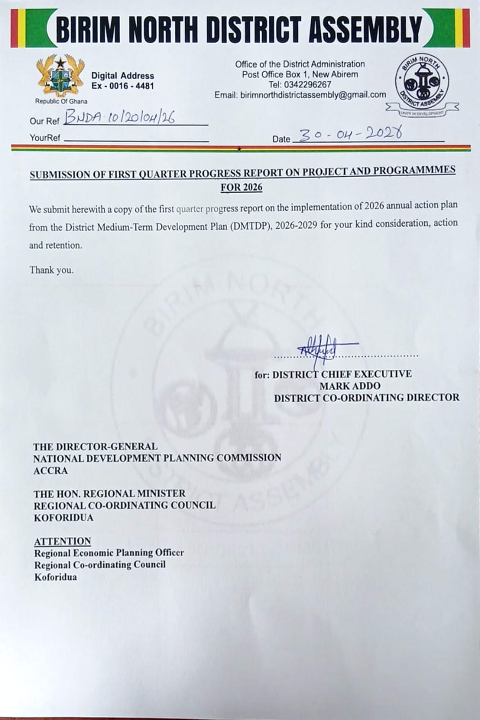

BIRIM NORTH DISTRICT ASSEMBLY

FIRST QUARTER PROGRESS REPORT ON THE IMPLEMENTATION OF THE MEDIUM- TERM DEVELOPMENT PLAN, 2026-2029

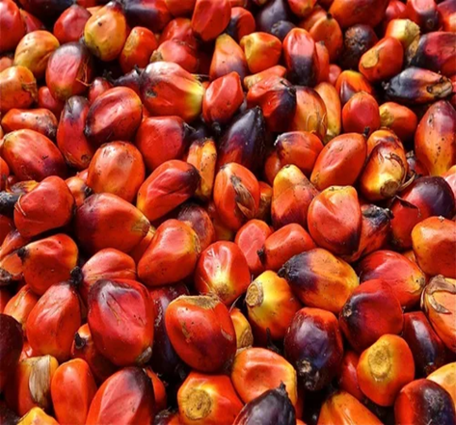

MONITORING AND EVALUATION REPORT, 2026

Prepared by:
DISTRICT PLANNING AND CO-ORDINATING UNIT (DPCU)

APRIL 2026

TABLE OF CONTENTS
LIST OF TABLES iii
LIST OF FIGURES iv
CHAPTER ONE 1
1.0 INTRODUCTION 1
1.2 Purpose of Monitoring and Evaluation for First Quarter 2026 2
1.3 Processes Involved and Difficulties Encountered 3
1.3.1 Processes Involved 3
1.3.2 Difficulties Encountered 5
1.4 Summary of Achievements in the Implementation of Planned Activities 6
1.4.1 Progress on the Implementation of the 2026 Annual Action Plan 7
1.4.2 Analysis of Quarterly Implementation of Planned Activities (As at First Quarter 2026) 9
1.4.4 Implementation of the Medium-Term Development Plan (DMTDP) 10
CHAPTER TWO 12
MONITORING AND EVALUATION ACTIVITIES REPORT 12
2.0 Introduction 12
2.1 Programmes Register for the First Quarter of 2026 12
2.1.1 Update on Programmes Register (Non-Physical Programmes) for First Quarter 2026 38
2.1.2 Collaborations with NGOs, CBOs and Development Partners 50
2.2 Update on Project Register for First Quarter 2026 51
2.2.1 Analysis of Physical Projects under Implementation as at First Quarter 2026 57
2.3 Update on Disbursements from Funding Sources for First Quarter 2026 59
2.3.1 Analysis of the Assembly’s Revenue Inflows as of the First Quarter of 2026 61
2.4 Update on Expenditure for First Quarter 2026 63
2.4.1 Analysis of Expenditure Performance – First Quarter 2026 64
2.5. Update on National Core Indicators and Targets 65
2.5.1 Analysis of District Performance Indicators and Targets as at First Quarter 2025 73
2.6.1 Update on Critical Development and Poverty Issues for First Quarter 2026 78
2.6.2 Government Flagship Programmes Implemented in the First Quarter of 2026 80
2.7 Update on District Specific Indicators for First Quarter 2026 82
2.7.1Analysis on District Specific Indicators and Targets for First Quarter 2026 86
2.9 Participatory Monitoring and Evaluation Undertaken 88
CHAPTER THREE 90
THE WAY FORWARD 90
3.0 Introduction 90
3.1 Key Issues Addressed 90
3.1.1 Disaster Issues Resolved 90
3.2 Key Issues Yet To Be Addressed 91

LIST OF TABLES
Table 1: Summary of Achievements of Implemented Activities as at First Quarter 2026. 6
Table 2: Quarterly Implementation of Planned Activities as at First Quarter 2026 8
Table 3: Update on Programmes Register for First Quarter 2026 14
Table 4: Projects Register for First Quarter 2026 52
Table 5: Update on Funding Source for First Quarter 2026 59
Table 6: Update on Expenditure for First Quarter 2026 62
Table 7: Update on District Performance Indicators and Targets as at First Quarter 2026 66
Table 8: Update on Critical Development and Poverty Issues in the District – First Quarter 2026 76
Table 9 : District Specific Indicators for First Quarter 2026 83
Table 10: Evaluations Conducted, Findings and Recommendations 87

LIST OF FIGURES
Figure 1: IMPLEMENTATION OF THE 2026 AAP BASE ON DIMENSSIONS 8
Figure 2: LEVEL OF IMPLEMENTATION OF THE 2026 ANNUAL ACTION PLAN (AAP) 9
Figure 3: PROPORTION OF THE 2026 ANNUAL ACTION PLAN (AAP) IMPLEMENTED 10
Figure 4: PROPORTION OF THE 2026-2029 MEDIUM TERM PLAN IMPLEMENTED 11
Figure 5: DISTRIBUTION OF 20,000 SANITARY PADS TO SUPPORT GIRL CHILD IN THE DISTRICT 39
Figure 6: DONATION OF COMPUTERS TO SELECTED SCHOOLS BY THE HON. DCE 39
Figure 7: PREPARATION FOR DISTRICT SPORT FESTIVAL IN THE DISTRICT 40
Figure 8: CULTURE DAY CELEBRATION BY A SCHOOL IN THE DISTRICT 40
Figure 9: CAPACITY –BUILDING SCIENCE AND MATHEMATICS TEACHERS IN THE DISTRICT 41
Figure 10: GIRLS IN STEM INTER-SCHOOLS COMPETITION HELD IN THE DISTRICT 41
Figure 11: SENSITIZATION OF JHS STUDENTS ON TVET PROGRAMMES BY AVTI 42
Figure 12: NATIONAL SANITATION DAY CLEAN-UP EXERCISE OBSERVED IN THE DISTRICT 43
Figure 13: INAUGURATION OF E-WASTE MANAGEMENT COMMITTEE IN THE DISTRICT 44
Figure 14: PUBLIC EDUCATION ON THE LEAP REASSESSMENT PROGRAMME ON ANANSE FM 44
Figure 15: SENSITIZATION ON THE LEAP REASSESSMENT PROGRAMME IN THE DISTRICT 45
Figure 16: VALIDATION OF LEAP PROSPECTIVE HOUSEHOLD MEMBERS 45
Figure 17: MONITORING OF PWD ACTIVITIES IN THE DISTRICT 45
Figure 18: CELEBRATION OF INDEPENDENCE DAY IN THE DISTRICT 47
FIGURE 19: WORKING VISIT BY PROF. LORD MENSAH-HEAD OF LOCAL GOVERNMENT SERVICE 47
Figure 20: WORKING VISIT/ MONITORING OF PROJECTS BY HON. RITA AWATEY- EASTERN REGIONAL MINISTER 48
Figure 21: INTERNAL MONITORING OF PROJECTS LED BY HON. ABDUL HAKIM ANTWI- DCE 48
Figure 22: SENSITIZATION OF DISASTER VOLUNTEER GROUPS (DVGS) ON SAFETY PROTOCOLS 49
Figure 23: DISTRIBUTION OF RELIEF ITEMS TO DISASTER VICTIMS IN THE DISTRICT 49
Figure 24: FOLLOW-UP VISITS TO COCOA FARMING COMMUNITIES 50
Figure 25: STATUS OF IMPLEMENTATION OF PHYSICAL PROJECTS 57
Figure 28: UPDATE ON REVENUE INFLOW OF THE ASSEMBLY 60
Figure 29: INTRODUCTION AND INAUGURATION OF BLUE WATER GUARD 79
Figure 30: DONATION OF VEHICLE IN SUPPORT OF BLUE WATER GUARD OPERATIONS 80
Figure 31: DISTRIBUTION OF LEARNING KITS UNDER THE NATIONAL APPRENTICESHIP PROGRAM (NAP) 80
Figure 32: DISTRIBUTION OF CHICKS UNDER THE NKOKO NKITINKITI PROGRAMME 81

CHAPTER ONE

1.0 INTRODUCTION
The Government of Ghana continues to pursue policies and programmes aimed at promoting sustainable socio-economic growth, improving public service delivery, and enhancing the living conditions of citizens. Central to this national development agenda is the implementation of strategic interventions focused on economic transformation, job creation, social inclusion, infrastructure development, environmental sustainability, and improved governance systems. These policy directions provide the framework within which Metropolitan, Municipal, and District Assemblies (MMDAs) prepare and implement their Medium-Term Development Plans (MTDPs) in alignment with national development priorities and the Sustainable Development Goals (SDGs).
In accordance with the requirements of Legislative Instrument (L.I.) 2232, particularly Regulations 8(3) and 10, all MMDAs are mandated to prepare Quarterly and Annual Progress Reports to monitor and evaluate the implementation of their development plans. These reports serve as important management and accountability tools that provide information on the status of projects and programmes, progress made toward achieving planned targets, challenges encountered during implementation, and measures adopted to address identified gaps.
The Birim North District Assembly prepared its 2026–2029 Medium-Term Development Plan in line with the Medium-Term National Development Policy Framework themed “Resetting Ghana: Creating Jobs, Ensuring Accountability, and Promoting Shared Prosperity.” The Plan outlines the Assembly’s development priorities and strategies across key thematic areas such as economic development, social services delivery, environmental management, infrastructure development, governance and accountability, disaster preparedness, and institutional strengthening.
This First Quarter Progress Report forms part of the Assembly’s statutory monitoring and reporting obligations and provides an assessment of the implementation status of programmes, projects, and activities undertaken during the period under review. The report also evaluates the extent to which financial and material resources were mobilized and utilized to support the achievement of planned objectives and targets.
The First Quarter of 2026 marked the commencement of the implementation of the Assembly’s 2026–2029 Medium-Term Development Plan. During the quarter, the Assembly implemented a number of interventions consistent with its 2026 Annual Action Plan, focusing on improving infrastructure, enhancing social service delivery, strengthening local economic development, and promoting the welfare of communities within the district.
This report provides a comprehensive account of the Assembly’s performance during the reporting period and serves as a basis for informed decision-making, improved planning, and effective monitoring of development interventions aimed at improving the socio-economic well-being of the people within the District.

1.2 Purpose of Monitoring and Evaluation for First Quarter 2026
During the First Quarter of 2026, the Birim North District Assembly undertook a series of Monitoring and Evaluation (M&E) activities aimed at tracking the implementation of programmes, projects, and activities outlined in the 2026 Annual Action Plan and the newly commenced 2026–2029 Medium-Term Development Plan (MTDP). The M&E activities were conducted in accordance with the Assembly’s monitoring framework and implementation schedules to ensure effective coordination, accountability, and performance assessment across all sectors.
The Monitoring and Evaluation exercise for the reporting period was intended to achieve the following objectives:
- Generate Data for Decision-Making
To collect, update, and analyze data on key performance indicators, targets, and emerging development issues to support evidence-based planning, informed decision-making, and effective management of development interventions.
- Enhance Accountability and Transparency
To strengthen accountability in the utilization of public resources by monitoring the use of funds, tracking outputs and outcomes, and ensuring that projects and programmes deliver the intended benefits to communities.
- Assess Project and Programme Implementation
To monitor the progress of ongoing and newly initiated projects and programmes, assess their implementation status, and validate field findings to ensure that interventions are being executed according to approved plans, specifications, and timelines.
- Support Learning and Stakeholder Participation
To facilitate feedback, document lessons learned, and encourage active stakeholder participation in the development process through consultations, field monitoring, and engagement with beneficiary communities and implementing departments.
- Identify Challenges and Recommend Corrective Measures
To identify implementation bottlenecks, operational constraints, and performance gaps affecting project execution and service delivery, and provide practical recommendations for corrective actions and improved implementation.
- Improve Future Planning and Service Delivery
To identify strengths, weaknesses, opportunities, and areas requiring improvement in order to enhance future planning, resource allocation, project implementation, and overall service delivery within the District.
- Evaluate Development Impact
To assess the extent to which implemented interventions contribute toward the achievement of the District’s development objectives, particularly in improving socio-economic conditions, infrastructure delivery, and access to essential social services.
The Monitoring and Evaluation activities conducted during the First Quarter of 2026 provided valuable information on the status of implementation of the Assembly’s programmes and projects and contributed significantly to performance assessment, accountability, and informed development management.

1.3 Processes Involved and Difficulties Encountered
This section presents an overview of the processes undertaken by the Birim North District Assembly in carrying out Monitoring and Evaluation (M&E) activities during the First Quarter of 2026. It outlines the approaches adopted to monitor the implementation of projects and programmes under the 2026 Annual Action Plan and the commencement of the 2026–2029 Medium-Term Development Plan (MTDP). The section also highlights the major challenges encountered during the reporting period which affected implementation, coordination, and reporting processes.

1.3.1 Processes Involved
- Review of Monitoring and Evaluation Schedule
The District Planning Coordinating Unit (DPCU) undertook a review of the Monitoring and Evaluation work plan and implementation schedule to identify key monitoring timelines and reporting requirements for the quarter. This ensured that M&E activities were aligned with statutory reporting obligations and the implementation framework of the Assembly’s Medium-Term Development Plan.

- Constitution of Monitoring Teams and Mobilization of Logistics
Monitoring teams comprising members of the DPCU, and other relevant stakeholders were constituted to undertake project inspections and data collection activities. Necessary logistics and resources were also mobilized to facilitate effective field monitoring and supervision.
- Stakeholder Consultations and Community Engagements
Consultative meetings and field engagements were organized with key stakeholders, including Traditional Authorities, Assembly Members, Unit Committee Members, beneficiary communities, and project implementation teams. These engagements provided opportunities to gather feedback, discuss implementation challenges, and assess the impact of ongoing interventions.
- Review and Validation of Indicators and Data Collection Tools
Monitoring indicators and data collection templates were reviewed and updated where necessary to ensure consistency, reliability, and accuracy in data collection and reporting. The updated tools were shared with decentralized departments and implementing units to support standardized reporting across sectors.
- Field Monitoring and Project Inspections
The DPCU and Specific Project Monitoring Team (SPMT) conducted site visits to inspect the progress of physical projects and assess the implementation status of programmes and activities across the District. Observations made during the monitoring exercises were documented and used for performance assessment and reporting.
- Data Compilation, Analysis, and Validation
Data collected from departments, field inspections, and stakeholder engagements were compiled and analyzed by the DPCU. The results were subsequently validated through DPCU review meetings to ensure completeness, consistency, and accuracy of the information presented in the report.
- Preparation and Dissemination of the Quarterly Progress Report
Based on the validated data and findings, the First Quarter Progress Report was prepared to capture the status of implementation of projects, programmes, indicators, and financial performance. The final report was then shared with relevant stakeholders to support decision-making, accountability, and future planning processes.

1.3.2 Difficulties Encountered
- Delayed Release of Statutory Funds
One of the major challenges encountered during the quarter was the delayed and release of statutory funds, particularly the District Assemblies Common Fund (DACF) and DACF–Responsive Factor Grant (DACF-RFG). This affected the timely execution of projects and implementation of planned activities.
- Inadequate Logistical Support
Limited logistics, including inadequate vehicles, office equipment, and monitoring tools, constrained the ability of departments and monitoring teams to effectively undertake field activities, reporting and supervision exercises.
- Weak Functionality of Sub-District Structures
Some sub-district structures remained weak and less functional, thereby affecting grassroots participation, local-level coordination, and effective monitoring of development interventions within communities.
- Late Submission of Departmental Reports
Delays in the submission of reports by some decentralized departments affected the timely compilation, validation, and analysis of data for the quarterly reporting process.
- Contractor Performance Challenges
Some contractors demonstrated slow work progress due to inadequate technical capacity, financial constraints, and limited access to construction equipments, leading to delays in project execution and completion.
- Financial Constraints Affecting Programme Implementation
Inadequate financial resources affected the implementation of some planned programmes, sensitization activities, and monitoring exercises during the quarter, particularly within the social services sector.
- Transportation and Accessibility Challenges:
Poor road conditions and transportation difficulties in some communities affected regular monitoring visits and delayed access to certain project sites, especially in remote areas of the District.
Despite these challenges, the Assembly continued to make efforts to ensure effective implementation, monitoring, and reporting of programmes and projects during the First Quarter of 2026 through collaboration, stakeholder engagement, and prudent resource utilization.

1.4 Summary of Achievements in the Implementation of Planned Activities
In pursuit of its development objectives for the 2026 fiscal year, the Birim North District Assembly undertook various interventions aimed at improving infrastructure, enhancing service delivery, promoting local economic growth, and improving the overall well-being of residents within the District.
During the quarter under review, progress was made across several sectors including education, health, water and sanitation, governance, social protection, and economic development. While some projects were fully completed and already delivering benefits to communities, others progressed steadily at various stages of implementation. The Assembly also undertook activities related to revenue mobilization, social welfare services, community sensitization, and monitoring and evaluation.
Despite challenges such as delays in the release of statutory funds and inadequate logistical support, the Assembly continued to collaborate with decentralized departments, stakeholders, development partners, contractors, and community members to implement planned interventions.
Table 1 below presents a summary of the implementation status of planned activities during the reporting period. The table provides an overview of the Assembly’s performance and highlights the extent to which programmes, projects, and activities were carried out in line with approved plans and development targets.

Table 1: Summary of Achievements of Implemented Activities as at First Quarter 2026.
S/N | Development Dimension | 2024 |  | 2025 |  | 1ST QTR 2026
S/N | Development Dimension | Plan | Exec | Plan | Exec | Plan | Exec
 | Economic Development | 29 | 27 | 27 | 27 | 33 | 15
 | Social Development | 72 | 69 | 44 | 42 | 76 | 40
 | Environment, Infrastructure and Human Settlement | 35 | 27 | 59 | 56 | 39 | 11
 | Governance, and Institutional Development | 39 | 35 | 30 | 28 | 46 | 26
 | Total | 175 | 158 | 160 | 153 | 204 | 92

Source: District Planning Co-coordinating Unit, BNDA April -2026

1.4.1 Progress on the Implementation of the 2026 Annual Action Plan
The implementation of the 2026 Annual Action Plan commenced in earnest during the First Quarter of 2026, marking the operationalization of the 2026–2029 Medium-Term Development Plan. During the quarter under review, a total of 92 activities were implemented out of 204 planned activities, representing an overall performance of approximately 45.1%. This reflects an initial implementation phase where activities were largely at commencement, mobilization, and early execution stages across all development dimensions.
In terms of Economic Development, 15 out of 33 planned activities were implemented, representing approximately 45.5% performance. This indicates moderate progress in economic-related interventions, particularly in local economic development, revenue mobilization, and support to productive sectors.
Under the Social Development dimension, 40 out of 76 planned activities were implemented, reflecting a performance level of approximately 52.6%. This represents an improved execution rate compared to earlier projections. The improved progress is largely driven by active, ongoing interventions across key education, health, environmental health and social protection programs.
For Environment, Infrastructure and Human Settlement, 11 out of 39 planned activities were implemented, representing about 28.2% performance. The lower implementation rate is primarily due to the early-stage nature of these infrastructure projects, with many still transitioning through procurement and mobilization phases. Additionally, it reflects a gradual rollout of critical preparedness and response interventions during the quarter.
Governance, and Institutional Development dimension recorded 26 out of 46 planned activities implemented, representing approximately 56.5% performance. This relatively strong progress highlights solid advancements in strengthening governance systems, administrative coordination, and accountability measures. It also reflects the success of sustained efforts in monitoring, coordination, and reporting to ensure effective project delivery.

Figure 1: IMPLEMENTATION OF THE 2026 AAP BASE ON DIMENSSIONS

In summary, the First Quarter performance demonstrates a moderate-to-strong level of implementation (45.1%), which is expected at the beginning of the planning cycle. Variations across development dimensions are largely due to differences in project readiness, funding release timelines, and procurement processes.
It is anticipated that implementation performance will improve significantly in subsequent quarters as ongoing projects progress from mobilization to full execution stages.

Table 2: Quarterly Implementation of Planned Activities as at First Quarter 2026
S/N | Indicators | Baseline  2022 | Actual  2023 | Target  2024 | Actual  2024 | Target  2025 | Actual  2025 | Target  2026 | Actual 1ST QTR  2026
 | Proportion of the Annual Action Plans implemented by the end of the year | 90% | 90.7% | 100% | 90.3% | 100% | 95.6% | 100% | 45.1%
 | Percentage completed | 75% | 55.4% | 80% | 81% | 80% | 81.8% | 95% | 4.4%
 | Percentage of ongoing interventions | 15% | 35.3% | 15% | 9% | 15% | 13.8% | 5% | 40.7%
 | Percentage of interventions abandoned | 0% | 0% | 0% | 0% | 0% | 0% | 0% | 0%
 | Percentage of interventions yet to start | 10% | 9.3% | 5% | 10% | 5% | 5% | 0% | 54.9%
2. | Proportion of the overall medium-term development plan implemented | 24.5% | 52% | 75% | 84% | 95% | 91.64% | 25% | 10.40%
Source: District Planning Co-ordinating Unit, BNDA. April -2026.

1.4.2 Analysis of Quarterly Implementation of Planned Activities (As at First Quarter 2026)
The First Quarter of 2026 reflects the initial operational phase of the 2026 Annual Action Plan under the 2026–2029 Medium-Term Development Plan (DMTDP). During the period under review, a total of 92 activities were implemented out of 204 planned activities, representing an overall implementation performance of 45.10%. This level of performance is considered moderate and appropriate for the commencement stage of a new planning cycle, where emphasis is typically placed on project mobilization, procurement processes, continuation of ongoing interventions, and preparatory activities.
The performance recorded during the quarter was influenced by variations in project readiness, timing of fund releases, and the sequencing of procurement and contract arrangements. Activities that were already on-going or required minimal preparatory work progressed faster, while new capital-intensive interventions remained largely at early stages of implementation.
1.4.3 Status of Implementation of the Annual Action Plan
Out of the total 204 planned activities, 92 were implemented, representing 45.1%, while 112 activities (54.90%) were yet to commence or were at preparatory stages. This reflects the typical implementation pattern of a first-quarter period, where a significant proportion of activities are still undergoing procurement, mobilization, or initial planning processes.
Figure 2: LEVEL OF IMPLEMENTATION OF THE 2026 ANNUAL ACTION PLAN (AAP)

The recorded 40.70% implementation rate represents activities that reached measurable stages of execution and 4.4% of the planned activities have been completed. Notably, no interventions were abandoned, indicating strong continuity in planning and implementation processes across sectors.
Figure 3: PROPORTION OF THE 2026 ANNUAL ACTION PLAN (AAP) IMPLEMENTED

The relatively high proportion of yet-to-start activities is largely attributed to delays in procurement processes, funding disbursement schedules, and the staggered commencement of projects across departments.

1.4.4 Implementation of the Medium-Term Development Plan (DMTDP)
The District Medium-Term Development Plan (DMTDP), comprising 887 activities, recorded 92 implemented activities in the First Quarter of 2026, representing an overall implementation level of approximately 10.4%.
This level of performance reflects the early-stage rollout of the plan, where implementation is focused primarily on foundational and preparatory activities. Given the broad scope of the DMTDP, which includes policy interventions, institutional strengthening, infrastructure development, and service delivery improvements, implementation is expected to be gradual and cumulative over the planning period.
The 10.4% achievement, therefore, represents an initial baseline performance, with stronger implementation expected in subsequent quarters as projects transition from preparatory stages into full execution.
Figure 4: PROPORTION OF THE 2026-2029 MEDIUM TERM PLAN IMPLEMENTED

It is evident from figure 5 above that, First Quarter of 2026 represents a moderate but stable start to implementation under the 2026–2029 development cycle. The achievement of 45.10% implementation under the Annual Action Plan demonstrates progress in ongoing and preparatory activities, while the 10.4% DMTDP implementation reflects the early-stage nature of long-term development programming.
The absence of abandoned interventions indicates strong institutional discipline and continuity in implementation. However, the relatively high proportion of yet-to-start activities highlights the need for improved early procurement planning, timely release of funds, and strengthened coordination across implementing departments.
It is anticipated that implementation performance will improve significantly in subsequent quarters as projects move into full execution stages and resource flows become more stable and predictable.

CHAPTER TWO

MONITORING AND EVALUATION ACTIVITIES REPORT

2.0 Introduction
This chapter presents an analysis of Monitoring and Evaluation (M&E) activities undertaken by the Birim North District Assembly during the First Quarter of 2026. It provides an overview of the implementation status of key programmes and projects, highlighting progress made in relation to planned targets, indicators, and expected outputs under the 2026 Annual Action Plan and the 2026–2029 Medium-Term Development Plan (DMTDP).
The chapter further examines financial and operational performance during the reporting period, including updates on funding inflows, resource utilization, and the extent to which available resources were effectively deployed to support development interventions across sectors.
In addition, it identifies key implementation challenges and emerging development issues affecting service delivery, with particular attention to vulnerable groups and communities. These insights provide an evidence-based understanding of the socio-economic conditions influencing programme outcomes and implementation efficiency within the District.
The chapter also presents findings from assessment and review exercises conducted during the quarter. These evaluations provide important lessons and inform recommendations aimed at strengthening project delivery, improving coordination, and enhancing the overall effectiveness of development interventions.
Furthermore, Participatory Monitoring and Evaluation (PM&E) activities undertaken during the period are highlighted. Through stakeholder engagement and community participation, PM&E continues to enhance transparency, accountability, and inclusiveness in local governance and development planning.

2.1 Programmes Register for the First Quarter of 2026
This section presents a consolidated summary of activities implemented during the First Quarter of 2026 under the 2026 Annual Action Plan. It provides a structured overview of implementation progress across sectors, highlighting key operational outputs, project status, and areas requiring management attention.
The activity register serves as a key monitoring tool for tracking the execution of development interventions across the District. It enables the assessment of progress against planned targets while also identifying implementation gaps, delays, and emerging operational challenges that require corrective action.
Beyond tracking implementation, the register also captures lessons learned during execution, thereby supporting evidence-based decision-making and improving future planning processes. These insights contribute to strengthening the alignment of interventions with community priorities and the broader development agenda of the District.
In addition, the analysis promotes continuous improvement in programme and project delivery, reinforcing the District’s commitment to effective service delivery and the achievement of national development priorities, including the Sustainable Development Goals (SDGs).

Table 3: Update on Programmes Register for First Quarter 2026
S/N | Programme Description | Development dimensions | Amount involved sum GH₵ | Source of funding | Date started | Expected date of completion | Planned expenditure  GH¢ | Actual Expenditure  GH¢ | Implementation status |  | Level of Completion | Issues for  leadership’s  attention
 |  |  |  |  |  |  |  |  | (% ) | Picture | Completed | Issues for  leadership’s  attention
 |  |  |  |  |  |  |  |  |  |  | Ongoing | Issues for  leadership’s  attention
 |  |  |  |  |  |  |  |  |  |  | Yet to start | Issues for  leadership’s  attention
FINANCE
 | Develop and implement the bill printing plan by the end of Dec. 2026 | Economic Development | 10,000.00 | IGF | 1ST January 2026 | 31st March 2026 | 26,000.00 | 5,000.00 | 20% |  | Ongoing
 | Organize Public sensitization on e-billing and payments by the end of Dec. 2026 | Economic Development | 50,000.00 | IGF | 1ST January 2026 | 31st March 2026 | 17,000.00 | 4,500.00 | 27% |  | Ongoing
 | Upgrading internet facility to improve GIFMIS operations by the end of Dec. 2026 | Economic Development | 5,000.00 | IGF | 1ST January 2026 | 31st March 2026 | 40,000.00 | 2,500.00 | 7% |  | Ongoing
 | Organise pay-your-levy campaigns by the end of Dec. 2026. | Economic Development | 20,000.00 | IGF | 1ST January 2026 | 31st March 2026 | 1,000.00 | 1,000.00 | 100% |  | Ongoing
AGRICULTURE
 | Organise 1no. District Farmers’ Day celebration by the end of Dec. 2026 | Economic Development | 10,000.00 | IGF | 1ST January 2026 | 31st March 2026 | 10,000.00 | 0.00 | 0% |  | Yet to start
 | Promote Alternative livelihood for employment and income generation for women by the end of Dec. 2026 | Economic Development | 9,000.00 | GOG/IGF | 1ST January 2026 | 31st March 2026 | 9,000.00 | 0.00 | 0% |  | Yet to start
 | Promotion of Birim North District Commodity Satellite Market by the end of Dec. 2026. | Economic Development | 20,000.00 | IGF | 1ST January 2026 | 31st March 2026 | 20,000.00 | 0.00 | 0% |  | Yet to start
 | Promote agricultural data collection and analysis by the end of Dec. 2026 | Economic Development | 15,000.00 | IGF | 1ST January 2026 | 31st March 2026 | 15,000.00 | 0.00 | 0% |  | Yet to start
 | Facilitate agricultural planning and policy implementation (RELC, PBB, PERD, etc.) by the end of Dec. 2026. | Economic Development | 6,165.65 | IGF | 1ST January 2026 | 31st March 2026 | 6,165.65 | 0.00 | 0% |  | Yet to start
 | Promote Effective and efficient extension service delivery by the end of Dec. 2026. | Economic Development | 2,000.00 | IGF | 1ST January 2026 | 31st March 2026 | 2,000.00 | 0.00 | 0% |  | Yet to start
 | Organise Staff capacity development by the end of Dec. 2026. | Economic Development | 5,000.00 | IGF | 1ST January 2026 | 31st March 2026 | 5,000.00 | 0.00 | 0% |  | Yet to start
 | Promote sustainable climate resilient agricultural production systems by the end of Dec. 2026 | Economic Development | 5,000.00 | IGF | 1ST January 2026 | 31st March 2026 | 5,000.00 | 0.00 | 0% |  | Yet to start
 | Development and formation of FBOs by the end of Dec. 2026 | Economic Development | 5,000.00 | IGF | 1ST January 2026 | 31st March 2026 | 5,000.00 | 0.00 | 0% |  | Yet to start
 | Promote agricultural innovation/technology through demonstrations by the end of Dec. 2026 | Economic Development | 5,000.00 | IGF | 1ST January 2026 | 31st March 2026 | 5,000.00 | 0.00 | 0% |  | Yet to start
 | Promote improved crop varieties for higher yields by the end of Dec. 2026 | Economic Development | 5,000.00 | IGF | 1ST January 2026 | 31st March 2026 | 5,000.00 | 0.00 | 0% |  | Yet to start
 | Promote safe use of Agro chemicals by the end of Dec. 2026 | Economic Development | 5,000.00 | IGF | 1ST January 2026 | 31st March 2026 | 5,000.00 | 0.00 | 0% |  | Yet to start
 | Organize stakeholder capacity building in crop disease and pest control by the end of Dec. 2026 | Economic Development | 10,000.00 | IGF | 1ST January 2026 | 31st March 2026 | 10,000.00 | 0.00 | 0% |  | Yet to start
 | Carry-out post-harvest loss reduction in agricultural commodities by the end of Dec. 2026. | Economic Development | 9,000.00 | GOG/IGF | 1ST January 2026 | 31st March 2026 | 9,000.00 | 0.00 | 0% |  | Yet to start
BUSINESS ADVISORY CENTRE (BAC)
 | Formation and improving Associations by the end of Dec. 2026 | Economic Development. | 10,000.00 | IGF | 1st January 2026 | 31st March 2026 | 10,000.00 | 0.00 | 0% |  | Yet to Start
 | Organise Business Forums by the end of Dec. 2026 | Economic Development. | 10,000.00 | IGF | 1st January 2026 | 31st March 2026 | 10,000.00 | 0.00 | 0% |  | Yet to Start
 | Strengthening of Association of Small-Scale Industries (ASSI) by the end of Dec. 2026. | Economic Development. | 10,000.00 | IGF | 1st January 2026 | 31st March 2026 | 10,000.00 | 0.00 | 0% |  | Yet to Start
 | Organise Business Counselling and Monitoring for 60 women and 40 Men by the end of Dec. 2026 | Economic Development. | 5,000.00 | IGF | 1st January 2026 | 31st March 2026 | 1500.00 | 1200.00 | 50% | 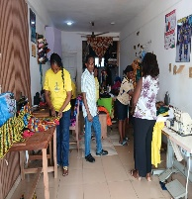 | Ongoing
 | Organise training in General Business Management and Planning for 100 women and 50 men by the end of Dec. 2026 | Economic Development. | 7,500.00 | IGF | 1st January 2026 | 31st March 2026 | 7,500.00 | 0.00 | 0% |  | Yet to Start
 | Organise Training, Coaching and Mentoring of Artisans by the end of Dec. 2026 | Economic Development. | 7,500.00 | IGFs | 1st January 2026 | 31st March 2026 | 7,500.00 | 0.00 | 0% |  | Yet to Start
 | Facilitate credit facilities for Enterprise (SMSE) by the end of Dec. 2026. | Economic Development. | 30,000.00 | IGF | 1st January 2026 | 31st March 2026 | 30,000.00 | 0.00 | 0% |  | Yet to Start
 | Organize NVTI exams and Provide Startup Kits for graduate apprentices by the end of Dec. 2026. | Economic Development. | 50,000.00 | IGF | 1st January 2026 | 31st March 2026 | 50,000.00 | 0.00 | 0% |  | Yet to Start
 | Support to the establishment of Wood village for artisans by the end of Dec. 2026. | Economic Development. | 35,975.40 | IGF | 1st January 2026 | 31st March 2026 | 35,975.40 | 0.00 | 0% |  | Yet to Start
 | Construct Community hostels for artisans by the end of Dec. 2026. | Economic Development. | 626,000.00 | IGF | 1st January 2026 | 31st March 2026 | 626,000.00 | 0.00 | 0% |  | Yet to Start
TOURISM DEVELOPMENT
 | Redevelopment of Adjendua waterfalls, canopy walkway and paragliding by the end of Dec. 2026. | Economic Development | 20,000.00 | IGF | 1st January 2026 | 31st March 2026 | 20,000.00 | 0.00 | 10% |  | On-going
COOPERATIVES
 | Identify, form, register, and train co-operative societies by the end of Dec. 2026. | Economic Development | 12,000.00 | IGF | 1st January 2026 | 31st March 2026 | 2,500.00 | 900.00 | 15% | 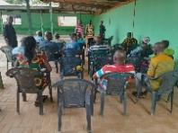 | On-going | Mobility and enough funds needed
 | Audit Co-operative societies by Dec. 2026 | Economic Development | 5,000.00 | IGF | 1st January 2026 | 31st March 2026 | 800.00 | 200.00 | 12% | 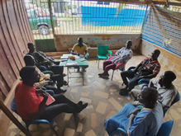 | On-going | Logistics and enough funds needed
 | Organize Monitoring and Evaluation activities for co-operative societies by Dec.2026. | Economic Development | 5000.00 | IGF | 1st January 2026 | 31st March 2026 | 900.00 | 400.00 | 15% | 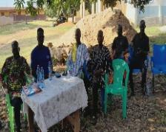 | On-going | Stationaries, Logistics and enough funds needed
 | Organize Annual General meeting and Election for co-operative Societies and unions by Dec.2026 | Economic Development | 5,000.00 | IGF | 1st January 2026 | 31st March 2026 | 1,200.00 | 1,000.00 | 25% | 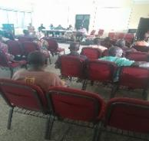 | On-going | Stationaries, Logistics and enough funds needed
EDUCATION
 | Organize School, Circuit, Zonal & Regional Sporting and Cultural Festivals by the end of Dec. 2026. | Social Development | 10.000.00 | IGF | 1st January 2026 | 31st March 2026 | 85,000.00 | 7,000.00 | 10% | 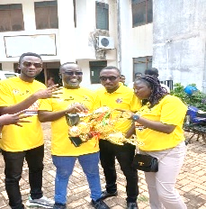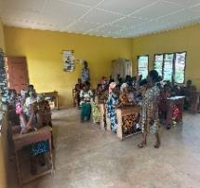 | On-going | During the period under review, the district participated in ‘U 13’ Zonal sports festival at Mpraeso and placed 3rd in the zone.
 | Celebrate Menstrual Hygiene & International Girls' Day by Dec. 2026. | Social Development | 5,000.00 | IGF | 1st January 2026 | 31st March 2026 | 17,000.00 | 0.00 | 0% |  | Yet-to-start | D/A sponsorship is eagerly expected
 | Organise Sensitization / Community Engagement on risks associated with substance use for adolescent age group and general population, establish adolescent clubs in schools, educate youth on clinical health on sexually transmitted disease and the promotion of condom use, promote malaria prevention and home gardening in school, provide counselling for adolescent boys and girls on domestic violence by the end of Dec. 2026. | Social Development | 5,000.00 | IGF | 1st January 2026 | 31st March 2026 | 12,600.00 | 6,000.00 | 50% | 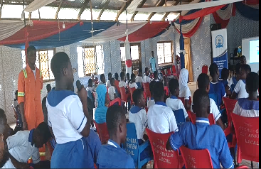 | On-going  On-going | The activity is part of all Schedule Officers duty thus 30+ school/communities have benefited from such engagements.
 | Organize ‘My First Day at School'. | Social Development | 30,000.00 | IGF | 1st January 2026 | 31st March 2026 | 30,000.00 | 0.00 | 0% |  | Yet to Start | This programme has not been implemented for the past four years.
 | Conduct SPAMs and Annual District Education Reviews. | Social Development | 3,000.00 | IGF | 1st January 2026 | 31st March 2026 | 12,600.00 | 8,000.00 | 80% | 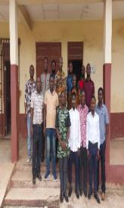 | On-going | School & Community levels SPAMs are frequently organize
 | Official Celebration (Independence Day) | Social Development | 50,000.00 | IGF | 1st January 2026 | 31st March 2026 | 50,000.00 | 50,000.00 | 100% | 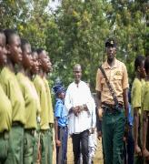 | Completed
 | Conduct 'Drop in the Bin' initiative by the end of Dec. 2026. | Social Development | 2,000.00 | IGF | 1st January 2026 | 31st March 2026 | 4,200.00 | 2,000.00 | 50% | 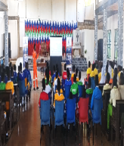 | On-going | The Directorate will need trash cans to be distributed to schools.
 | Organize Read with the Community Day & Culture Week Annually by the end of Dec. 2026. | Social Development | 10,000.00 | IGF | 1st January 2026 | 31st March 2026 | 10,000.00 | 10,000.00 | 50% | 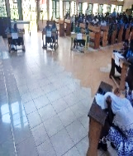 | On-going
 | Organize School, Circuit, Municipal, Zonal & Regional STMIE Clinics by Dec. 2026. | Social Development | 20,000.00 | IGF | 1st January 2026 | 31st March 2026 | 50,000.00 | 20,000.000 | 30% | 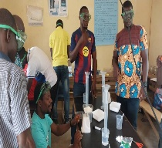 | On-going | Girls in STEM Quiz competitions were organized. Akoase Kissinger Baptist International School won.
 | Organize Annual Education Review by the end of Sept. 2026. | Social Development | 5,000.00 | IGF | 1st January 2026 | 31st March 2026 | 14,000.00 | 0.00 | 0% |  | Yet – to -start
HEALTH SERVICE DELIVERY
 | Increase uptake of Expanded Programme on Immunization (EPI) services through outreach and supportive supervision/promote malaria prevention/organize health screening for adolescent age group on HIV/Aids by the end of Dec. 2026. | Social Development | 25,660,00 | IGF | 1st January 2026 | 31st March 2026 | 25,660,00 | 0.00 | 25% | 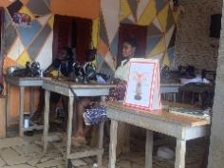 | On-going
 | Undertake Mass Drug Administration against Onchocerciasis, Schistosomiasis, Intestinal worms, Yaws/support to Integrated Disease Surveillance and response to epidemic prone disease and other disease of public health importance by the end of Dec. 2026. | Social Development | 51,000.00 | IGF | 1st January 2026 | 31st March 2026 | 51,000.00 | 0.00 | 0% |  | Yet – to -start
 | Expand screening programmes for selected non-communicable diseases|: hypertension, diabetes, sickle cell, and selected cancers and Increase access to modern FP services through public education and regular supplies of FP commodities by the end of Dec. 2026. | Social Development | 60,000.00 | IGF | 1st January 2026 | 31st March 2026 | 60,000.00 | 0.00 | 25% | 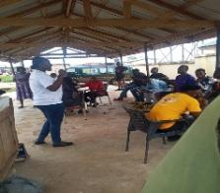 | On-going
 | Provide basic equipment’s: BP apparatus, HB meters and autoclave by the end of Dec. 2026. | Social Development | 45,000.00 | IGF | 1st January 2026 | 31st March 2026 | 45,000.00 | 0.00 | 0% |  | Yet – to -start
 | Increase access to modern FP services through public education and regular supplies of FP commodities/Promote mental health related issues by the end of Dec. 2026. | Social Development | 2,000.00 | IGF | 1st January 2026 | 31st March 2026 | 2,000.00 | 0.00 | 25% |  | On-going
ENVIRONMENTAL HEALTH
 | Support to E-Waste projects by the end of Dec. 2026. | Social Development | 20,000.00 | IGF | 1ST January 2026 | 31st March 2026 | 20,000.00 | 0.00 | 25% | 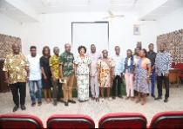 | On-going
 | Purchase of sanitary tools and equipment’s including veronica buckets for public schools and health centers by the end of Dec. 2026. | Social Development | 183,173.01 | DACF | 1ST January 2026 | 31st March 2026 | 183,173.01 | 0.00 | 0% |  | Yet to start
 | Support to Sanitation Improvement Package by the end of Dec. 2026. | Social Development | 430,378.01 | DACF | 1ST January 2026 | 31st March 2026 | 430,378.01 | 0.00 | 25% | 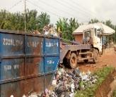 | On-going
 | Manage Sanitation in the District by the end of Dec. 2026. | Social Development | 31,900.00 | DACF | 1ST January 2026 | 31st March 2026 | 31,900.00 | 0.00 | 25% | 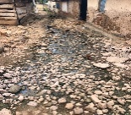 | On-going
 | Evacuate refuse dump and maintain final dumping sites in the Districts by the end of Dec. 2026. | Social Development | 240,663.33 | DACF | 1ST January 2026 | 31st March 2026 | 240,663.33 | 0.00 | 0% |  | Yet to start
 | Celebrate World Toilet and Global Hand-Washing Day by the end of Dec. 2026. | Social Development | 10,560.00 | IGF | 1ST January 2026 | 31st March 2026 | 10,560.00 | 0.00 | 0% |  | Yet to start
 | Organize health education and creation of awareness to construct household latrines by the end of Dec. 2026. | Social Development | 13,750.00 | IGF | 1ST January 2026 | 31st March 2026 | 13,750.00 | 600.00 | 20% | 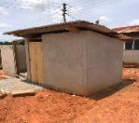 | On-going
 | Organize health screenings for food and drink vendors by the end of Dec. 2026. | Social Development | 10,000.00 | IGF | 1ST January 2026 | 31st March 2026 | 10,000.00 | 0.00 | 0% |  | Yet to start
 | Undertake a district-wide fumigation exercise by the end of Dec. 2026. | Social Development | 409,445.01 | DACF | 1ST January 2026 | 31st March 2026 | 409,445.01 | 0.00 | 25% | 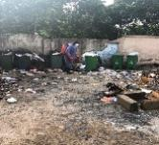 | On-going
 | Support implementation of Community Led Total Sanitation by the end of Dec. 2026. | Social Development | 123,173.01 | DACF | 1ST January 2026 | 31st March 2026 | 123,173.01 | 0.00 | 0% |  | Yet to start
 | Conduct sensitization on WASH activities by the end of Dec. 2026. | Social Development | 93173.01 | DACF | 1ST January 2026 | 31st March 2026 | 93173.01 | 25,000.00 | 25% |  | On-going
 | Organise National Sanitation Day by the end of Dec. 2026. | Social Development | 143,173.04 | DACF | 1ST January 2026 | 31st March 2026 | 143,173.04 | 64,000.00 | 25% | 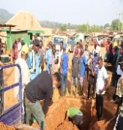 | On-going
 | Procure 10No. refuse containers by the end of Dec. 2026. | Social Development | 440,663.33 | DACF | 1ST January 2026 | 31st March 2026 | 440,663.33 | 0.00 | 0% |  | Yet to start
 | Regularly dislodge all institutions and public toilets by the end of Dec. 2026. | Social Development | 270,640.46 | IGF/DACF | 1ST January 2026 | 31st March 2026 | 270,640.46 | 0.00 | 25% | 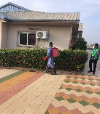 | On-going
 | Procurement of land for the establishment of the assembly cemetery by the end of Dec. 2026. | Social Development | 316,600.00 | IGF | 1ST January 2026 | 31st March 2026 | 316,600.00 | 0.00 | 0% |  | Yet to start
SOCIAL WELFARE & COMMUNITY DEVELOPMENT
 | Reassess, Monitor, Educate, and Facilitate the implementation of LEAP Activities by the end of Dec. 2026. | Social Development | 46,200.00 | World Bank | 1st Jan, 2026 | 31st March, 2026 | 46,200.00 | 46,200.00 | 50% | 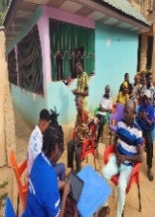 | On-going
 | Disbursement of Disability Common Fund to support in these areas; Health, Education, Assistive device, Start-Up Kits, Start-Capital, Apprenticeship training, Skill Training, Capacity building workshop and PWDs organizations by the end of Dec. 2026. | Social Development | 573,421.62 | DACF-PWD | 1st January 2026 | 31st March 2026 | 1,000.00 | 0.00 | 15% | 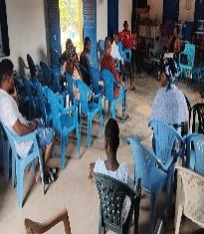 | On-going
 | Register, Enroll PWDs on NHIS and Monitor activities of PWDs with emphasis on adolescent age group by the end of Dec. 2026. | Social Development | 100.000.00 | DACF-PWD | 1st January 2026 | 31st March 2026 | 10,000.00 | 0.00 | 25% | 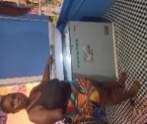 | On-going
 | Roll out of the Child Protection Tool Kits through community engagements and dialogue with emphasis on adolescent age group by the end of Dec. 2026. | Social Development | 2,000.00 | GOG | 1st January 2026 | 31st March 2026 | 2,000.00 | 0.00 | 0% |  | Yet to start
 | Register, Supervise and Monitor activities of Day Care Centers in the district by the end of Dec. 2026. | Social Development | 2,000.00 | GOG | 1st January 2026 | 31st March 2026 | 2,000.00 | 0.00 | 0% |  | Yet to start
 | Organize sensitization on Teenage Pregnancy, Sexual Harassment and domestic violence abuse, malaria prevention, mental health promotion, good nutrition, provision of psychosocial support for victims by the end of Dec. 2026. | Social Development | 4,000.00 | GOG | 1st January 2026 | 31st March 2026 | 4,000.00 | 0.00 | 0% |  | Yet to start
 | Educate communities on Child and Family Welfare issues by the end of Dec. 2026. | Social Development | 1,000.00 | IGF | 1st January 2026 | 31st March 2026 | 1,000.00 | 0.00 | 0% |  | Yet to start
 | Celebrate World Day Against Child Labor by the end of Dec. 2026. | Social Development | 6,000.00 | GOG/IFG | 1st January 2026 | 31st March 2026 | 1,000.00 | 0.00 | 0% |  | Yet to start
 | Intensify comprehensive education on HIV/AIDS and STIs, including reduction of stigmatization in schools and communities/Intensify efforts to eliminate mother to child transmission of HIV (MTCTHIV)/ Celebrate World AIDs Day by the end of Dec. 2026. | Social Development | 112,236.94 | DACF | 1st January 2026 | 31st March 2026 | 10,000.00 | 0.00 | 0% |  | Yet to start
 | Celebrate international day for the Girl Child by the end of Dec. 2026. | Social Development | 4,000.00 | GOG/IFG | 1st January 2026 | 31st March 2026 | 1,000.00 | 0.00 | 0% |  | Yet to start
 | Organize training on Women Empowerment and skill development by the end of Dec. 2026. | Social Development | 8,222.00 | GOG/IFG | 1st January 2026 | 31st March 2026 | 1,000.00 | 0.00 | 0% |  | Yet to start
 | Organize sensitization on Menstrual Hygiene in schools and celebrate Menstrual Hygiene Day by the end of Dec. 2026. | Social Development | 3,000.00 | GOG/IFG | 1st January 2026 | 31st March 2026 | 1,000.00 | 0.00 | 0% |  | Yet to start
 | Organize sensitization on gender-based violence in schools and communities by the end of Dec. 2026. | Social Development | 5,000.00 | GOG/IFG | 1st January 2026 | 31st March 2026 | 1,000.00 | 0.00 | 0% |  | Yet to start
BIRTH & DEATH REGISTRY
 | Organize Public education and sensitization on importance of Births and Deaths Registration by the end of Dec. 2026. | Social Development | 3,000.00 | IGF | 1ST January 2026 | 31st March 2026 |  | 0.00 | 20% | 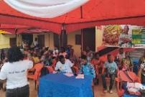 | On-going
 | Organize outreach registration exercises (Mobile Registration) by the end of Dec. 2026. | Social Development | 2,000.00 | IGF | 1ST January 2026 | 31st March 2026 |  | 0.00 | 20% | 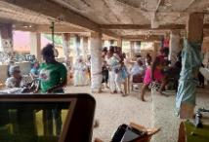 | On-going
 | Organize 2 durbars during the Child Health Promotion and Birth registration week respectively by the end of Dec. 2026. | Social Development | 3,000.00 | IGF | 1ST January 2026 | 31st March 2026 | 0.00 | 0.00 | 0% |  | Yet to start
 | Establish 5No. Registration Centers for Birth and Death Registry by the end of Dec. 2026. | Social Development | 2,000.00 | IGF | 1ST January 2026 | 31st March 2026 | 0.00 | 0.00 | 0% |  | Yet to start
PHYSICAL PLANNING
 | Support Street Naming and Property Address system by the end of Dec. 2026. | Environment, Infrastructure and Human Settlement | 150,000.00 | DACF/ZA | 1ST January 2026 | 31st March 2026 |  | 0.00 | 10% |  | Yet to start
 | Prepare base maps and local Plans for 2 communities by the end of Dec. 2026. | Environment, Infrastructure and Human Settlement | 15,000.00 | IGF | 1ST January 2026 | 31st March 2026 |  |  | 20% |  | On-going
 | Prepare District Spatial Development  Framework by the end of Dec. 2026. | Environment, Infrastructure and Human Settlement | 98,760.98 | DACF | 1ST January 2026 | 31st March 2026 | 0.00 | 0.00 | 0% |  | Yet to start
 | Organize monthly technical & spatial planning committee meeting by the end of Dec. 2026. | Environment, Infrastructure and Human Settlement | 30,000.00 | IGF | 1ST January 2026 | 31st March 2026 | 30,000.00 | 0.00on | 20% |  | On-going
 | Revise 2 sector plans for communities by the end of Dec. 2026. | Environment, Infrastructure and Human Settlement | 20,200.00 | IGF | 1ST January 2026 | 31st March 2026 | 20,200.00 | 0.00On | 20% |  | On-going
 | Facilitate the documentation of assembly’s lands by the end of Dec. 2026. | Environment, Infrastructure and Human Settlement | 30,000.00 | IGF | 1ST January 2026 | 31st March 2026 | 30,000.00 | 0.00 | 0% |  | Yet to start
 | Conduct monthly site inspection for the processing of development application for permitting by the end of Dec. 2026. | Environment, Infrastructure and Human Settlement | 10,000.00 | IGF | 1ST January 2026 | 31st March 2026 | 10,000.00 | 0.00 | 20% |  | On-going
 | Landscaping and planting of ornamental plants to beautify the environment by the end of Dec. 2026. | Environment, Infrastructure and Human Settlement | 10,000.00 | IGF | 1ST January 2026 | 31st March 2026 | 0.00 | 0.00 | 0% |  | Yet to start
 | Develop Parks and garden by the end of Dec. 2026. | Environment, Infrastructure and Human Settlement | 10,000.00 | IGF | 1ST January 2026 | 31st March 2026 | 0.00 | 0.00 | 0% |  | Yet to start
 | Compensate and acquire Title deeds for Assembly lands by the end of Dec. 2026. | Environment, Infrastructure and Human Settlement | 25,000.00 | IGF | 1ST January 2026 | 31st March 2026 | 0.00 | 0.00 | 0% |  | Yet to start
WORKS
 | Support District Roads Improvement Programme (DRIP) by the end of Dec. 2026. | Environment, Infrastructure and Human Settlement | 100,000.00 | IGF | 1ST January 2026 | 31st March 2026 | 0.00 | 0.00 | 0% |  | Yet to start
 | Reshape Feeder roads by the end of Dec. 2026. | Environment, Infrastructure and Human Settlement | 200,000.00 | IGF | 1ST January 2026 | 31st March 2026 | 0.00 | 0.00 | 0% |  | Yet to start
 | Install road signs and speed ramps by the end of Dec. 2026. | Environment, Infrastructure and Human Settlement | 20,000.00S | DACF | 1ST January 2026 | 31st March 2026 | 0.00 | 0.00 | 0% |  | Yet to start
 | Create town roads/lanes/ access roads by the end of Dec. 2026. | Environment, Infrastructure and Human Settlement | 500,000.00 | IGF | 1ST January 2026 | 31st March 2026 | 0.00 | 0.00 | 0% |  | Yet to start
 | Support MPs projects by the end of Dec. 2026. | Environment, Infrastructure and Human Settlement | 250,000.00 | DACF | 1ST January 2026 | 31st March 2026 | 0.00 | 0.00 | 0% |  | Yet to start
 | Support Contract Management by the end of Dec. 2026. | Environment, Infrastructure and Human Settlement | 300,000.00 | DACF | 1ST January 2026 | 31st March 2026 | 0.00 | 0.00 | 0% |  | Yet to start
 | Support Self-help projects by the end of Dec. 2026. | Environment, Infrastructure and Human Settlement | 200,000.00 | IGF | 1ST January 2026 | 31st March 2026 | 0.00 | 0.00 | 0% |  | Yet to start
 | Provide, install and repair Streets lights by the end of Dec. 2026. | Environment, Infrastructure and Human Settlement | 50,000.00 | IGF | 1ST January 2026 | 31st March 2026 | 0.00 | 0.00 | 0% |  | Yet to start
 | Extend Electricity to communities by the end of Dec. 2026. | Environment, Infrastructure and Human Settlement | 500,000.00 | IGF | 1ST January 2026 | 31st March 2026 | 0.00 | 0.00 | 10% |  | OOn-goin On-going g
 | Provide Network Booster by the end of Dec. 2026. | Environment, Infrastructure and Human Settlement | 45,000.00 | IGF | 1ST January 2026 | 31st March 2026 | 0.00 | 0.00 | 40% |  | On-going
TRANSPORT
 | Register and organize eye screening for transport unions, prajia drivers in the district by the end of Dec. 2026. | Environment, Infrastructure and Human Settlement | 10,000.00 | IGF | 1ST January 2026 | 31st March 2026 | 0.00 | 0.00 | 0% |  | Yet to start
 | Train and sensitize transport unions, prajia operators on road signs and safety measures by the end of Dec. 2026. | Environment, Infrastructure and Human Settlement | 5,000.00 | IGF | 1ST January 2026 | 31st March 2026 | 0.00 | 0.00 | 0% |  | Yet to start
NADMO
 | Organize Public education on disaster prevention-(flooding, rain/windstorm, domestic bushfires/epidemics, erosion and land degradation) by the end of Dec. 2026. | Emergency planning and response ( Including Covid-19 recovery plan) | 2,000.00 | IGF | 1ST January 2026 | 31st March 2026 | 2,000.00 | 0.00 |  | 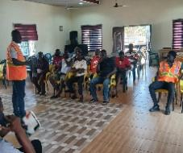 | On-going
 | Assessed and register disaster incidents and victims by the end of Dec. 2026. | Emergency planning and response ( Including Covid-19 recovery plan) | 2,000.00 | IGF | 1ST January 2026 | 31st March 2026 | 2,000.00 | 0.00 |  |  | On-going
 | Distribute relief items to disaster victims by the end of Dec. 2026. | Emergency planning and response ( Including Covid-19 recovery plan) | 2,000.00 | IGF | 1ST January 2026 | 31st March 2026 | 2,000.00 | 0.00 |  | 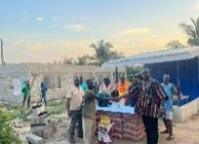  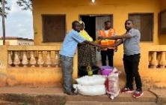 | On-going
 | Visits and sensitize Disaster Volunteer Groups in communities (DVGs) by the end of Dec. 2026. | Emergency planning and response ( Including Covid-19 recovery plan) | 2,000.00 | IGF | 1ST January 2026 | 31st March 2026 | 2,000.00 | 0.00 |  | 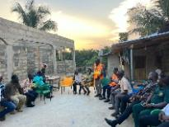 | On-going
 | Organize quarterly District Disaster Management Committee Meetings by the end of Dec. 2026. | Emergency planning and response ( Including Covid-19 recovery plan) | 2,000.00 | IGF | 1ST January 2026 | 31st March 2026 | 2,000.00 | 0.00 | 0% |  | Yet to start
 | Celebrate International disaster day by the end of Dec. 2026. | Emergency planning and response ( Including Covid-19 recovery plan) | 2,000.00 | IGF | 1ST January 2026 | 31st March 2026 | 2,000.00 | 0.00 | 0% |  | Yet to start
 | Prepare Disaster Management Plan (2026-2029) by the end of Dec. 2026. | Emergency planning and response ( Including Covid-19 recovery plan) | 2,000.00 | IGF | 1ST January 2026 | 31st March 2026 | 2,000.00 | 0.00 | 0% |  | Yet to start
 | Conduct 2 Patrols to inspect and educate filling station operators on safety and regulatory compliance by the end of Dec. 2026. | Emergency planning and response ( Including Covid-19 recovery plan) | 2,000.00 | IGF | 1ST January 2026 | 31st March 2026 | 2,000.00 | 0.00 | 0% |  | Yet to start
 | Plant and inspect economic trees (Neem tree, Oil Palm, Mango, Coconut, Orange, Moringa) by the end of Dec. 2026. | Emergency planning and response ( Including Covid-19 recovery plan) | 4,000.00 | IGF | 1ST January 2026 | 31st March 2026 | 4,000.00 | 0.00 | 0% |  | Yet to start
 | Organise sensitization on climate change and environmental protection and adopt to climate change activities by the end of Dec. 2026. | Emergency planning and response ( Including Covid-19 recovery plan) | 2,000.00 | IGF | 1ST January 2026 | 31st March 2026 | 2,000.00 | 0.00 | 0% |  | On-going
 | Organize Green Ghana Day by the end of Dec. 2026. | Emergency planning and response ( Including Covid-19 recovery plan) | 9,450.00 | IGF | 1ST January 2026 | 31st March 2026 | 9,450.00 | 0.00 | 0% |  | Yet to start
 | Organise Hazard Mapping by the end of Dec. 2026. | Emergency planning and response ( Including Covid-19 recovery plan) | 2,500.00 | IGF | 1ST January 2026 | 31st March 2026 | 2,500.00 | 0.00 | 0% |  | Yet to start
 | Conduct inspections and provide education at mining sites by the end of Dec. 2026. | Emergency planning and response ( Including Covid-19 recovery plan) | 4,000.00 | IGF | 1ST January 2026 | 31st March 2026 | 4,000.00 | 0.00 | 0% |  | Ongoing
ADMINISTRATION
 | Organize Statutory meetings (General Assembly, Executive Committee, Sub-Committee, Management Meetings) by the end of Dec. 2026. | Governance, Corruption And Social Accountability | 1,055,000.00 | IGF | 1ST January 2026 | 31st March 2026 | 1,055,000.00 | 0.00 | 25% | 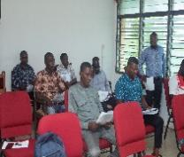 | On-going
 | Organize DCE’s engagement in selected communities by the end of Dec. 2026. | Governance, Corruption And Social Accountability | 108,000.00 | IGF | 1ST January 2026 | 31st March 2026 | 108,000.00 | 0.00 | 25% |  | On-going
 | Gazette and strengthen enforcement on Assembly By-laws by the end of Dec. 2026 | Governance, Corruption And Social Accountability | 11,500.00 | IGF | 1ST January 2026 | 31st March 2026 | 11,500.00 | 0.00 | 0% |  | Yet to start
 | Support NALAG activities by the end of Dec. 2026. | Governance, Corruption And Social Accountability | 71,831.64 | DACF | 1ST January 2026 | 31st March 2026 | 71,831.64 | 0.00 | 0% |  | Yet to start
 | Organise 40 No Area Council activities in the 4 Area Councils by the end of Dec. 2026. | Governance, Corruption And Social Accountability | 40,192.68 | IGF | 1ST January 2026 | 31st March 2026 | 40,192.68 | 0.00 | 0% |  | On-going
 | Strengthen Sub District Structures by the end of Dec. 2026. | Governance, Corruption And Social Accountability | 106,684.65 | IGF/DACF | 1ST January 2026 | 31st March 2026 | 106,684.65 | 0.00 | 0% |  | On-going
 | Recruit and train revenue collectors at the Area Council level by the end of Dec. 2026. | Governance, Corruption And Social Accountability | 10,000.00 | IGF | 1ST January 2026 | 31st March 2026 | 10,000.00 | 0.00 | 0% |  | Yet to start
NCCE
 | Sensitization on laws against tax evasion and non-compliance in support of revenue mobilization | Governance, Corruption And Social Accountability | 8,000.00 | IGF/DACF | 1ST January 2026 | 31st March 2026 | 8,000.00 | 0.00 | 25% | 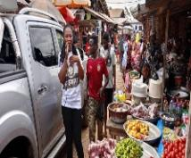 | On-going
 | Sensitization on Child Protection: Cyber-Bullying | Governance, Corruption And Social Accountability | 5,000.00 | IGF/DACF | 1ST January 2026 | 31st March 2026 | 5,000.00 | 0.00 | 25% | 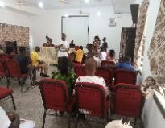 | On-going
 | Public awareness on Good Environment and Sanitation Practices | Governance, Corruption And Social Accountability | 9,000.00 | IGF/DACF | 1ST January 2026 | 31st March 2026 | 9,000.00 | 0.00 | 25% | 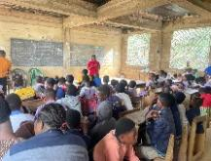 | On-going
CHRAJ
 | Organize forty (40) public education in schools, churches and other communities by the end of 2026 | Governance, Corruption And Social Accountability | 5,600.00 | IGF/DACF | 1ST January 2026 | 31st March 2026 | 1,900.00 | 1,500.00 | 25% | 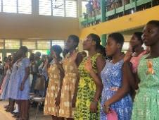 | On-going
INTERNAL AUDIT
 | Organize Public education to promote District Accountability and PFM by the end of Dec. 2026. | Governance, Corruption And Social Accountability | 20,000.00 | IGF | 1ST January 2026 | 31st March 2026 | 20,000.00 | 0.00 | 0% |  | Yet to start
 | Conduct Internal Auditing on (procurement, cash management, fixed asset management, stores management, building permit, contract/project management, monitoring and GIFMIS) by the end of Dec. 2026. | Governance, Corruption And Social Accountability | 20,000.00 | IGF | 1ST January 2026 | 31st March 2026 | 20,000.00 | 0.00 | 10% |  | On-going
 | Organize 4No. quarterly audit committee meetings by the end of Dec. 2026. | Governance, Corruption And Social Accountability | 70,000.00 | IGF | 1ST January 2026 | 31st March 2026 | 70,000.00 | 0.00 | 200% |  | On-going
 | Conduct monitoring and auditing of PWDs activities by the end of Dec. 2026. | Governance, Corruption And Social Accountability | 20,000.00 | IGF | 1ST January 2026 | 31st March 2026 | 20,000.00 | 0.00 | 0% |  | On-going
 | Prepare Annual Audit Plan for 2026. | Governance, Corruption And Social Accountability | 20,000.00 | IGF | 1ST January 2026 | 31st March 2026 | 20,000.00 | 0.00 | 0% |  | Yet to start
PROCUREMENT
 | Procure office furniture by the end of Dec. 2026 | Governance, Corruption And Social Accountability | 150,000.00 | IGF | 1ST January 2026 | 31st March 2026 | 150,000.00 | 0.00 | 0% |  | Yet to start
 | Procure furniture for schools by the end of Dec. 2026 | Governance, Corruption And Social Accountability | 1,853,475.13 | DACF | 1ST January 2026 | 31st March 2026 | 1,853,475.13 | 0.00 | 0% |  | Yet to start
 | Procure office supplies, consumable and materials by the end of Dec. 2026. | Governance, Corruption And Social Accountability | 250,000.00 | IGF | 1ST January 2026 | 31st March 2026 | 250,000.00 | 0.00 | 15% | 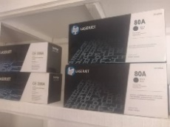 | On-going
 | Procure 5No. motorbikes for Environmental Health Unit, BAC Officers and registry by the end of Dec. 2026 | Governance, Corruption And Social Accountability | 300,000.00 | IGF | 1ST January 2026 | 31st March 2026 | 300,000.00 | 0.00 | 0% |  | Yet to start
 | Procure Laptops, Computers &Printers for Departments and Units by Dec. 2026. | Governance, Corruption And Social Accountability | 250,000.00 | IGF | 1ST January 2026 | 31st March 2026 | 250,000.00 | 0.00 | 0% |  | Yet to start
 | Procure Plants to Adausena CHPS compound by the end of Dec. 2026. | Governance, Corruption And Social Accountability | 50,000.00 | IGF | 1ST January 2026 | 31st March 2026 | 50,000.00 | 0.00 | 0% |  | Yet to start
 | Organise entity tender committee meeting by the end of Dec. 2026. | Governance, Corruption And Social Accountability | 50,000.00 | IGF | 1ST January 2026 | 31st March 2026 | 50,000.00 | 0.00 | 0% |  | Yet to start
HUMAN RESOURCE DEVELOPMENT
 | Organize Capacity building workshops for revenue collectors, staff, Assembly members and Security by the end of Dec. 2026. |  | 167,574.00 | DACF | 1st January 2026 | 31st March 2026 | 167,574.00 | 0.00 | 25% | 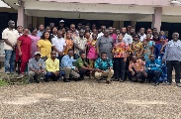 | On-going
DEVELOPMENT PLANNING
 | Organise 4no. quarterly DPCU meetings by the end of Dec. 2026. | Implementation, Co-ordinating Monitoring & Evaluation | 40,000.00 | IGF | 1ST January 2026 | 31st March 2026 | 0.00 | 0.00 | 25% | 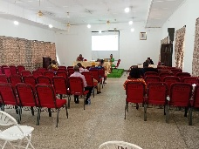 | On-going
 | Prepare quarterly and annual progress report by the end of Dec. 2026. | Implementation, Co-ordinating Monitoring & Evaluation | 40,000.00 | IGF | 1ST January 2026 | 31st March 2026 | 2,000.00 | 2,000.00 | 25% | 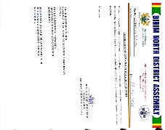 | On-going
 | Organize 2 no inter-sectoral meetings by the end of the second and third quarter 2026. | Implementation, Co-ordinating Monitoring & Evaluation | 35,000.00 | IGF | 1ST January 2026 | 31st March 2026 | 35,000.00 | 0.00 | 0% |  | Yet to start
 | Organize 2 No Town hall meetings by the end of the First and Third 2026. | Implementation, Co-ordinating Monitoring & Evaluation | 50,000.00 | IGF | 1ST January 2026 | 31st March 2026 | 50,000.00 | 0.00 | 0% |  | Yet to start
 | Organize quarterly Monitoring and evaluation activities by the end of Dec. 2026. | Implementation, Co-ordinating Monitoring & Evaluation | 150,000.00 | DACF | 1ST January 2026 | 31st March 2026 | 20,000.00 | 10,000.00 | 25% | 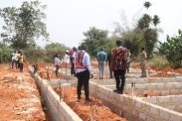 | On-going
 | Prepare Annual Action Plan and project Concept Note for 2027 by the end of Oct. 2026 | Implementation, Co-ordinating Monitoring & Evaluation | 30,000.00 | DACF | 1ST January 2026 | 31st March 2026 | 30,000.00 | 0.00 | 0% |  | Yet to Start
 | Undertake Social Audit and Support their activities by the end of Dec. 2026. | Implementation, Co-ordinating Monitoring & Evaluation | 20,000.00 | IGF | 1ST January 2026 | 31st March 2026 | 2,000.00 | 0.00 | 25% | 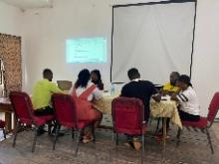 | On-going
 | Support to NACAP activities by the end of Dec. 2026. | Implementation, Co-ordinating Monitoring & Evaluation | 100,000.00 | IGF | 1ST January 2026 | 31st March 2026 | 100,000.00 | 0.00 | 0% |  | Yet to Start
 | Organize Mid-Year review on 2026 Annual Action Plan and Budget By July 2026. | Implementation, Co-ordinating Monitoring & Evaluation | 60,000.00 |  | 1ST January 2026 | 31st March 2026 | 60,000.00 | 0.00 | 0% |  | Yet to Start
BUDGETING
 | Preparation of Composite budget, fee fixing by the end of Dec. 2026. | Implementation, Co-ordinating Monitoring & Evaluation | 80,000.00 | IGF | 1ST January 2026 | 31st March 2026 | 70,440.00 | 70,440.00 | 25% |  | Yet to start
 | Prepare 2027 Revenue Improvement Action Plan. | Implementation, Co-ordinating Monitoring & Evaluation | 30,000.00 | IGF | 1ST January 2026 | 31st March 2026 | 29,600.00 | 29,600.00 | 25% |  | Yet to start
STATISTICS
 | Update and extend the scope of data hub in BNDA by the end of Dec. 2026. | Statistics, Planning, and Budgeting | 10,074.00 | IGF | 1ST January 2026 | 31st March 2026 | 10,074.00 | 0.00 | 0% |  | Yet to Start
 | Undertake monthly market reading on selected goods and services from designated markets Centers for the computation of CPI, PPI, and PI by GSS by the end of Dec. 2026. | Statistics, Planning, and Budgeting | 30,000.00 | DACF | 1ST January 2026 | 31st March 2026 | 30,000.00 | 0.00 | 25% |  | On-going
 | Collect Compile and analyzed administrative data / Conduct data validation and data cleaning on administrative data collected by the end of Dec. 2026. | Statistics, Planning, and Budgeting | 5,000.00 | DACF | 1ST January 2026 | 31st March 2026 | 5,000.00 | 0.00 | 25% |  | On-going
 | Collect and Compile data from departments and units to be uploaded to the District Data Development Platform (DDDP) by the end of Dec. 2026. | Statistics, Planning, and Budgeting | 5,000.00 | DACF | 1ST January 2026 | 31st March 2026 | 5,000.00 | 0.00 | 25% |  | On-going
 | Conduct Field Surveys and other relevant field work by the end of Dec. 2026 | Statistics, Planning, and Budgeting | 1,311.84 | DACF | 1ST January 2026 | 31st March 2026 | 1,311.84 | 0.00 | 25% |  | On-going
SECURITY
 | Support security operations in the District by the end of Dec. 2026. | Governance, Corruption And Social Accountability | 90,000.00 | DACF | 1ST January 2026 | 31st March 2026 | 90,000.00 | 0.00 | 25% |  | On-going
 | Procure Public address systems, radio space and gear for managing public order for Police and the Administration by the end of Dec. 2026. | Governance, Corruption And Social Accountability | 45,000.00 | IGF | 1ST January 2026 | 31st March 2026 | 0.00 | 0.00 | 0% |  | Yet To-Start
 | Organize Domestic violence awareness in schools/community outreach & health tips for GPS personnel by the end of Sept.2026. | Governance, Corruption And Social Accountability | 40,000.00 | IGF | 1ST January 2026 | 31st March 2026 | 40,000.00 | 0.00 | 25% |  | On-going

2.1.1 Update on Programmes Register (Non-Physical Programmes) for First Quarter 2026
The Birim North District Assembly implemented a number of non-physical programmes during the First Quarter of 2026 as part of its Annual Action Plan. These interventions were largely service-oriented and focused on improving governance, strengthening institutional capacity, enhancing revenue mobilization, promoting public health, supporting education delivery, and improving social protection systems within the District. The programmes were implemented using funds from IGF, DACF, GOG, and development partner support, and were carried out through coordinated efforts of the various departments and units of the Assembly.
Revenue Generation and Financial Management in the District
In the area of financial administration, the Assembly successfully implemented key revenue enhancement and financial management interventions. These included the development and implementation of the bill printing system to improve billing efficiency, public sensitization on e-billing and electronic payment systems to enhance compliance, upgrading of internet facilities to strengthen GIFMIS operations, and the organization of pay-your-levy campaigns. These activities contributed to improved revenue awareness, increased taxpayer compliance, and strengthened financial reporting systems within the Assembly.
Agricultural Development in the District
In the agricultural sector, although many planned activities were at preparatory stages, some institutional and coordination-related interventions were implemented, particularly those related to agricultural planning processes, extension service coordination, and capacity strengthening engagements. These activities supported ongoing efforts to improve agricultural service delivery systems and enhance coordination between the Department of Agriculture and farmers within the District.
Trade and Industry Development in the District
Within the Business Advisory Centre (BAC) and trade support services, implemented activities included business counselling and monitoring sessions for small and medium-scale enterprises, as well as targeted coaching and advisory services for entrepreneurs, particularly women and youth. These interventions strengthened enterprise performance, improved business management practices, and enhanced the sustainability of small businesses in the District.
Tourism Development in the District
Under tourism, proposals have been submitted to the Ghana Tourism Authority through the Eastern Regional Coordinating Council (ERCC) for onward consideration and engagement with prospective investors. These proposals seek to facilitate the development of key potential tourist sites within the district, including the Adjendua Waterfalls, the Noyem Natural Dam, and the confluence of the Abenasuo and Pra rivers.
The initiative aims to attract private sector participation to harness these natural assets, promote eco-tourism, and stimulate local economic development. Once developed, these sites are expected to create employment opportunities, improve livelihoods, and position the district as an emerging tourist destination within the region. Ongoing efforts are underway to ensure proper planning, sustainable management, and the provision of supporting infrastructure to enhance the viability of these projects.
Education Youth and Sports Development in the District
During the First Quarter of 2026, the Birim North District Assembly, through the Department of Education and other stakeholders, implemented several programmes and activities aimed at improving education delivery, youth empowerment, sports development, and student welfare within the district. These interventions were geared towards enhancing teaching and learning outcomes, promoting extracurricular development, improving adolescent health awareness, and encouraging active participation of students in educational and cultural activities.
One of the major interventions undertaken during the quarter was the distribution of twenty thousand (20,000) sanitary pads to schoolgirls across the district to support menstrual hygiene management and improve school attendance among adolescent girls. The intervention formed part of efforts to promote girl-child education, reduce absenteeism during menstrual periods, and enhance the confidence and wellbeing of female students within schools.
Figure 5: DISTRIBUTION OF 20,000 SANITARY PADS TO SUPPORT GIRL CHILD IN THE DISTRICT
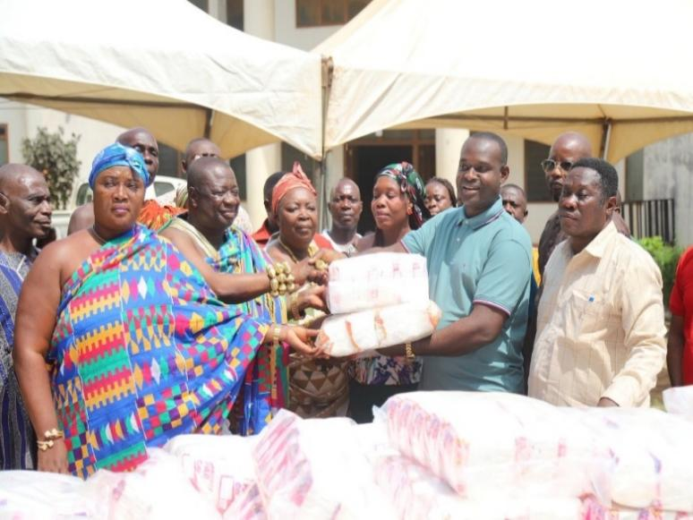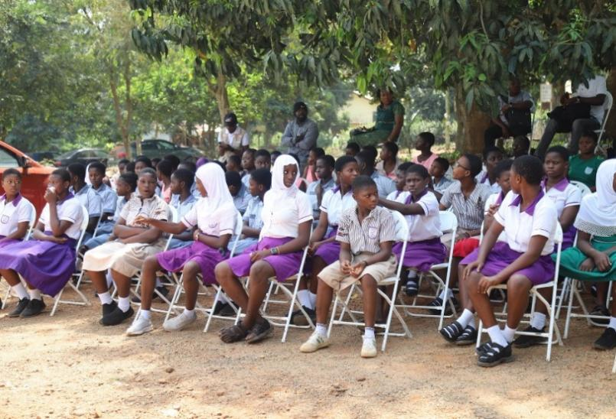
The Hon. District Chief Executive, Abdul Hakim Antwi, also supported education delivery in the district through the donation of computers to selected schools to enhance Information and Communication Technology (ICT) education and improve students’ access to digital learning opportunities. The intervention was aimed at promoting digital literacy and strengthening ICT teaching and learning within schools across the district.
Figure 6: DONATION OF COMPUTERS TO SELECTED SCHOOLS BY THE HON. DCE
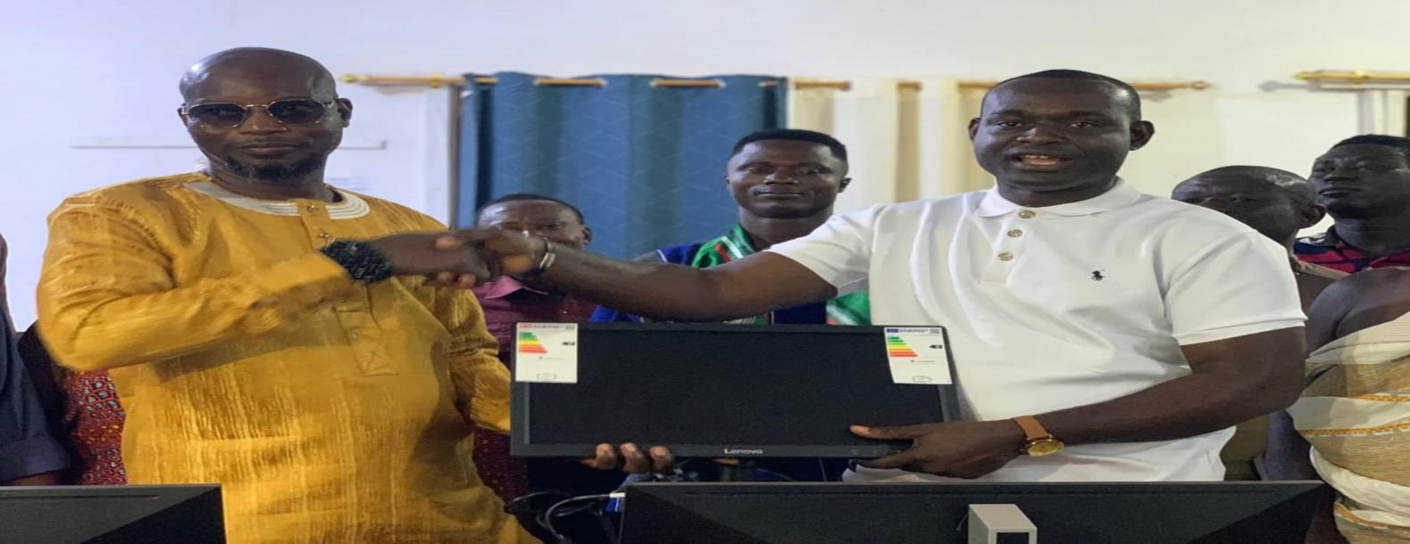
The district also intensified preparations towards the organization of the District Sports Festival as part of efforts to promote sports development and nurture young sporting talents within the district. During the reporting period, the district participated in the Under-13 (U-13) Zonal Sports Festival held at Mpraeso, where the district placed third (3rd) within the zone. This achievement reflects the continued commitment of the Assembly and the Ghana Education Service toward sports development and talent identification among school children.
Figure 7: PREPARATION FOR DISTRICT SPORT FESTIVAL IN THE DISTRICT
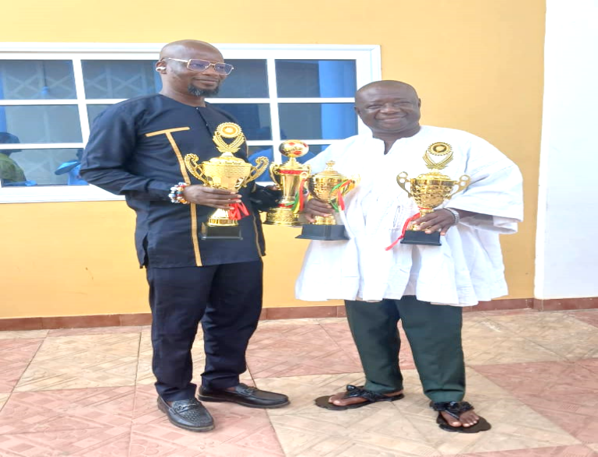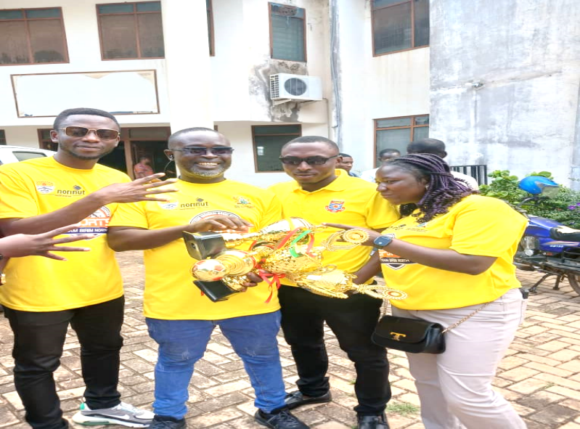
Cultural and educational activities were also organized during the quarter to promote creativity, cultural identity, and community participation in education. Schools within the district actively participated in Culture Day celebrations and educational festivals aimed at preserving Ghanaian cultural heritage and promoting social cohesion among students. In addition, “Read with the Community Day” and Culture Week activities were promoted to strengthen reading culture and community involvement in education delivery.
Figure 8: CULTURE DAY CELEBRATION BY A SCHOOL IN THE DISTRICT
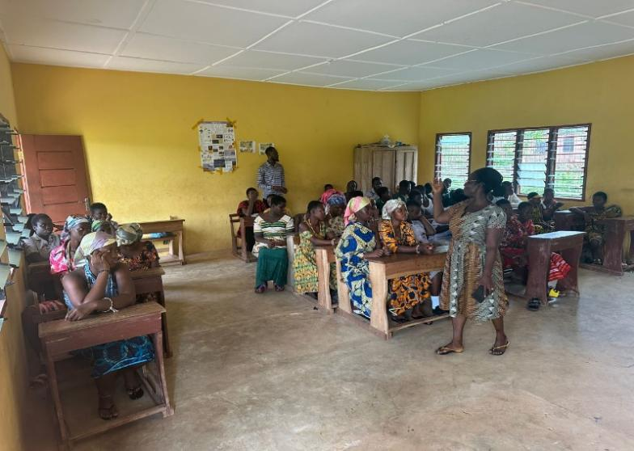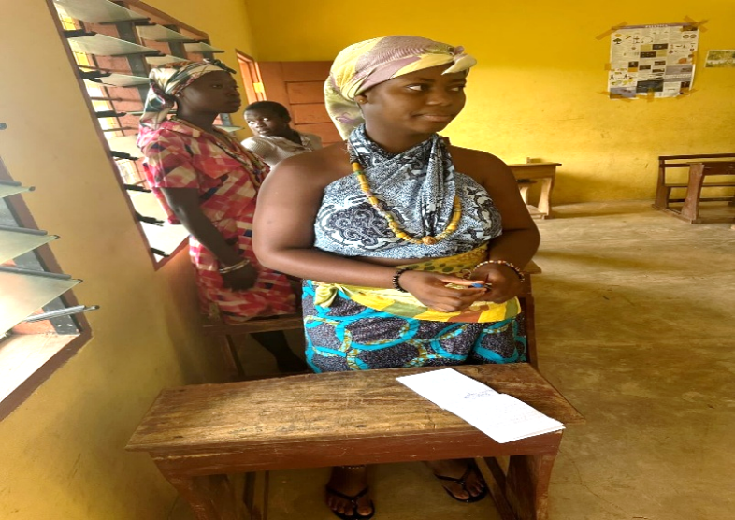
To improve teaching and learning outcomes, the District Education Directorate organized capacity-building programmes for Science and Mathematics teachers within the district. A total of twenty-eight (28) Science and Mathematics teachers from fourteen (14) selected schools benefitted from the training programme. The training sought to strengthen pedagogical skills, improve lesson delivery, and enhance student performance in Science, Technology, Engineering, and Mathematics (STEM)-related subjects.
Figure 9: CAPACITY –BUILDING SCIENCE AND MATHEMATICS TEACHERS IN THE DISTRICT
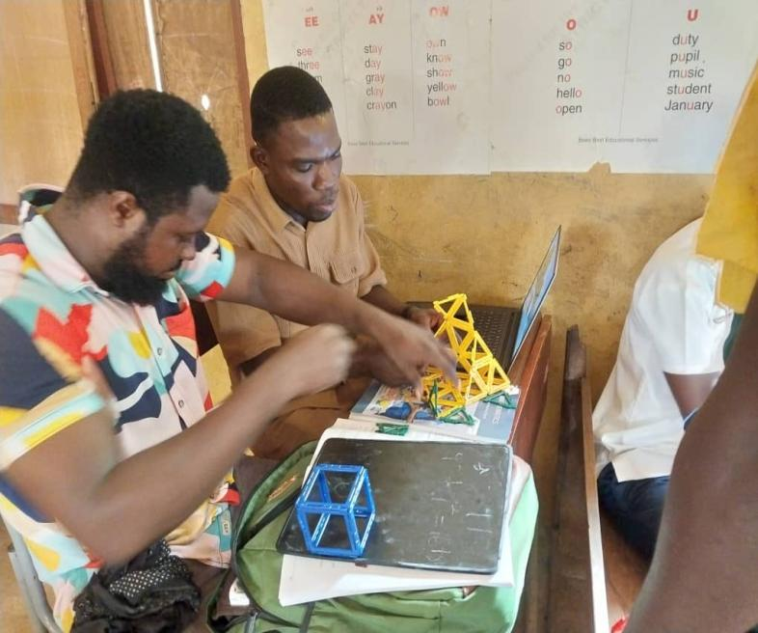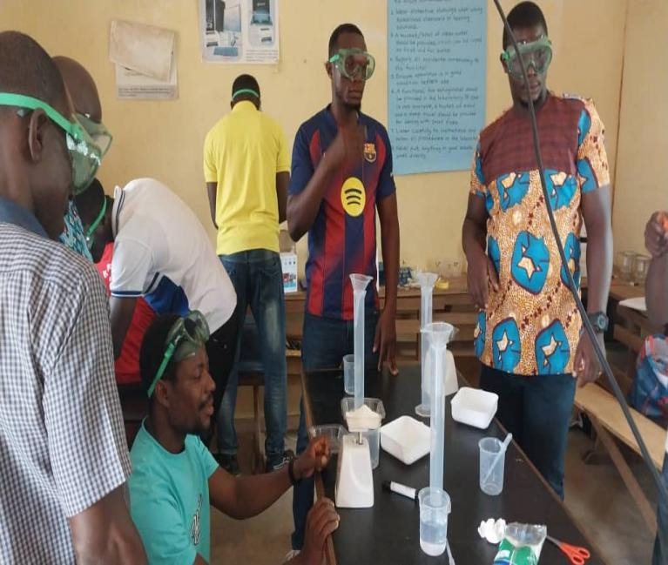
The district also organized Girls in STEM inter-schools quiz competitions to encourage female participation in science and technology education. The competition formed part of efforts to bridge the gender gap in STEM education and motivate girls to pursue careers in science and technology-related fields. Akoase Kissinger Baptist International School emerged as the winner of the competition. This initiative contributed significantly toward promoting innovation, confidence, and academic excellence among female students within the district.
Figure 10: GIRLS IN STEM INTER-SCHOOLS COMPETITION HELD IN THE DISTRICT
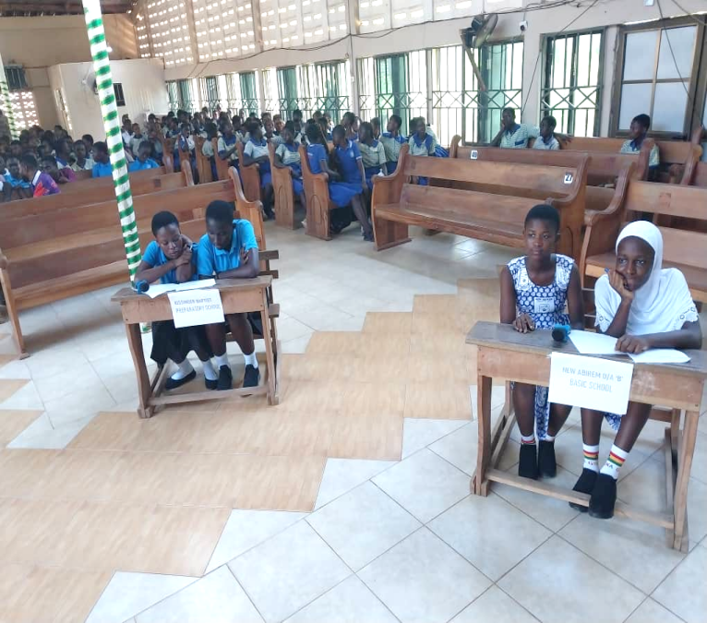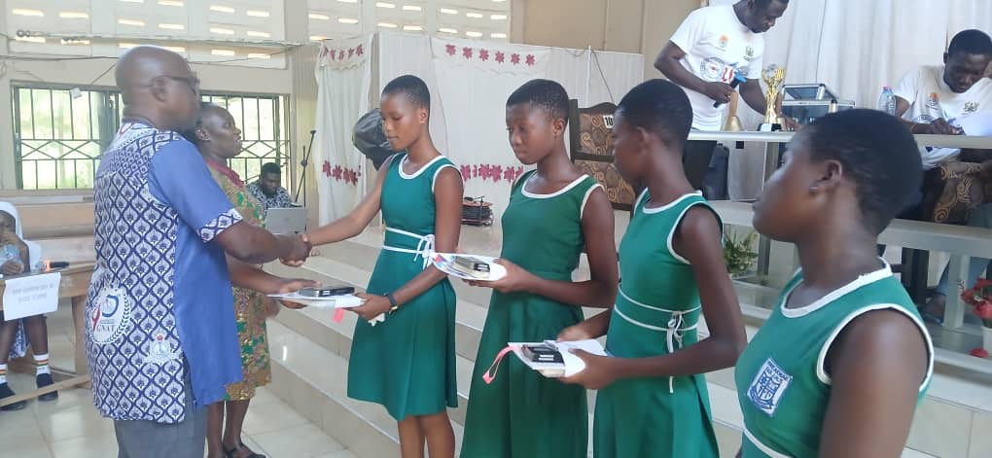
As part of efforts to promote technical and vocational education, sensitization programmes were organized for Junior High School students on Technical and Vocational Education and Training (TVET) opportunities by the Abirem Vocational Training Institute (AVTI). The programme aimed at educating students on vocational career pathways and encouraging interest in technical and skills-based education as a means of addressing unemployment and promoting self-employment among the youth.
Figure 11: SENSITIZATION OF JHS STUDENTS ON TVET PROGRAMMES BY AVTI
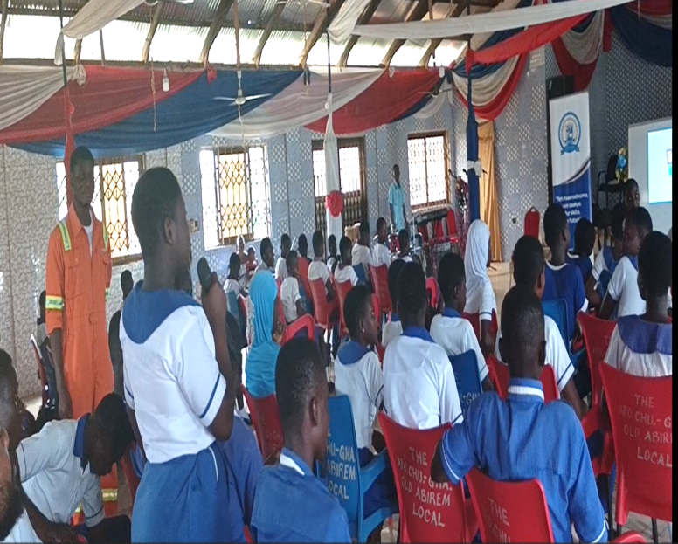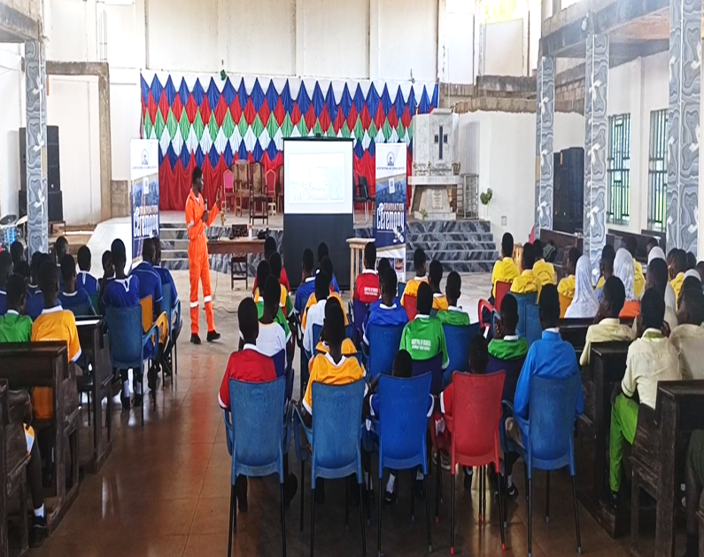
The Assembly, in collaboration with health officers and educational stakeholders, also conducted extensive sensitization and community engagement programmes targeting adolescents and the general population. These engagements focused on the risks associated with substance abuse, sexually transmitted infections, adolescent reproductive health, domestic violence, malaria prevention, and the promotion of condom use and home gardening among adolescent boys and girls. A little over thirty (30) schools and communities benefitted from these educational and health promotion engagements during the quarter. Adolescent clubs were also promoted in schools to encourage peer education and positive behavioural change among students.
In addition, School Performance Appraisal Meetings (SPAMs) and Annual District Education Review engagements were conducted during the reporting period to assess school performance, identify challenges affecting education delivery, and develop strategies to improve learning outcomes within the district. These review meetings also strengthened collaboration among education stakeholders and promoted accountability within the education sector.
The district also successfully organized the official Independence Day Celebration during the quarter as part of civic education and national identity promotion. The celebration provided students with the opportunity to participate in patriotic activities and deepen their understanding of national values, discipline, and citizenship responsibilities.
The education, youth, and sports development interventions implemented during the First Quarter of 2026 contributed significantly toward improving student welfare, strengthening teaching and learning, promoting sports and cultural development, and enhancing adolescent health awareness within the district. However, challenges such as inadequate educational infrastructure, limited logistics, and funding constraints continue to affect effective implementation of some educational programmes and activities. Continued investment and stakeholder collaboration will therefore be essential to sustain progress within the sector.
Health Service Delivery in the District
In the health sector, implemented programmes focused on preventive and promotive healthcare services. These included immunization outreach activities, health education on malaria prevention, adolescent health screening on non-communicable diseases, and family planning awareness creation. These interventions contributed to increased community awareness on disease prevention and improved access to essential health education services.
Environmental Health
The Environmental Health Unit also implemented key sanitation and hygiene-related programmes. These included Community-Led Total Sanitation (CLTS) sensitization activities, WASH education campaigns, inspections of public eating and drinking establishments, National Sanitation Day mobilization and participation, as well as targeted public health education on hygiene practices. These activities contributed to improved sanitation awareness and environmental health compliance within communities.
Figure 12: NATIONAL SANITATION DAY CLEAN-UP EXERCISE OBSERVED IN THE DISTRICT
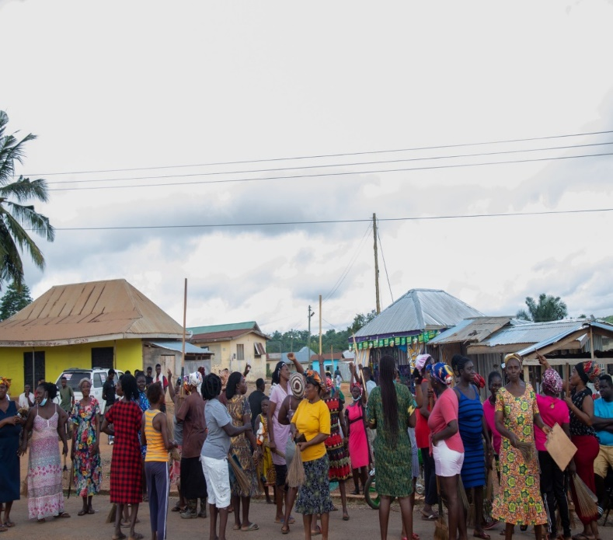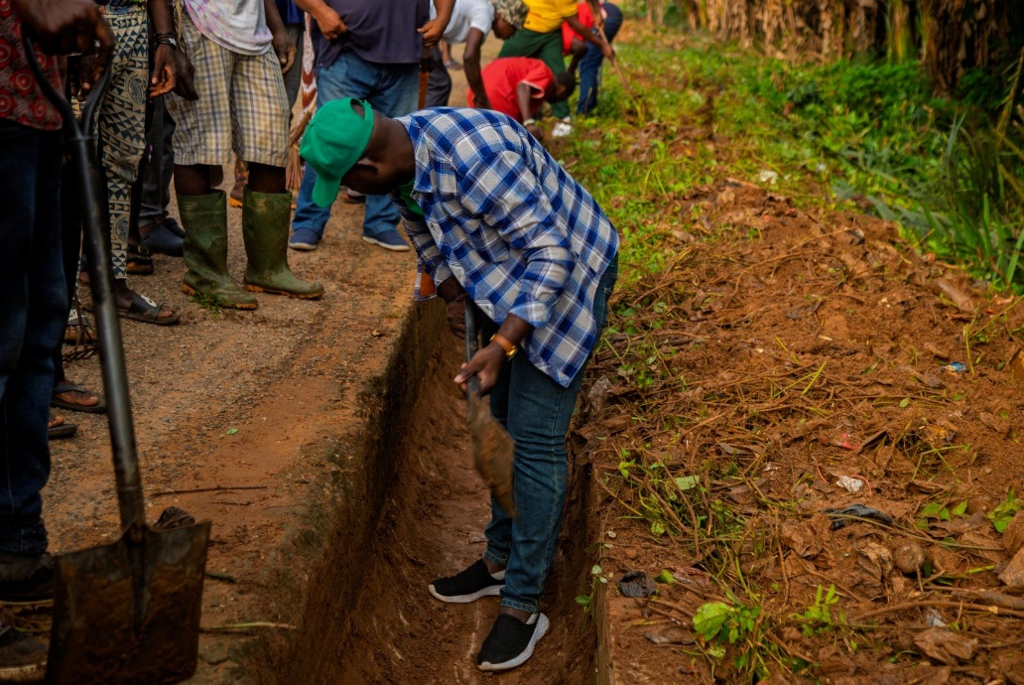
Figure 13: INAUGURATION OF E-WASTE MANAGEMENT COMMITTEE IN THE DISTRICT
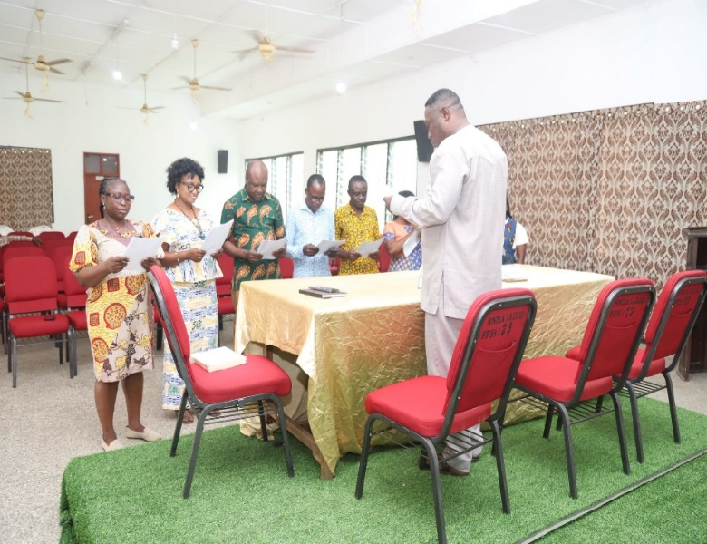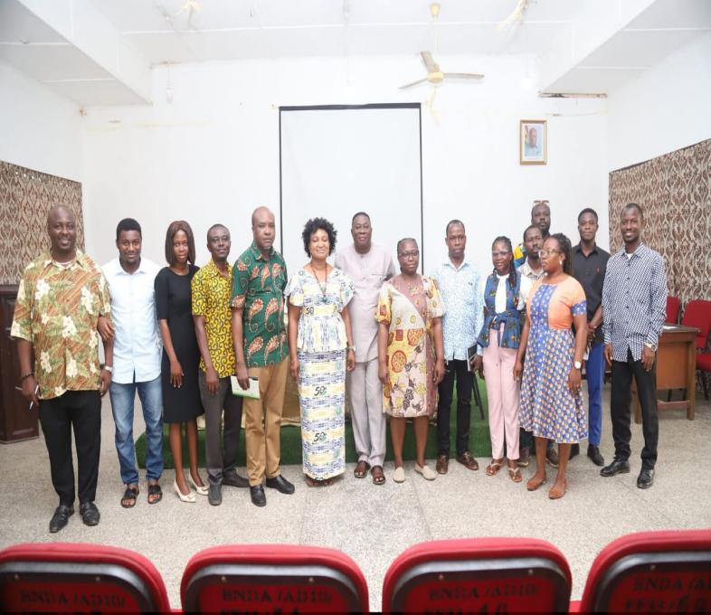
Social Protection in the District
In the area of Social Protection, the Assembly through the Department of Social Welfare and Community Development implemented several social protection and community welfare interventions aimed at supporting vulnerable groups and promoting social inclusion within the district. Key activities undertaken during the quarter included public education and sensitization on the LEAP reassessment programme through community engagements and media outreach on Ananse FM.
Figure 14: PUBLIC EDUCATION ON THE LEAP REASSESSMENT PROGRAMME ON ANANSE FM
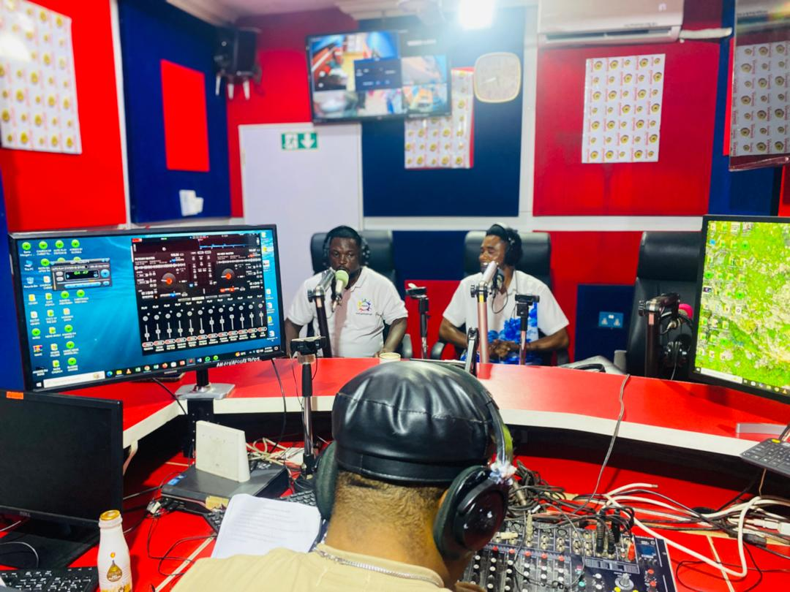
Also, sensitization programmes were organized within LEAP beneficiary communities to educate households on the reassessment exercise and ensure effective participation in the programme. The department also conducted validation exercises for prospective LEAP household beneficiaries to ensure that eligible vulnerable households were properly identified and enrolled onto the programme.
Figure 15: SENSITIZATION ON THE LEAP REASSESSMENT PROGRAMME IN THE DISTRICT
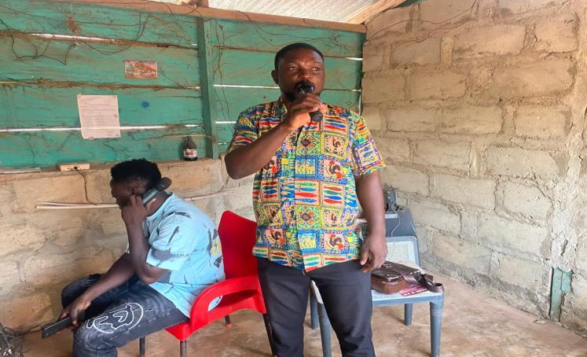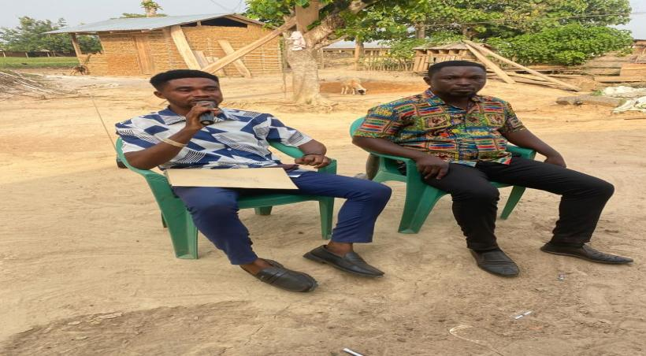
Figure 16: VALIDATION OF LEAP PROSPECTIVE HOUSEHOLD MEMBERS
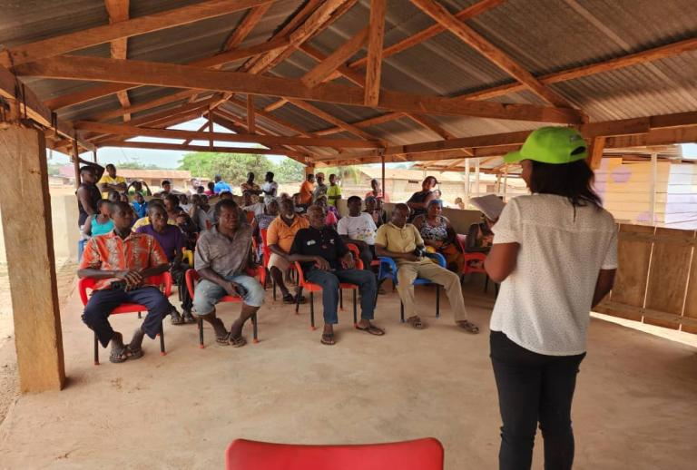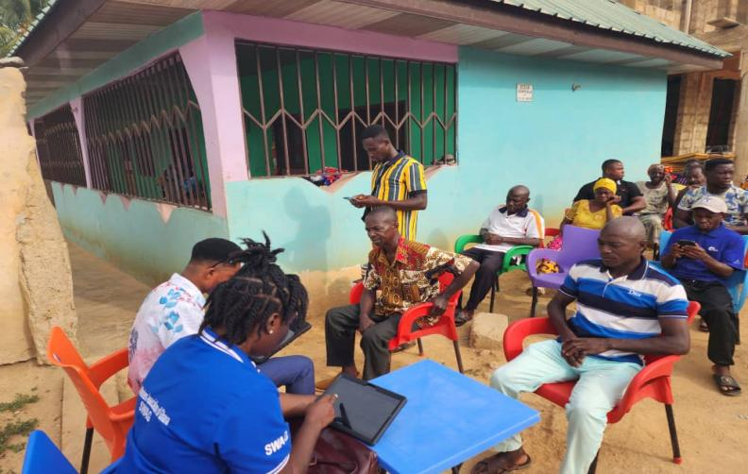
In addition, the Assembly monitored Persons with Disabilities (PWDs) who had previously received start-up kits under the Disability Common Fund support programme. The monitoring exercise was conducted from 10th to 11th March 2026 across communities including Amuana Praso, Akoase, Tenkyemso, Kyenkyenku, Mamanso, Old Abirem, and Praso Kuma. A total of fifteen (15) PWD beneficiaries comprising eight (8) males and seven (7) females were engaged to assess the progress and sustainability of their economic activities after receiving the support kits.
Figure 17: MONITORING OF PWD ACTIVITIES IN THE DISTRICT
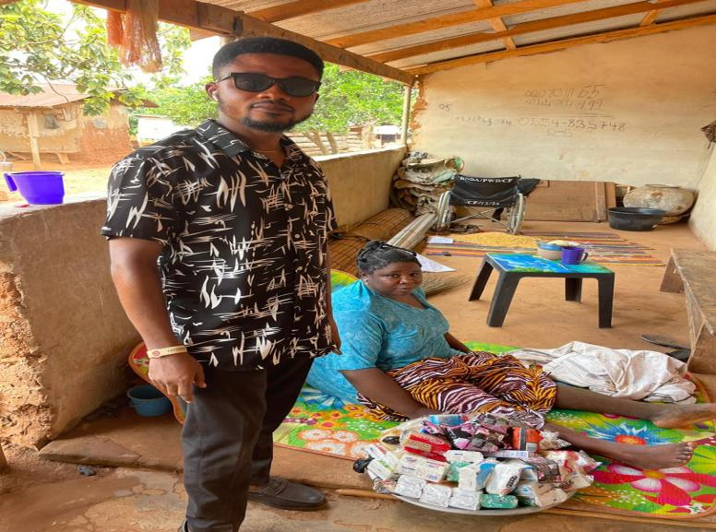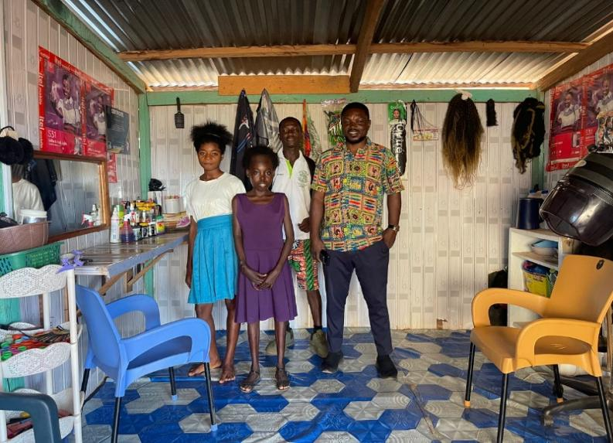
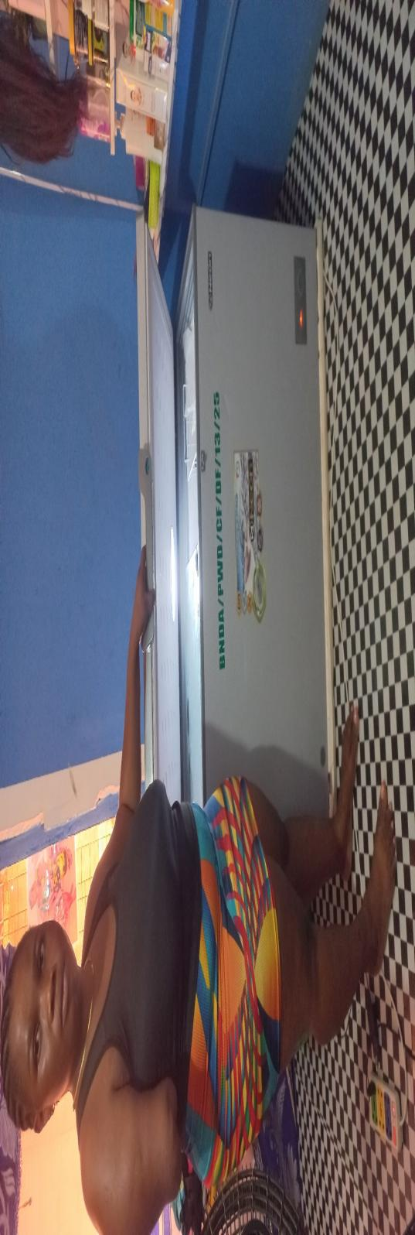
The Assembly also continued community sensitization and awareness creation on child protection, teenage pregnancy, domestic violence, gender-based violence, HIV/AIDS prevention, and social welfare counselling services during the reporting period. These interventions contributed toward improving public awareness, protecting vulnerable persons, and strengthening social welfare service delivery within the district.
Birth and Death Registration
The Birth and Death Registry carried out public education and sensitization activities on the importance of registration of births and deaths, as well as mobile registration outreach exercises to improve registration coverage within communities. These interventions enhanced public awareness and improved access to vital registration services.
Governance and institutional administration
In the area of Governance and Institutional Administration, the Birim North District Assembly strengthened administrative coordination and oversight through the implementation of statutory meetings, management sessions, sub-committee meetings, executive committee meetings, DPCU meetings, and Budget committee meetings. These platforms supported effective decision-making, improved inter-departmental collaboration, and enhanced overall institutional efficiency. Capacity-building programmes were also organized for staff and revenue collectors to improve performance and strengthen local revenue mobilization.
The quarter also featured key public and civic engagement activities, notably the celebration of Independence Day, which promoted patriotism, civic responsibility, and community participation in governance processes within the district.
Figure 18: CELEBRATION OF INDEPENDENCE DAY IN THE DISTRICT
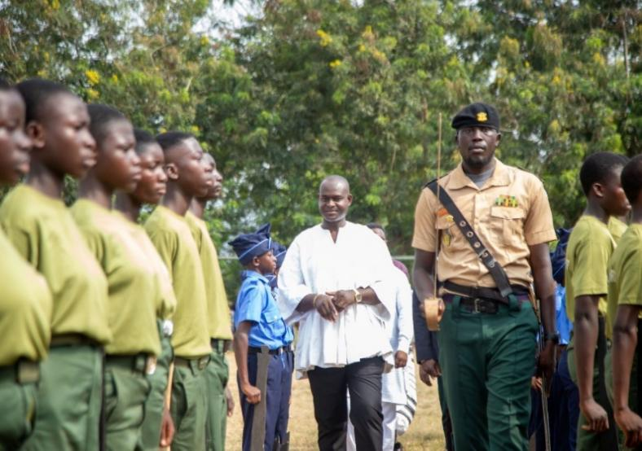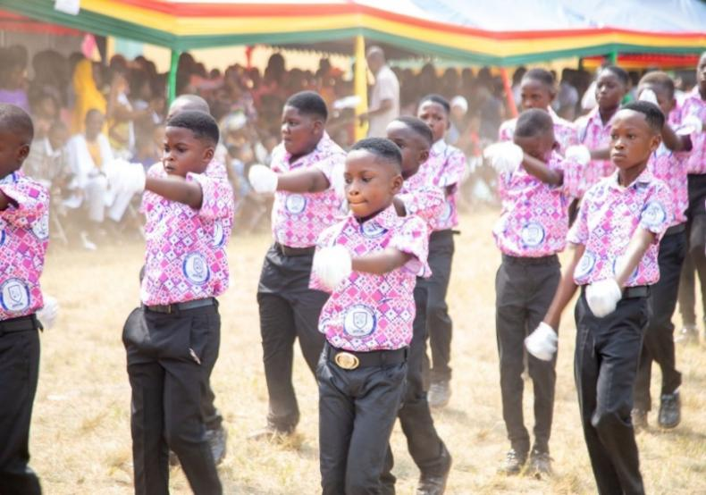
In addition, the district benefited from high-level monitoring and supervisory visits aimed at strengthening accountability and improving service delivery. The Head of the Local Government Service, Professor Lord Mensah, conducted a working visit to assess administrative performance and institutional effectiveness.
FIGURE 19: WORKING VISIT BY PROF. LORD MENSAH-HEAD OF LOCAL GOVERNMENT SERVICE
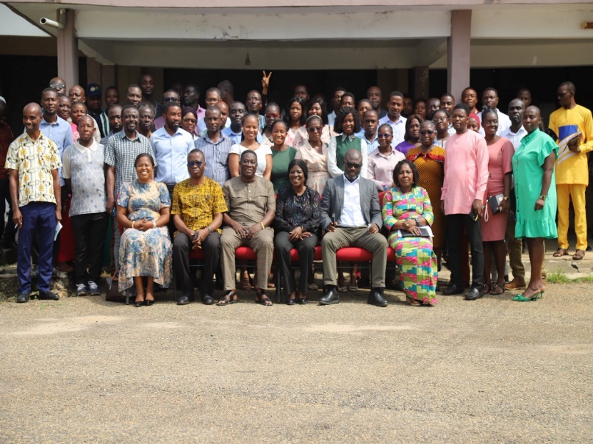
The Eastern Regional Minister, Hon. Rita Awatey, also undertook a monitoring visit focused on ongoing physical development projects to ensure quality, compliance, and timely execution.
Figure 20: WORKING VISIT/ MONITORING OF PROJECTS BY HON. RITA AWATEY- EASTERN REGIONAL MINISTER
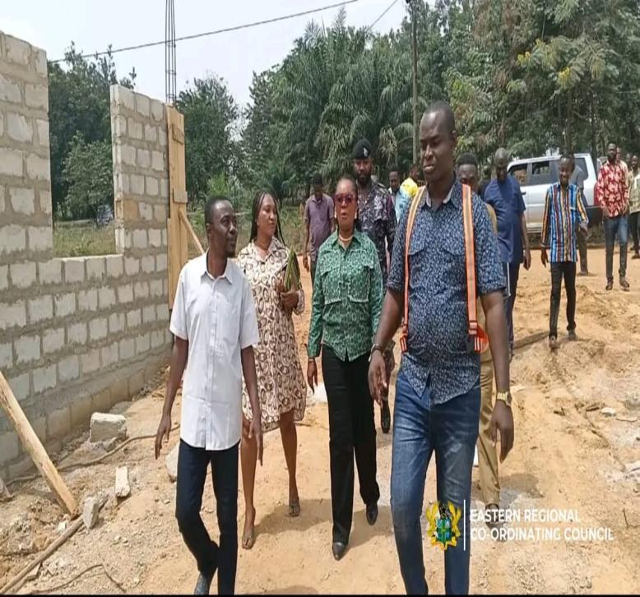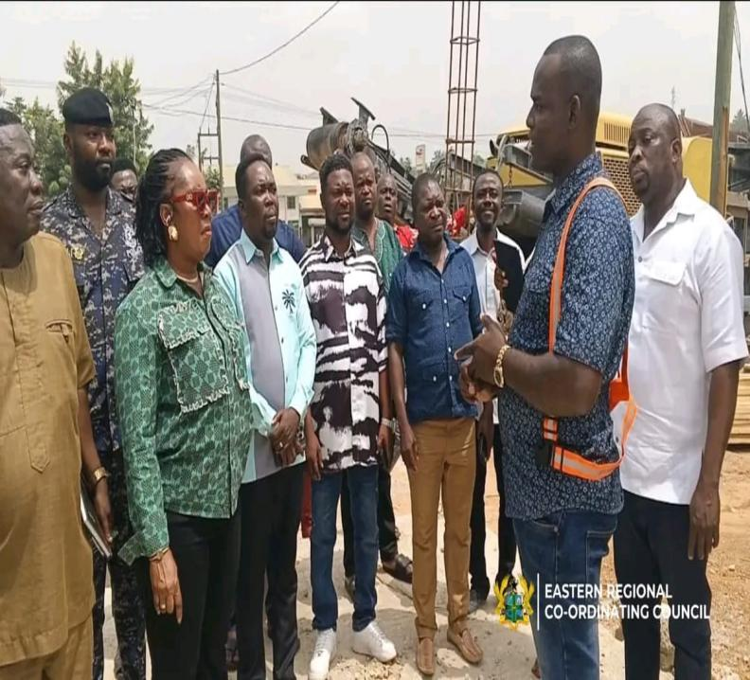
At the district level, internal monitoring of projects was led by the District Chief Executive, Hon. Abdul Hakim Antwi, who supervised various ongoing development interventions to ensure progress, transparency, and value for money.
Figure 21: INTERNAL MONITORING OF PROJECTS LED BY HON. ABDUL HAKIM ANTWI- DCE
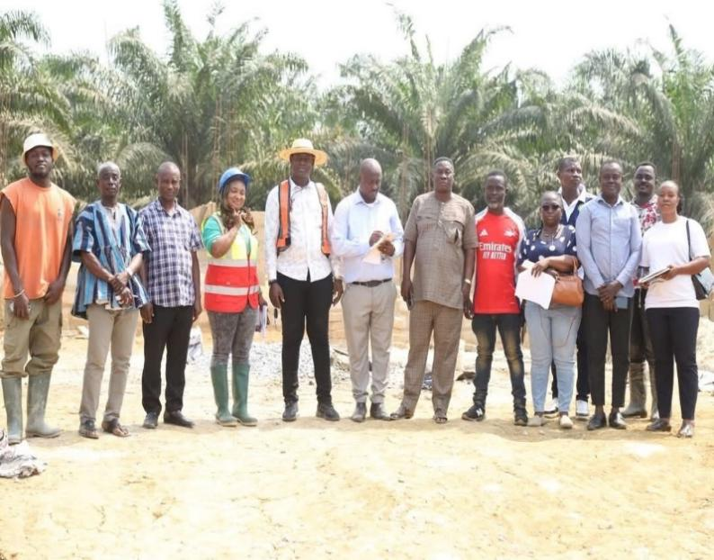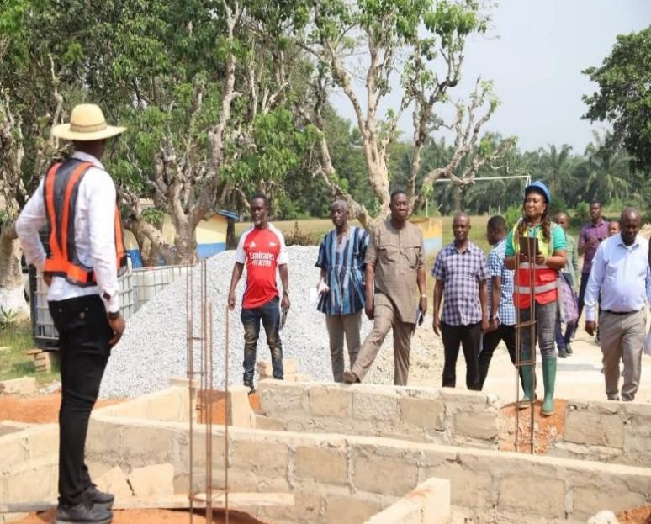
Disaster Management in the District
During the First Quarter of 2026, the National Disaster Management Organization (NADMO) Unit of the Birim North District Assembly implemented disaster prevention and public education activities aimed at improving disaster preparedness and community resilience within the district. Sensitization programmes were organized for Disaster Volunteer Groups (DVGs) and community members on flood prevention, bushfire control, safety protocols, and environmental risk management.
The Assembly also undertook community engagement and public education campaigns on proper waste disposal, prevention of indiscriminate burning, and other disaster prevention measures to reduce risks within vulnerable communities.
Figure 22: SENSITIZATION OF DISASTER VOLUNTEER GROUPS (DVGS) ON SAFETY PROTOCOLS
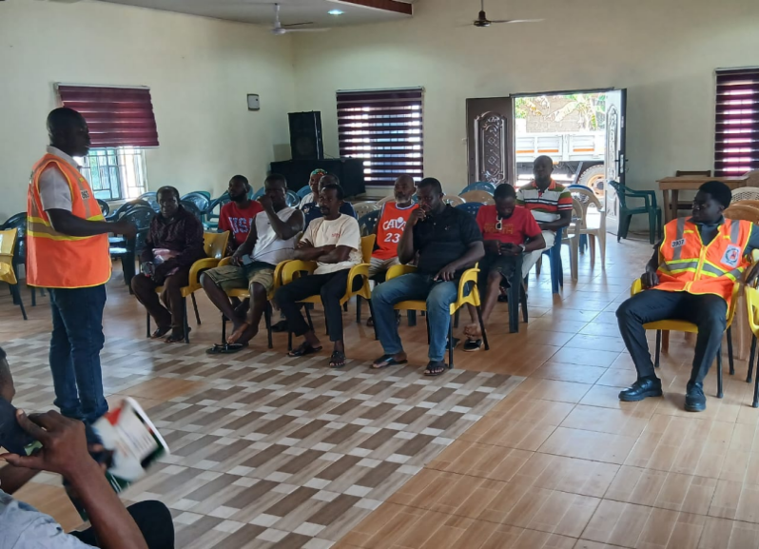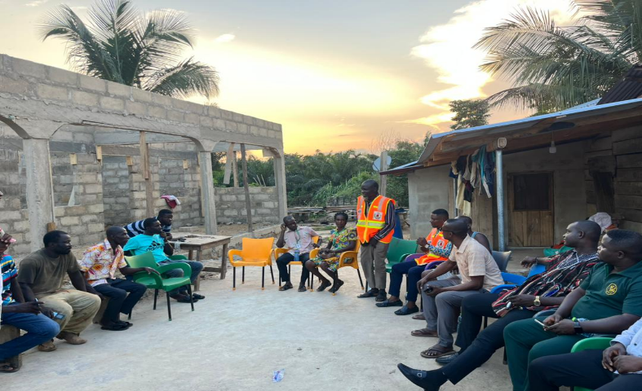
In addition, relief items were distributed to disaster victims within the district to support affected households. Items distributed included rice, maize, cooking oil, roofing sheets, rubber buckets, and rubber bowls.
Overall, the activities implemented during the quarter contributed toward strengthening disaster preparedness, improving public awareness, and enhancing emergency response mechanisms within the district.
Figure 23: DISTRIBUTION OF RELIEF ITEMS TO DISASTER VICTIMS IN THE DISTRICT
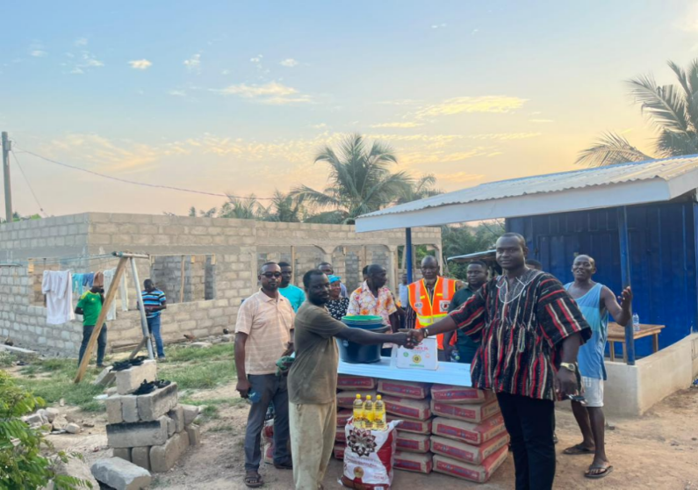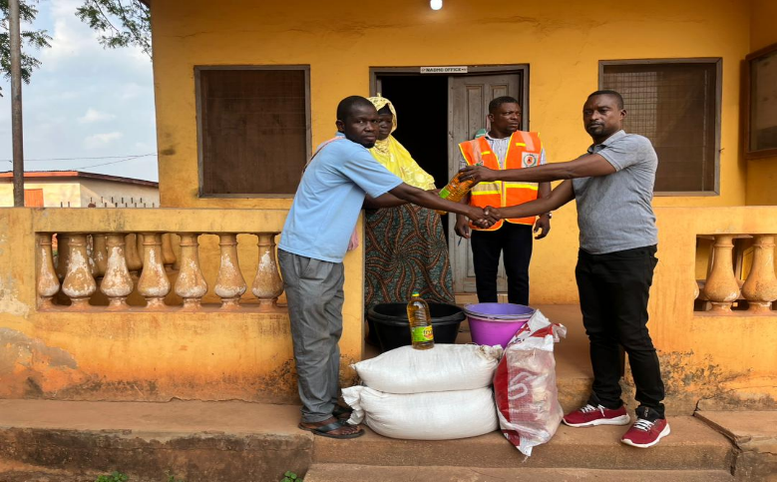
It is worth stating that, the First Quarter of 2026-recorded significant implementation of non-physical programmes across key sectors of the Birim North District Assembly. These interventions largely focused on improving institutional efficiency, enhancing public service delivery, strengthening community awareness, and promoting inclusive development. The successful implementation of these activities reflects the Assembly’s continued commitment to effective governance and sustainable district development.

2.1.2 Collaborations with NGOs, CBOs and Development Partners
During the First Quarter of 2026, the Birim North District Assembly strengthened collaboration with NGOs and development partners to address child protection and social welfare issues within the district. PDA Africa, in partnership with Yonkopa Cocoa, engaged the Department of Social Welfare and Community Development to conduct follow-up visits to cocoa farming communities to assess and address child labour cases among children assisting their parents during the cocoa season. The exercise involved direct engagement with affected farmers and children to identify challenges and possible interventions.
Figure 24: FOLLOW-UP VISITS TO COCOA FARMING COMMUNITIES
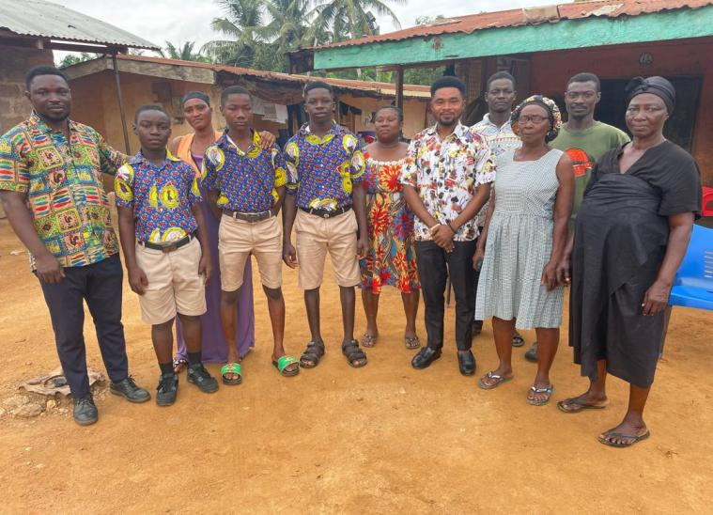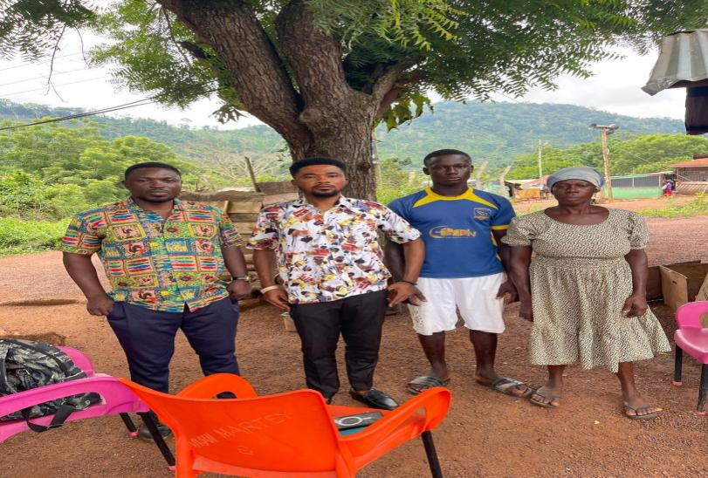
Additionally, the International Cocoa Initiative (ICI) organized a stakeholder meeting in the district to officially introduce its operations and planned interventions aimed at promoting sustainable cocoa farming and eliminating child labour. The meeting brought together key stakeholders including the District Assembly, Education Directorate, Health Directorate, Labour Department, CHRAJ, NCCE, DOVVSU, NHIS, traditional authorities, and other institutions to discuss collaborative approaches toward child protection and community development.
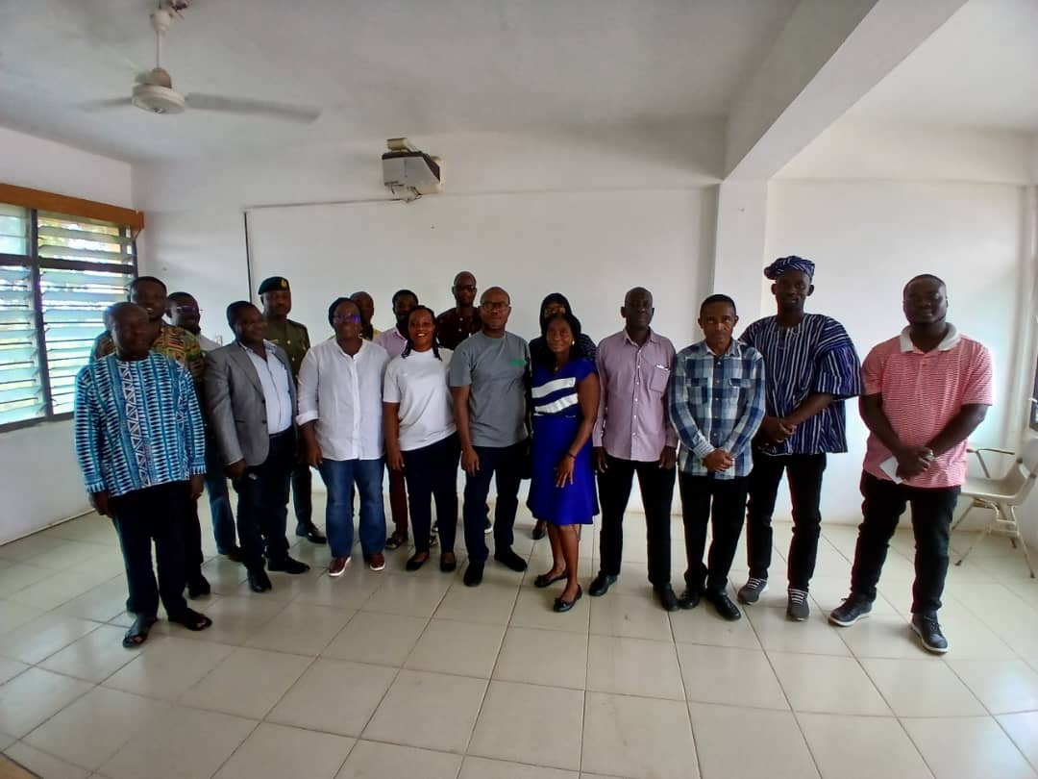
These collaborations contributed to strengthening stakeholder coordination, promoting child welfare, and supporting ongoing efforts to reduce child labour and improve social protection services within the district.

2.2 Update on Project Register for First Quarter 2026
The Project Register continues to serve as a vital management tool for tracking all development initiatives being implemented within the District. It functions as a comprehensive database that captures detailed information on both ongoing and completed projects, offering clear insights into their status, scope, and level of progress. Through systematic documentation, the register enhances the effectiveness of monitoring and evaluation across all sectors of development.
The projects included in the register span a broad spectrum of sectors including infrastructure, education, health, and local economic development thereby reinforcing transparency, accountability, and coordination in the implementation of the District’s Annual Action Plan (AAP). By recording project milestones, activities, and outcomes in a structured manner, the register enables the Assembly to make evidence-based decisions, prioritize resource allocation, and strengthen strategic planning processes.
As the central reference point for development activities, the Project Register ensures that implementation remains aligned with the District’s long-term objectives of sustainable growth, improved service delivery, and equitable distribution of interventions.
Table 4 below provides an updated summary of all projects under implementation as at the end of the First Quarter of 2026. The table outlines key project details, including Project Description, Development Dimension, Location, Contractor, Contract Sum, Source of Funding, Date of Award, Start Date, Expected Completion Date, Expenditure to Date, Outstanding Balance, and Current Implementation Status.
Table 4: Projects Register for First Quarter 2026
Project Description |  | Development Dimension |  | Location | Contractor | Contract Sum | Source Of Funding | Date of Award | Date Started | Expected Date of Completion | Expenditure to Date | OutStanding  Balance | Implementation Status |  | Remarks
 |  |  |  |  |  |  |  |  |  |  |  |  | % | Pictures | Remarks
CO  DE | Name
 | - Completion of 1No. Health Centre | Social development | Akoase |  | Gu-manuel Co. Limited | 375,311.97 | IGF | 28/06/22 | 05/07/22 | 22/09/22 | 356,546.37 | 18,765.60 | 100% | 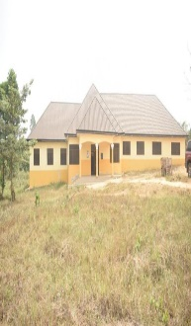 | Completed -Defect Liability Period
 | - Construction of 1No. CHPS Compound | Social development | Mpintimpi |  | Gu-manuel Co.Limited | 493,312.68 | IGF | 02/11/21 | 21/12/21 | 21/04/22 | 433,821.26 | 59,491.42 | 98% | 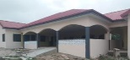 | Finishing
 | - Construction of 1No. 12-Seater W/C toilet with mechanized borehole | Social development | Amuana Praso |  | Ikeboa Co. Limited | 445,793.40 | DACF-RFG | 01/08/24 | 05/08/24 | 26/01/25 | 377,823.99 | 67,969.41 | 100% | 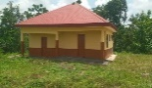 | Completed
 | - Construction of fence wall Landscaping and Furnishing of Adausena Library | Social development | Adausena/ Hweakwae |  | Markplant Enterprise | 549,914.40 | IGF | 01/08/24 | 05/08/24 | 31/12/24 | 320,000.00 | 229,914.4 | 80% | 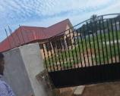 | On-going
 | - Construction of 1No. 6-Unit classroom block, office, store, staff common room, library and 4-Seater KVIP | Social development | Odontuase |  | M/S Guzuu Enterprise | 545,418.72 | IGF | 06/11/20 | 15/12/20 | 15/06/21 | 471,043.44 | 74,375.28 | 100% | 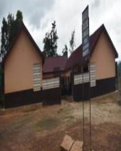 | Completed
 | - Construction of 1No.16-seater W/C toilet with 4No. Bathroom | Social development | New Abirem |  | M/S Jossam Ghana Ltd. | 418,315.17 | DACF | 28/07/22 | 22/08/22 | 26/01/23 | 62,747.28 | 175,567.89 | 75% | 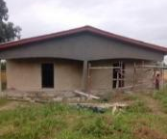 | On-going
 | - Construction of 16-Seater W/C toilet | Social development | Akoase St. Michael’s SHS |  | M/S IkeBoa Company Ltd. | 537,575.85 | IGF | 18/01/24 | 22/01/24 | 10/07/24 | 233,756.20 | 303.819.65 | 100% | 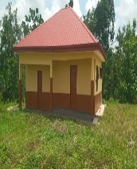 | On-going
 | - Pavement of lorry Park | Economic development | New Abirem |  | M/S Palm Tre0e Cont. Ltd. | 682,069.57 | DACF / IGF | 15/10/15 | 29/02/16 | 30/06/16 | 620,062.59 | 62,006.98 | 100% | 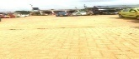 | Completed and in use
 | - Construction of 1No. 64 lockable stores | Economic development | New Abirem |  | Gu-manuel comp. Ltd. | 3,223,871.86 | DACF / IGF | 28/07/22 | 22/08/22 | 25/07/23 | 2,909,552.57 | 314,319.29 | 95% | 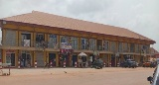 | On-going
 | - Construction of 1No. 8-Lockable Stores and Banking hall complex (phase I) | Economic development | New Abirem |  | IkeBoa Company Ltd. | 2,263,619.61 | IGF | 01/10/24 | 04/10/24 | 04/06/25 | 800,000.00 | 1,463,619.61 | 100% | 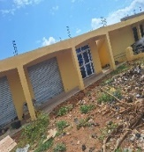 | On-going
 | - Construction of 16-Lockable Stores (Phase II) | Economic development | Afosu |  | IkeBoa Company Ltd. | 2,019,400.15 | IGF | 15/12/23 | 02/01/24 | 31/05/24 | 1,569,400.00 | 450,000.15 | 100% | 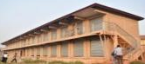 | Completed
 | - Construction of Sheds, Storeroom, Washroom, Chimney and connection of Electricity for Palm Oil Processing Group | Economic development | Okaikrom |  | M/S Markplant Enterprise | 547,960.00 | DACF-REG | 10/10/24 | 15/10/24 | 20/05/25 | 520,562.00 | 27,398 | 100% | 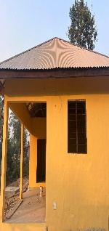 | On-going
 | - Completion of police quarters | Governance, corruption and public accountability | Akoase |  | Pro.Work.M Venture Ltd. | 179,668.00 | IGF | 02/11/21 | 21/12/21 | 03/02/22 | 64,223.10 | 15,444.90 | 75% | 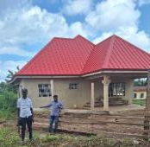 | On-going
NEW PROJECT
 | - Construction of 3-unit classroom block | Social development | Okaikrom |  | Ab-Sha Golden Ventures | 691,070.10 | IGF | 24/10/25 | 7/11/25 | 7/03/26 | 287,424.10 | 403,646.10 | 50% | 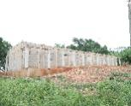 | On-going
 | - Construction of 1No 6-Unit Classroom Block, Offices, Stores and Library | Social development | Old Abirim |  | Mso Engineering Ltd | 1,273,348.23 | DACF | 24/10/25 | 7/11/25 | 7/05/26 | 625,624.59 | 647,723.34 | 65% | 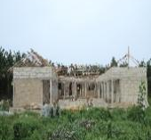 | On-going
 | - Construction of 2-unit classroom block | Social development | Kyenkyenku |  | Integra Engineering And Const. Gh. Ltd | 549,743.23 | DACF | 24/10/25 | 7/11/25 | 7/03/26 | 395,571.60 | 154,171.63 | 85% | 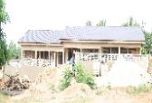 | On-going
 | - Construction of 3-unit classroom block, Office, Store and Library | Social development | Akoase Haya Islamic |  | Picanso Solution | 820,433.88 | DACF | 24/10/25 | 7/11/25 | 7/03/26 | 390,743.46 | 429,690.42 | 65% | 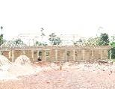 | On-going
 | - Construction of 1 No CHPS Compound | Social development | Nwinso |  | Simeslink Company Ltd | 1,232,407.45 | IGF | 24/10/25 | 7/11/25 | 7/05/26 | 426,139.04 | 806,268.41 | 65% | 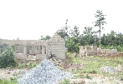 | On-going
 | - Repair and Maintenance of 20No Boreholes | Social development | Gambia, Praso-Kuma, Oseikrom, Amenam, Amoana Praso, Oworombra, Mamanso, Akwetey, Domeabra, Abenaso, Botwekrom, Kyenkyenku, Noyem, Hweakwea, Afosu, Nkwanteng |  | Ikeboa Company | 201,000.00 | DACF | 24/10/25 | 7/11/25 | 7/02/26 | 0.00 | 201,000.00 | 30% | 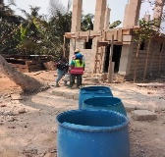 | On-going
 | - Drilling and Mechanization of 7 No. Limited Mechanized Boreholes | Social development | Kyenkyenku, Nyafoman, Kuntenase, Afosu Junior Quarters, Akoase Health Centre, Gambia & New Abirem Roundabout |  | Adwenpa Engineering Ltd | 1,235,395.35 | DACF | 24/10/25 | 7/11/25 | 7/02/26 | 1,117,738.65 | 117,656.70 | 90% | 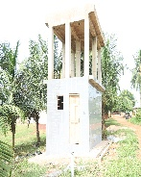 | On-going
 | - Drilling and Mechanization of 10 No. Boreholes fitted with Hand Pumps | Social development | Fasemkye, Asawase, Bramkrom, Abenaso No.2, Afosu Sika Woabuom, Old Abirem, Noyem, Adrobenso, Hweakwae, Tenkyemso |  | Ikeboa Company Ltd | 545,130.00 | DACF | 24/10/25 | 7/11/25 | 7/02/26 |  |  | 65% |  | On-going
 | - Construction of Office Complex for Fire Service, Immigration, Ambulance Service, NADMO & NIB | Governance, corruption and public accountability | New Abirem |  | Apeani Company Limited | 3,540,277.64 | DACF | 24/10/25 | 24/11/25 | 7/07/26 | 505,130.00 | 3,546,031.58 | 50% | 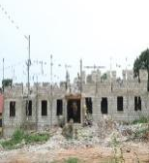 | On-going
 | - Pavement of the frontage of the 64-Lockable Sores at New Abirem | Economic Development | New Abirem |  | Ikeboa Company Ltd | 523,479.00 | IGF | 24/12/25 | 01/01/26 | 01/03/26 | 495,862.74 | 27,616.26 | 95% | 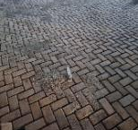 | On-going
 | - Construction of 1No CHPS Compound | Social development | Amenam |  | Gu-Manuel Company Limited | 970,794.00 | DACF | 24/12/25 | 01/01/26 | 01/05/26 | 0.00 | 970,794.00 | 65% | 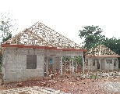 | On-going
 | - Provision of Network Booster to communities | Infrastrucuture Development | Odontuase  Akrofonso  Hweakwa  Domeabra  Nwinso  Okaikrom  Sakapia |  | DPCU | - | - | - | - | - | - | - | - |  | On-going
 | - Construction of CHPS Compound | Social development | Odontuase |  | M. Namsa Ventures | 984,089.00 | DACF | 24/12/25 | 01/01/26 | 01/05/26 | 688,365.42 | 295,723.58 | 50% | 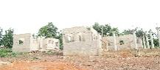 | On-going

2.2.1 Analysis of Physical Projects under Implementation as at First Quarter 2026
The Birim North District Assembly continued the implementation of its physical development projects under the 2026 Annual Action Plan and the broader 2026–2029 Medium-Term Development Framework. These projects represent the Assembly’s capital investment programme aimed at expanding infrastructure, improving service delivery, and strengthening socio-economic development across the District. The interventions cut across key sectors including education, health, water and sanitation, security, governance, and local economic development, and are financed mainly from Internally Generated Funds (IGF), the District Assemblies Common Fund (DACF), DACF-RFG, and other government sources.
As at the end of the First Quarter of 2026, a total of twenty-five (25) physical projects were at various stages of implementation. These projects include both ongoing developments inherited from previous periods and newly initiated projects under the current planning cycle. The implementation status reflects a mixed level of progress, with some projects fully completed, others at advanced stages of completion, and a number still at early implementation or mobilization stages.
Completed projects during the quarter include key infrastructure such as the Completion of 1No. Health Centre at Akoase, the Construction of a 12-Seater W/C Toilet with mechanized borehole at Amuana Praso, the Construction of a 6-Unit Classroom Block with ancillary facilities at Odontuase, and the Construction of 16-Lockable Stores at Afosu. These completed facilities are fully operational and are already contributing to improved health service delivery, educational access, sanitation, and local economic activities within their respective communities.
A significant proportion of ongoing projects are at advanced stages of completion and are expected to be finalized in subsequent quarters. Notable among these are the Construction of a CHPS Compound at Mpintimpi which is nearing completion, the Construction of 64 Lockable Stores at New Abirem, and the drilling and mechanization of boreholes across multiple communities, all of which have recorded substantial progress. Similarly, several classroom block projects in communities such as Okaikrom, Old Abirim, Kyenkyenku, and Akoase Haya Islamic are progressing steadily, with completion levels ranging from moderate to advanced stages. These interventions are expected to significantly improve access to basic education, potable water, and primary healthcare services upon completion.
In addition, a number of new projects initiated during the first quarter are currently at early stages of execution. These include the Construction of CHPS Compounds at Nwinso, Amenam, and Odontuase, the Construction of educational infrastructure such as classroom blocks at selected communities, and the Construction of an Office Complex to accommodate key security agencies in the District. These projects are currently undergoing mobilization and early construction activities and are expected to progress steadily in the subsequent quarters.
The overall implementation performance for the First Quarter of 2026 indicates a positive trend, with several projects either completed or nearing completion, while others are progressing according to contract schedules. The distribution of projects across sectors demonstrates the Assembly’s continued commitment to balanced development and equitable access to social and economic infrastructure.
Figure 25: STATUS OF IMPLEMENTATION OF PHYSICAL PROJECTS
However, the implementation process continues to face challenges such as funding release delays, contractor mobilization constraints, and logistical limitations, which occasionally affect project timelines. Strengthening contract management, improving monitoring systems, and ensuring timely disbursement of funds will be critical to sustaining implementation momentum.
The Quarter of 2026 reflects steady progress in the implementation of physical development projects within the Birim North District Assembly. The combination of completed, ongoing, and newly initiated projects demonstrates the Assembly’s commitment to infrastructure development and service delivery improvement. Continued coordination among stakeholders will be essential to ensure timely completion and maximize the developmental impact of these investments across the District.

2.3 Update on Disbursements from Funding Sources for First Quarter 2026
The Birim North District Assembly continues to finance its development programmes and administrative activities through a combination of internally generated revenue and external funding support. These funding sources include the Internally Generated Fund (IGF), Government of Ghana (GoG) transfers, the District Assemblies’ Common Fund (DACF), DACF–Responsive Factor Grant (DACF-RFG), Mineral Royalties, MP’s Common Fund, Persons with Disabilities Common Fund (PWDs CF), MSHAP, LEAP, and other donor or government-supported interventions.
The First Quarter of 2026 marked the commencement of the implementation of the Assembly’s 2026–2029 Medium-Term Development Plan (MTDP). As such, the financial inflows received during the quarter were critical in supporting the rollout of planned programmes, projects, and activities outlined under the new development framework. The funds received were utilized to support interventions aimed at improving socio-economic development, infrastructure delivery, social protection, health services, administrative efficiency, and overall service delivery across the district.
During the quarter under review, the Assembly received inflows from some of the identified funding sources to support the implementation of approved programmes and activities under the Annual Action Plan and Composite Budget. The major sources of inflows during the period were Internally Generated Funds (IGF), Government of Ghana Salary transfers, and Mineral Royalties. IGF recorded the highest contribution during the quarter, reflecting improved local revenue mobilization efforts and increased commitment toward strengthening the Assembly’s fiscal capacity. Government salary transfers also remained a stable source of funding for administrative and personnel-related expenditures, while Mineral Royalties continued to support development interventions due to sustained mining activities within the district.
Additional inflows were received from the MP’s Common Fund, MSHAP, and LEAP interventions, which supported constituency development projects and social intervention programmes aimed at improving the welfare of vulnerable groups within the district. However, major statutory funding sources such as the District Assemblies’ Common Fund (DACF), DACF-RFG, GOG Transfers, PWDs Common Fund, MP-SIP, and other grants did not record any disbursements during the quarter under review. The absence of these inflows, particularly DACF and DACF-RFG allocations, may affect the timely implementation of some planned programmes and capital projects if the delays persist into subsequent quarters.
The first-quarter funding inflows provided the Assembly with the financial foundation required to initiate the implementation of the 2026–2029 Medium-Term Development Plan. The strong performance of IGF during the quarter is particularly encouraging, as it demonstrates the Assembly’s growing efforts toward improving fiscal independence and strengthening local revenue generation. Nonetheless, the continued dependence on external transfers emphasizes the need for timely release of statutory funds and the diversification of revenue sources to ensure sustainable financing of development programmes throughout the plan period.
Details of the various funding sources and their corresponding receipts during the first quarter of 2026 are presented in Table 2.3. The information provides insight into the Assembly’s financial position during the reporting period and supports transparency, accountability, effective budget implementation, and informed decision-making in the management of public resources.

Table 5: Update on Funding Source for First Quarter 2026
UPDATE ON RECEIPT | BASELINE 2024 | TARGET 2025 | ACTUAL 2025 | TARGET 2026 | QUARTERLY PERFORMANCE
 |  |  |  |  | 1ST QUARTER
GOG SALARIES | 6,915,429.10 | 9,029,781.00 | 7,369,027.44 | 11,029,789.00 | 2,757,445.26
GOG TRANSFERS | 3,058,142.13 | 101,500.00 | 31,390.48 | 56,205.00 | 0.00
IGF | 9,137,591.38 | 8,822,567.42 | 4,835,892.97 | 4,149,419.78 | 3,536,049.63
MINERAL ROYALTIES | 4,802,637.53 | 1,000,037.38 | 1,014,523.23 | 5,773,547.46 | 1,192,546.26
DACF | 1,254,191.08 | 3,579,741.58 | 9,406,075.37 | 26,067,098.60 | 0.00
MP’s CF | 433,933.45 | 400,000.00 | 777,954.02 | 1,021,447.16 | 360,667.21
PWDs CF | 269,119.00 | 300,000.00 | 553,513.05 | 673,421.62 | 0.00
MSHAP | 6,659.64 | 20,000.00 | 39,724.9 | 112,236.94 | 247,000.00
DACF-RFG | 475,705.00 | 90,000.00 | 0.00 | 8,863,690.00 | 0.00
LEAP | 174,528.00 | 40,896.00 | 251,808 | 46,200.00 | 46,200.00
MP-SIP | 0.00 | 60,000.00 | 0.00 | 0.00 | 0.00
OTHERS (MAG) | 0.00 | 300,000.00 | 0.00 | 300,000.00 | 0.00
TOTAL | 26,527,936.31 | 14,714,742.38 | 24,279,909.35 | 58,093,055.56 | 8,139,908.36
Source: Finance Department, BNDA, New Abirem, April 2026
Figure 28: UPDATE ON REVENUE INFLOW OF THE ASSEMBLY

2.3.1 Analysis of the Assembly’s Revenue Inflows as of the First Quarter of 2026

The revenue performance of the Birim North District Assembly during the first quarter of 2026 indicates a moderate start toward achieving the Assembly’s annual revenue target. Out of the projected annual revenue target of GHS 58,093,055.56, the Assembly realized a total amount of GHS 8,139,908.36 during the quarter, representing approximately 14.0 percent of the expected annual receipts. The revenue inflows for the period were mainly driven by Internally Generated Funds (IGF), Government of Ghana (GOG) Salary transfers, and Mineral Royalties.
Internally Generated Funds (IGF) recorded the best performance among all revenue sources during the quarter, contributing GHS 3,536,049.63, which represents about 85.2 percent of the annual IGF target of GHS 4,149,419.78. This exceptional performance may be attributed to intensified revenue mobilization efforts by the Assembly, improved monitoring and supervision of revenue collectors, increased compliance among ratepayers, and the adoption of effective revenue collection strategies. The strong IGF performance demonstrates the Assembly’s growing capacity to mobilize local resources to support development activities and administrative operations.
Government of Ghana (GOG) Salaries also performed relatively well during the quarter, with receipts amounting to GHS 2,757,445.26, representing exactly 25.0 percent of the annual target of GHS 11,029,789.00. This performance is consistent with expectations since salary releases are generally regular and predictable on a quarterly basis. GOG Salary transfers therefore continue to provide a stable source of revenue for the Assembly’s recurrent expenditure, particularly staff compensation.
Mineral Royalties also recorded a commendable performance during the period under review. The Assembly received GHS 1,192,546.26, representing approximately 20.7 percent of the annual target of GHS 5,773,547.46. The relatively strong performance of mineral royalties may be linked to sustained mining activities within the district and timely disbursement of royalty allocations from the relevant authorities. This highlights the significant role of the mining sector in supporting the Assembly’s local economic development and revenue generation efforts.
The MP’s Common Fund equally showed moderate performance by recording GHS 360,667.21, representing about 35.3 percent of its annual target of GHS 1,021,447.16. Additionally, the Maternal and Child Health and Nutrition Improvement Project (MSHAP) exceeded its annual target significantly by recording GHS 247,000.00 against an annual target of GHS 112,236.94. This performance suggests increased support and disbursement under the programme during the quarter. Similarly, LEAP achieved 100 percent of its annual target with receipts amounting to GHS 46,200.00 during the first quarter.
Despite these positive performances, several key revenue sources performed poorly during the quarter. The District Assemblies Common Fund (DACF), DACF-RFG, GOG Transfers, PWDs Common Fund, MP-SIP, and Other Grants (MAG) recorded no inflows during the period under review. The poor performance of these funding sources may largely be attributed to delays in the release of statutory transfers and central government disbursements. The absence of DACF and DACF-RFG inflows in particular could negatively affect the implementation of capital projects and planned development interventions if the delays continue into subsequent quarters.
Overall, the first-quarter revenue performance reveals that the Assembly’s strongest-performing areas were IGF, MSHAP, LEAP, and Mineral Royalties, mainly due to improved local revenue mobilization, regular programme disbursements, and sustained mining activities within the district. However, the continued dependence on external transfers remains a challenge, especially where delays in statutory fund releases affect project implementation and service delivery.
Going forward, the Assembly should sustain its strong IGF mobilization strategies by intensifying public education, strengthening enforcement measures, improving revenue monitoring systems, and adopting innovative digital revenue collection mechanisms. Additionally, management should continue engaging relevant central government institutions to facilitate the timely release of statutory funds to ensure smooth implementation of programmes and projects during the remaining quarters of the 2026 fiscal year.

2.4 Update on Expenditure for First Quarter 2026
During the reporting period, the Assembly’s expenditures were classified into three main categories: employee compensation, covering both internal staff and contracted personnel; Goods and Services; and Assets and Investments. Funds from various sources were strategically deployed to support ongoing initiatives, new projects, and service delivery programs, in line with the priorities outlined in the Annual Action Plan and Budget.
Significant allocations were directed towards fulfilling employee compensation obligations, procuring essential goods and services, and financing strategic investments aimed at improving development outcomes across the district. These expenditures demonstrate the Assembly’s commitment to efficient and transparent resource utilization, ensuring that financial provisions are focused on priority sectors and programs.
Table 2.4 and Figure 2.4 provide a comprehensive overview of the Assembly’s expenditure during the reporting period, illustrating the distribution of resources across the three primary categories and highlighting trends in financial management and allocation priorities.
Table 6: Update on Expenditure for First Quarter 2026
EXPENDITURE | BASELINE 2024 | TARGET 2025 | ACTUAL 2025 | TARGET 2026 | QUARTERLY PERFORMANCE
 |  |  |  |  | 1ST QUARTER
GOG & IGF COMPENSATION | 7,345,132.07 | 9,071,939.06 | 7,716.575.77 | 11,589,270.20 | 2,828,077.54
GOODS AND SERVICE | 6,893,111.34 | 7,980,666.00 | 3,3962,864.00 | 20,551,710.09 | 2,976,875.86
ASSETS/INVESTMENTS | 7,449,370.05 | 5,056,696.00 | 1,187.982.40 | 26,560,362.91 | 5,334,017.77
TOTAL | 21,313,233.67 | 22,109,301.06 | 33,962,864 | 58,701,343.20 | 11,138,971.17
Source: Finance Department, BNDA, New Abirem, January, 2026

2.4.1 Analysis of Expenditure Performance – First Quarter 2026
During the first quarter of 2026, the Birim North District Assembly incurred a total expenditure of GHS 11,138,971.17 against an annual expenditure target of GHS 58,701,343.20, representing approximately 19.0 percent of the projected annual expenditure. The expenditure pattern during the quarter reflects the Assembly’s commitment toward meeting recurrent obligations while simultaneously investing in infrastructure development and service delivery improvement.
Expenditure on Assets and Investments recorded the highest performance during the quarter, amounting to GHS 5,334,017.77, which accounted for approximately 47.9 percent of total expenditure for the period. This expenditure also represents about 20.1 percent of the annual target for Assets and Investments. The strong performance under this expenditure category may be attributed to the commencement and ongoing execution of capital projects, rehabilitation works, and other development interventions across the district. The Assembly’s decision to prioritize capital expenditure during the quarter demonstrates its commitment toward improving infrastructure, enhancing service delivery, and addressing the developmental needs of communities within the district.
Expenditure on Goods and Services also performed strongly during the quarter, recording GHS 2,976,875.86, representing approximately 26.7 percent of total expenditure and about 14.5 percent of the annual target. This expenditure supported routine administrative operations, monitoring and evaluation activities, maintenance works, official travels, capacity-building programmes, and other operational activities necessary for the effective functioning of the Assembly. The relatively high expenditure under Goods and Services may further be attributed to increased operational activities and implementation of programmes outlined in the Assembly’s annual action plan during the quarter.
Similarly, expenditure on GoG and IGF Compensation amounted to GHS 2,828,077.54, accounting for approximately 25.4 percent of total expenditure during the first quarter and about 24.4 percent of the annual compensation target. This category covered salaries, wages, allowances, and other staff-related compensation costs. The stable performance of compensation expenditure reflects the Assembly’s continued commitment to meeting its obligations toward staff remuneration and maintaining administrative efficiency.
Among the three expenditure categories, Assets and Investments emerged as the best-performing expenditure area during the quarter due to the significant level of capital spending recorded. This strong performance was mainly driven by the Assembly’s focus on project implementation and infrastructure development activities. Compensation expenditure also performed steadily because salary payments are regular and predictable, while Goods and Services recorded moderate to high performance due to increased administrative and operational demands during the quarter.
Overall, the expenditure pattern for the first quarter of 2026 indicates a balanced approach between recurrent expenditure and development-oriented spending. The significant allocation toward Assets and Investments is encouraging, as it demonstrates the Assembly’s commitment to developmental projects and long-term service delivery improvement. However, the heavy concentration of expenditure on capital projects also highlights the need for effective monitoring, procurement efficiency, and prudent financial management to ensure value for money and timely completion of projects.
Going forward, the Assembly should continue strengthening expenditure control mechanisms, improve budget implementation monitoring, and ensure timely release and utilization of funds to support both recurrent and capital expenditure activities. In addition, management should prioritize efficient cash flow planning and expenditure tracking to sustain balanced fiscal performance throughout the remaining quarters of the 2026 financial year.

2.5. Update on National Core Indicators and Targets
This section presents an assessment of the District’s performance against the National Core Indicators and set targets for the reporting period. It provides an overview of progress made in the implementation of key development interventions, highlighting achievements recorded as well as challenges encountered across priority sectors.
The analysis focuses on critical development areas such as infrastructure delivery, social service provision, revenue mobilization, health, education, and social protection programmes. It further examines how available financial and human resources were utilized to support the District’s development priorities during the period under review. This provides a clear picture of implementation efficiency and service delivery performance.
In addition, the section identifies key gaps and constraints that affected the attainment of set targets, thereby drawing attention to areas that require strategic intervention and improved resource allocation. It also highlights sectors where performance was relatively strong, offering insights into good practices that can be sustained and scaled up.
The updated National Core Indicators provide a comprehensive measure of the District’s development performance, particularly in relation to economic growth, employment creation, enterprise development, and access to essential social services. The findings serve as an important tool for evidence-based planning, informed decision-making, and performance tracking, while ensuring alignment with national development priorities and policy objectives.

Table 7: Update on District Performance Indicators and Targets as at First Quarter 2026
S/N | Indicator (Categorised by Development Dimension |  | BASE LINE 2022 | Actual  2023 | Actual 2024 | Actual 2025 | TARGET 2026 | ACTUAL 1ST QTR 2026
 | Economic Development
 | Total output in agricultural production | - Maize | 3.0 | 1.9 | 1.97 | 1.98 | 2.0 | N/A
 | Total output in agricultural production | - Rice (milled), | 3.2 | 3.4 | 3.6 | 3.9 | 3.8 | N/A
 | Total output in agricultural production | - Millet | N/A | N/A | N/A | N/A | N/A | N/A
 | Total output in agricultural production | - Sorghum | N/A | N/A | N/A | N/A | N/A | N/A
 | Total output in agricultural production | - Cassava | 21.1 | 22.4 | N/A | N/A | 22.5 | N/A
 | Total output in agricultural production | - Yam | 12.3 | 8 | 0 | 8.4 | N/A | N/A
 | Total output in agricultural production | - Cocoyam | 12.3 | 11.1 | 0 | N/A | 8 | N/A
 | Total output in agricultural production | - Plantain | 15.4 | 11.1 | 12.2 | 12.89 | 11.5 | N/A
 | Total output in agricultural production | - Groundnut | N/A | N/A | N/A | N/A | N/A | N/A
 | Total output in agricultural production | - Cowpea | N/A | N/A | N/A | N/A | N/A | N/A
 | Total output in agricultural production | - Soybean | N/A | N/A | N/A | N/A | N/A | N/A
 | Total output in agricultural production | - Cocoa | N/A | N/A | N/A | N/A | N/A | N/A
 | Total output in agricultural production | - Shea nut | N/A | N/A | N/A | N/A | N/A | N/A
 | Total output in agricultural production | - Oil palm | N/A | N/A | N/A | N/A | N/A | N/A
 | Total output in agricultural production | - Cashew nut | 7.4 | 13.2 | 14.2 | 14.58 | 13.5 | N/A
 | Total output in agricultural production | - Cotton | 213 | 398 | 2,443 | 2,443 | 500 | N/A
 | Total output in agricultural production | - Cattle | 4,254 | 7,757 | 11,336 | 11,336 | 8,000 | N/A
 | Total output in agricultural production | - Sheep | 6,547 | 7,657 | 13,402 | 13,402 | 9,000 | N/A
 | Total output in agricultural production | - Goat | 1,895 | 2,567 | 5,616 | 5,616 | 3,000 | N/A
 | Total output in agricultural production | - Pig | 4,348 | 8,243 | 79,419 | 79,419 | 10,000 | N/A
 | Average productivity of selected crop (mt/ha): |  | - | - | - | -
 | Percentage of arable land under cultivation |  | 75% | 65% | 68% | 68% | 100% | N/A
 | Number of new industries established | - Agriculture, | 5 | 2 | 1 | 1 | 5 | N/A
 | Number of new industries established | - Industry, | 5 | 32 | 0 | 0 | 4 | N/A
 | Number of new industries established | iii. Service | 50 | 166 | 0 | 0 | 10 | N/A
 | Number of new jobs created | - Agriculture | 5 | 2 | 0 | 8 | 5 | N/A
 | Number of new jobs created | - Industry | 5 | 32 | 0 | 1 | 5 | N/A
 | Number of new jobs created | - Service | 50 | 166 | 93 | 103 | 20 | N/A
 | Percentage change in IGF |  | 25.68% | 24.% | 24.02% | (47%) | 100% | (26.88%)
 | Social Development
 | Net enrolment ratio | - Kindergarten | 59.7% | 34.1% | 46.79% | 60.21% | 60.21% | 49.86%
 | Net enrolment ratio | - Primary | 71.5% | 15.5% | 39.99% | 46.53% | 46.53% | 39.74%
 | Net enrolment ratio | - JHS | 29.7% | 23.3% | 23.40% | 36.41% | 36.41% | 30.27%
 | Gender Parity Index | - Kindergarten | 0.98 | 0.97 | 0.96 | 0.94 | 0.96 | 0.96
 | Gender Parity Index | - Primary | 0.98 | 0.98 | 1.03 | 1.01 | 1.03 | 1.01
 | Gender Parity Index | - JHS | 1.03 | 1.0 | 1.0 | 0.98 | 1.0 | 1.05
 | Gender Parity Index | - SHS | 1.07 | 1.4 | 1.3 | 1.39 | 1.39 | 1.15
 | Completion rate | - Kindergarten | 63.8% | 63.8% | 63.8% | 91.41% | 91.41% | 90.88%
 | Completion rate | - Primary | 96.8% | 94.7% | 92.54 | 84.7% | 92.54% | 92.69%
 | Completion rate | - JHS | 100.5% | 96.3% | 89.56% | 82.47% | 89.56% | 87.95%
 | Completion rate | - SHS | 93.6% | 110.5% | 99.1% | 38.99% | 99.10% | 39.20%
 | Pass rate | - JHS | 89.2% | 91.8% | 91.8% | Broad sheet yet to be released by WAEC for Analysis | 100% | Will be written in May
 |  | - SHS | 92% | 82.8% | 82.8% | Broad sheet yet to be released by WAEC for Analysis | 100% | Will be written in June
 | Proportion of health facilities that are functional | - CHPS Compound | 100% | 100% | 100% | 100% | 100% | 100%
 | Proportion of health facilities that are functional | - Clinic | 100% | 100% | 100% | 100% | 100% | 100%
 | Proportion of health facilities that are functional | - Health Center | 100% | 100% | 100% | 100% | 100% | 100%
 | Proportion of health facilities that are functional | - Polyclinic | Not Applicable | Not Applicable | Not Applicable | Not Applicable | 100% | 100%
 | Proportion of health facilities that are functional | - Hospital | 100% | 100% | 100% | 100% | 100% | 100%
 | Prevalence of malnutrition (institutional) | Wasting | 0 | 0 | 0 | 0 | 0 | 0
 | Prevalence of malnutrition (institutional) | •Underweight | 3 | 43 | 56 | 5.8 | 0 | 6
 | Prevalence of malnutrition (institutional) | •Stunting | 2 | 6 | 1 | 4.91 | 0 | 0
 | Prevalence of malnutrition (institutional) | •Overweight | 0 | 0 | 0 | 0 | 0 | 0
 | Maternal mortality ratio (Institutional) |  | 47.2% | 0% | 0% | 57.6% | 0% | 0%
 | Malaria case fatality (Institutional) | - District total | 0 | 0 | 0 | 0 | 0 | 0
 | Malaria case fatality (Institutional) | - Under five years | 0 | 0 | 0 | 0 | 0 | 0
 | Malaria case fatality (Institutional) | - Women between 15-49 | 0 | 0 | 0 | 0 | 0 | 0
 | Proportion of population who have tested positive for covid-19 |  | 5% | 0% | 0% | 0% | 0% | 0%
 | Proportion of population with valid NHIS card | - Total | 76% | 54% | 81.61% | 83.62% | 83.62% | 84.32%
 | Proportion of population with valid NHIS card | - Indigents | 12.2% | 13% | 9.4% | 9.7% | 9.7% | 9.8%
 | Proportion of population with valid NHIS card | - Informal | 19.4% | 21% | 31.60% | 31.60% | 31.60% | 31.80%
 | Proportion of population with valid NHIS card | - Aged | 17% | 21% | 3.69% | 4.79% | 4.79% | 4.30%
 | Proportion of population with valid NHIS card | - Under 18years | 54% | 112% | 34.95% | 36.95% | 36.95% | 36.97%
 | Proportion of population with valid NHIS card | Pregnant Women | 74% | 75.2% | 1.64% | 1.69% | 1.69% | 1.70%
 | Number of births and deaths registered  - Birth (sex) | TOTAL | 2,684 | 2734 | 2,926 | 3,096 | 3,096 | 664
 | Number of births and deaths registered  - Birth (sex) | Male | 1,433 | 1,442 | 1,494 | 1,637 | 1,637 | 332
 | Number of births and deaths registered  - Birth (sex) | Female | 1,251 | 1,292 | 1,432 | 1,456 | 1,456 | 332
 | - Death (sex, age group) | TOTAL | 91 | 78 | 65 | 71 | 0 | 14
 | - Death (sex, age group) | Male | 54 | 43 | 41 | 45 | 0 | 8
 | - Death (sex, age group) | Female | 37 | 35 | 24 | 26 | 0 | 6
 | - Death Age 15-64 | TOTAL | 58 | 70 | 37 | 42 | 0 | 6
 | - Death Age 15-64 | Male | 40 | 41 | 24 | 26 | 0 | 4
 | - Death Age 15-64 | Female | 18 | 29 | 13 | 16 | 0 | 3
 | - Death Age (65+) | TOTAL | 33 | 8 | 27 | 29 | 0 | 6
 | - Death Age (65+) | Male | 14 | 2 | 16 | 16 | 0 | 4
 | - Death Age (65+) | Female | 19 | 6 | 11 | 29 | 0 | 3
 | Percent of population with sustainable access to safe drinking water sources | - District | 95.2% | 98% | 89.73% | 89.96% | 100% | 89.96%
 |  | - Urban | 56.1% | 70.70% | 40.41% | 40.42% | 45% | 40.42%
 |  | - Rural | 39.1% | 27.30% | 49.32% | 49.54% | 55% | 49.54%
 | Proportion of population with access to improved sanitation services | - District | 70% | 29.58% | 34.17% | 3.45% | 100% | 84%
 |  | - Urban | 42% | 11.25 | 13.40 | 0.80% | 60% | 42%
 |  | - Rural | 28% | 18.33 | 20.77 | 2.60s% | 40% | 42%
 | Recorded cases of child abuse | - Child trafficking, | 0 | 0 | 0 | 0 | 0 | 0
 | Recorded cases of child abuse | - child labour, | 0 | 16 | 0 | 269 | 0 | 0
 | Recorded cases of child abuse | - sexual abuse, | 0 | 0 | 0 | 0 | 0 | 0
 | Recorded cases of child abuse | - emotional abuse | 0 | 8 | 3 | 12 | 0 | 1
 | Recorded cases of child abuse | - neglect. | 2 | 1 | 0 | 2 | 0 | 0
 | Recorded cases of child abuse | - early marriage | 0 | 0 | 0 | 1 | 0 | 0
 | Recorded cases of child abuse | - female genital mutilation | 0 | 0 | 0 | 0 | 0 | 0
 | Recorded cases of child abuse | family-child separation | 4 | 8 | 0 | 15 | 0 | 1
 | Percentage of road network in good condition | Total | 50% | 60% | 221km | 221km | 100% | 221km
 | Percentage of road network in good condition | Urban | N/A | N/A | N/A | N/A | N/A | N/A
 | Percentage of road network in good condition | Feeder | 45.7km | 46.2km | 52.10km | 52.10km |  | 52.10km
 | Percentage of communities covered by electricity | - District | 93% | 93% | 95% | 95% | 100% | 95%
 | Percentage of communities covered by electricity | - Rural | 89% | 89% | 91% | 91% | 95% | 91%
 | Percentage of communities covered by electricity | - Urban | 4% | 4% | 4% | 4% | 5% | 4%
 | Reported cases of crime | - Rape | 0 | 0 | 0 | 0 | 0 | 0
 | Reported cases of crime | - Armed robbery | 0 | 0 | 0 | 0 | 0 | 0
 | Reported cases of crime | - Defilement | 0 | 3 | 0 | 1 | 0 | 0
 | Reported cases of crime | - Murder | 4 | 0 | 0 | 0 | 0 | 0
 | Reported cases of crime | - Drug trafficking | 0 | 0 | 0 | 0 | 0 | 0
 | Reported cases of crime | - Peddling | 0 | 0 | 0 | 0 | 0 | 0
 | Reported cases of crime | - Drug abuse | 0 | 0 | 0 | 0 | 0 | 0
 | Reported cases of crime | - Domestic violence | 0 | 2 | 0 | 0 | 0 | 0
 | Number of communities affected by disaster | - Bushfire | 0 | 0 | 1 | 1 | 0 | 0
 | Number of communities affected by disaster | - Floods | 0 | 6 | 0 | 4 | 0 | 0
 | Number of communities affected by disaster | - Wind/Rain Storm | 0 | 3 | 1 | 5 | 0 | 0
 | Percentage of annual action plan implemented |  | 87% | 90.7% | 90.3% | 95.3% | 100% | 40.70%

2.5.1 Analysis of District Performance Indicators and Targets as at First Quarter 2025
Economic Development Dimension
Performance under the Economic Development Dimension during the First Quarter of 2026 presents a mixed outlook. The District continued to maintain relatively stable agricultural production levels in some key crops and livestock categories, although most crop indicators had not yet recorded quarterly outputs at the time of reporting due to the seasonal nature of agricultural activities. Consequently, several indicators such as maize, rice, cassava, yam, cocoyam, plantain, cashew, and other crop production outputs were reported as not available for the quarter under review.
Livestock production indicators remained comparatively strong based on previous annual performances. The District continued to maintain high stock levels in cattle, sheep, goats, pigs, and cotton production compared to baseline values, reflecting sustained growth in animal production activities over the years. This demonstrates continued farmer interest in livestock production and the impact of veterinary and agricultural extension services within the District.
The percentage of arable land under cultivation remained at 68 percent against the annual target of 100 percent, indicating that land utilization for agricultural purposes still remains below expectation. This suggests the need for intensified agricultural support services, improved access to farm inputs, and investment in mechanized farming to encourage expansion in cultivated land area.
Performance relating to industrial and service sector development remained low during the quarter, as no new industries or significant service establishments were recorded. Similarly, no substantial quarterly progress was recorded under job creation indicators for agriculture, industry, and services during the period under review.
With respect to Internally Generated Fund (IGF), the District recorded a negative percentage change of 26.88 percent during the First Quarter of 2026. IGF performance declined from an actual figure of GHS 4,835,892.97 in 2025 to GHS 3,536,049.63 in the First Quarter of 2026. This decline may be attributed to reduced revenue mobilisation activities, delays in fee collection, and broader economic challenges affecting local revenue generation.
Overall, performance under the Economic Development Dimension remains moderate, with strengths in livestock production and revenue mobilisation potential, but challenges persist in agricultural expansion, industrial development, and employment creation.
Social Development Dimension
Performance under the Social Development Dimension during the First Quarter of 2026 generally remained stable, particularly in education, health service delivery, and access to social services.
In the education sector, Net Enrolment Ratios recorded moderate performance across all levels of education. Kindergarten enrolment stood at 49.86 percent against the annual target of 60.21 percent, while Primary and Junior High School enrolment ratios recorded 39.74 percent and 30.27 percent respectively, both below their annual targets. This indicates that although school participation remains relatively stable, challenges relating to enrolment and retention still persist within the District.
The Gender Parity Index across all levels of education remained close to or above parity, indicating sustained progress towards gender equality in access to education. Kindergarten recorded a parity index of 0.96, Primary stood at 1.01, JHS recorded 1.05, while SHS recorded 1.15 during the quarter under review. This demonstrates balanced participation between males and females within the educational system.
Completion rates across Kindergarten, Primary, and JHS remained relatively high during the quarter. Kindergarten completion rate stood at 90.88 percent, Primary recorded 92.69 percent, and JHS recorded 87.95 percent. However, SHS completion rate remained comparatively low at 39.20 percent, suggesting persistent challenges relating to transition, retention, and completion at the secondary education level.
The District maintained 100 percent functionality across all categories of health facilities, including CHPS compounds, clinics, health centres, polyclinics, and hospitals. This reflects the Assembly’s continued commitment towards improving healthcare delivery and ensuring accessibility to quality health services across the District.
Institutional malaria case fatality remained at zero for all categories, including district total, children under five years, and women between 15 and 49 years, indicating effective malaria prevention and treatment interventions within the District.
Nutritional indicators showed mixed results during the quarter. While wasting and overweight cases remained at zero, underweight cases increased slightly to six cases compared to the target of zero. Stunting cases remained at zero during the quarter under review, reflecting some improvement in child nutrition interventions.
Performance in NHIS coverage remained encouraging. The proportion of the population with valid NHIS cards increased to 84.32 percent against the annual target of 83.62 percent. Informal sector enrolment also improved marginally to 31.80 percent, while indigent enrolment increased to 9.8 percent during the quarter.
Birth registration recorded a total of 664 births during the quarter, comprising 332 males and 332 females. Death registration recorded a total of 14 deaths, indicating continued improvements in civil registration and vital statistics reporting within the District.
Overall, the Social Development Dimension recorded generally satisfactory performance during the First Quarter of 2026, particularly in health service delivery, gender parity, and completion rates. However, enrolment gaps and low SHS completion rates remain areas requiring further intervention.
Water, Sanitation, Energy, and Infrastructure
Performance under water, sanitation, energy, and infrastructure indicators during the First Quarter of 2026 was varied. Access to safe drinking water remained relatively high within the District. District-wide access stood at 89.96 percent against the annual target of 100 percent. Urban water coverage recorded 40.42 percent while rural coverage stood at 49.54 percent during the quarter under review. Although access levels remain relatively high, the District still falls short of achieving universal access to safe drinking water.
Sanitation coverage recorded significant improvement compared to previous years. District-wide access to improved sanitation services increased sharply to 84 percent during the First Quarter of 2026 against a target of 100 percent. Urban sanitation coverage stood at 42 percent while rural sanitation coverage also recorded 42 percent. This improvement may be attributed to ongoing sanitation interventions, increased public education, and the construction of sanitation facilities across the District.
The percentage of communities covered by electricity remained stable at 95 percent for the District as a whole. Rural electricity coverage stood at 91 percent while urban coverage remained at 4 percent. This indicates continued expansion in electricity access, particularly within rural communities.
Road infrastructure conditions remained largely unchanged during the quarter. The District maintained a total road network condition of 221 kilometres in good condition, while feeder roads accounted for 52.10 kilometres. Despite this, the District remains below its infrastructure improvement targets, indicating the need for increased investment in road rehabilitation and maintenance.
The District recorded moderate progress in water, sanitation, and electricity coverage, although road infrastructure development remains a challenge.
Governance, Safety, and Disaster Management
Performance under Governance, Safety, and Disaster Management indicators during the First Quarter of 2026 remained generally stable.
Reported crime levels within the District remained low throughout the quarter. No cases of rape, armed robbery, murder, drug trafficking, peddling, drug abuse, or domestic violence were recorded during the reporting period. Only isolated cases of defilement were recorded previously, but none occurred during the First Quarter of 2026. This suggests continued collaboration between security agencies and the District Assembly in maintaining peace and security.
Child protection indicators showed relatively low levels of abuse and neglect during the quarter. No cases of child trafficking, sexual abuse, early marriage, female genital mutilation, or child labour were recorded. However, one case each of emotional abuse and family-child separation were reported during the quarter under review.
The District recorded no major disaster incidents during the quarter. No cases of bushfires, floods, or wind and rainstorms were reported, indicating relatively stable environmental and climatic conditions during the period.
The percentage implementation of the Annual Action Plan stood at 40.70 percent during the First Quarter of 2026 against an annual target of 100 percent. This reflects moderate progress in programme and project implementation within the District during the reporting period.
The governance and security conditions within the District remained stable, with low crime rates, minimal disaster occurrences, and steady implementation of planned interventions during the quarter under review.
2.6 Update on Critical Development and Poverty Issues
The alleviation of poverty in the Birim North District remains central to the Assembly’s mandate of promoting inclusive growth and improving the living conditions of its residents. Addressing critical development and poverty-related issues is therefore a key priority of the Assembly, as these interventions help tackle cross-cutting development challenges and reduce inequalities among the population. These initiatives also provide strategic direction for development planning and implementation, particularly in supporting poverty reduction efforts in line with Goal 1 of the Sustainable Development Goals (SDGs).
Table 2.6 presents a summary of the District’s interventions aimed at addressing these critical issues. The table highlights the various development areas, budget allocations, actual receipts, and the number of beneficiaries reached during the reporting period. The Assembly continues to track and report on programmes implemented within the District where activities have commenced and beneficiaries have been identified.
It should be noted that in some instances, data on certain national programmes implemented within the District may need to be sourced from central institutions, which may require additional time for validation. Nevertheless, Table 17 below, provides an overview of the progress made in addressing critical development and poverty challenges within the District during the period under review.
Table 8: Update on Critical Development and Poverty Issues in the District – First Quarter 2026
No | Critical Development and Poverty | Allocation (GHs) | Actual Receipt  (GHs) | No of beneficiaries
 |  |  |  | Targets | Actuals
 | Ghana School Feeding Programme | 39,684.00 | 38493.48 | 6,614 | 6,614
 | National Health Insurance Scheme | N/A | N/A | 85,000 | 18,685
 | Capitation Grants | 0.00 | 0.00 | 16,633 | 16,633
 | Livelihood Empowerment Against Poverty (LEAP) programme | 46,200.00 | 46,200.00 | 107 | 107
 | Free SHS Programme  (New Abirem/ Afosu SHS) | 478,143.90 | 478,143.9 | 1540 | 1540
 | Free SHS Programme  Amoana Praso Senior High School (SHS) | 9,000.00 | 9,000.00 | 132 | 132
 | Free SHS Programme  Saint Michael’s Senior High School (SMISS) | N/A | N/A | N/A | N/A
 | National Youth Employment Programme | N/A | N/A | N/A | N/A
 | Agricultural for Job Programme | N/A | N/A | N/A | N/A
 | Big Push Infrastructure Development Initiative | N/A | N/A | N/A | N/A
 | 24-Hour Economy Initiative | N/A | N/A | N/A | N/A
 | Women’s Development Bank Support Programme | N/A | N/A | N/A | N/A
 | National Apprenticeship Programme | N/A | N/A | N/A | N/A
 | Adwumawura’ Programme | N/A | N/A | N/A | N/A
 | Digital Jobs initiative | N/A | N/A | N/A | N/A
 | Ghana Medical Care trust (MahamaCares) | N/A | N/A | N/A | N/A
 | Rapid Industrialization Programme | N/A | N/A | N/A | N/A
 | Feed Ghana Programme | N/A | N/A | N/A | N/A
 | Nkoko Nkitinkiti | N/A | N/A | 10,000 | 10,000
 | National Youth Employment Programme | N/A | N/A | N/A | N/A
 | Planting for Food and Jobs Programme | N/A | N/A | N/A | N/A
 | Others (PERD) | N/A | N/A | N/A | N/A
 | Source: Departmental Reports, 2025

2.6.1 Update on Critical Development and Poverty Issues for First Quarter 2026
The implementation of critical development and poverty reduction interventions during the First Quarter of 2026 reflects the Government’s continued commitment to improving social welfare, education, health care delivery, youth empowerment, and livelihood support within the Birim North District. The various flagship programmes under implementation continue to contribute significantly towards poverty reduction, human capital development, and improved access to essential social services across the District.
School Feeding Programme
During the quarter under review, the Ghana School Feeding Programme remained one of the key social intervention programmes supporting basic school enrolment, retention, and nutrition among school children. The programme recorded an allocation of GH¢39,684.00, out of which GH¢38,493.48 was received, representing a high level of fund realization during the quarter. The programme successfully achieved its beneficiary target by supporting a total of 6,614 pupils across beneficiary basic schools within the District. The programme continues to play a critical role in improving school attendance and reducing the burden on vulnerable households.
National Health Insurance Scheme (NHIS)
Under the National Health Insurance Scheme (NHIS), a total of 18,685 beneficiaries were recorded during the First Quarter of 2026 against an annual target of 85,000 beneficiaries. Although financial allocation and actual receipt figures were not available during the reporting period, the Scheme continues to improve access to healthcare services for residents within the District. However, it is important to note that NHIS data for the Birim North District also covers the Akyemansa District due to administrative operational arrangements, making district-specific disaggregation difficult.

Capitation Grant Programme
The Capitation Grant Programme also maintained full beneficiary coverage during the quarter. Although no allocation or actual receipt was recorded during the reporting period, the programme successfully supported all 16,633 targeted pupils within public basic schools in the District. The programme continues to support school administration and reduce financial barriers to basic education delivery.
Implementation of the Livelihood Empowerment Against Poverty (LEAP) Programme remained satisfactory during the quarter under review. An amount of GH¢46,200.00 was both allocated and fully received for the programme, benefiting all 107 targeted households within the District. The LEAP intervention continues to provide financial support to extremely poor and vulnerable households, thereby improving household welfare and social inclusion.
Free Senior High School Programme
The Free Senior High School Programme continued to enhance access to secondary education within the District. At the New Abirem/Afosu Senior High School, an amount of GH¢478,143.90 was allocated and fully received, benefiting 1,540 students during the quarter. Similarly, Amoana Praso Senior High School received GH¢9,000.00, which fully benefited 132 students. These interventions continue to reduce the financial burden on parents and guardians while promoting access to secondary education.
Despite the gains made under the Free SHS Programme, some challenges persist within the beneficiary schools. New Abirem/Afosu SHS continues to face accommodation deficits, inadequate water supply, and security concerns due to increasing student population and infrastructural pressure. Amoana Praso SHS also continues to face inadequate classroom infrastructure, dormitory accommodation, and limited logistical support, which affect effective teaching and learning.
Nkoko Nkitinkiti Programme
The Nkoko Nkitinkiti Programme also recorded significant beneficiary coverage during the quarter, with 10,000 beneficiaries supported under the initiative. The programme is expected to contribute towards household livelihood improvement, food security, and local economic empowerment through poultry production support.
The implementation of critical development and poverty reduction programmes during the First Quarter of 2026 contributed positively towards improving access to education, healthcare, social protection, and livelihood support services within the District. Programmes such as the School Feeding Programme, LEAP, NHIS, Free SHS, and Nkoko Nkitinkiti continue to provide direct support to vulnerable populations and promote inclusive development.
However, challenges relating to inadequate infrastructure, delays in funding releases, operational constraints, and limited implementation of some flagship programmes continue to affect the full realization of programme objectives. Strengthening coordination among implementing agencies, ensuring timely release of funds, and addressing infrastructural gaps will be critical to improving programme effectiveness and sustaining development outcomes within the District.

2.6.2 Government Flagship Programmes Implemented in the First Quarter of 2026
During the First Quarter of 2026, the Birim North District Assembly, in collaboration with Government and other stakeholders, implemented a number of flagship programmes aimed at promoting environmental protection, youth empowerment, skills development, and agricultural transformation within the District.
Blue Water Guard initiative
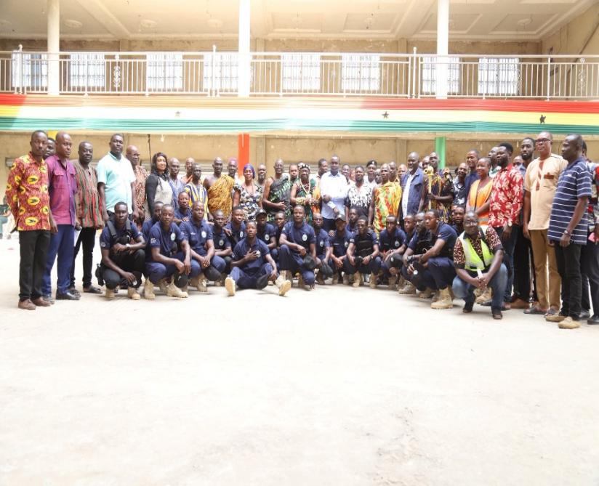
As part of efforts to support the fight against illegal mining and protect water bodies within the District, the Blue Water Guard initiative was officially introduced and inaugurated during the quarter under review. The programme seeks to strengthen environmental monitoring and safeguard water resources from pollution and destruction caused by illegal mining activities. The inauguration of the taskforce demonstrates Government’s commitment towards environmental sustainability and natural resource protection within mining communities.
Figure 29: INTRODUCTION AND INAUGURATION OF BLUE WATER GUARD
. 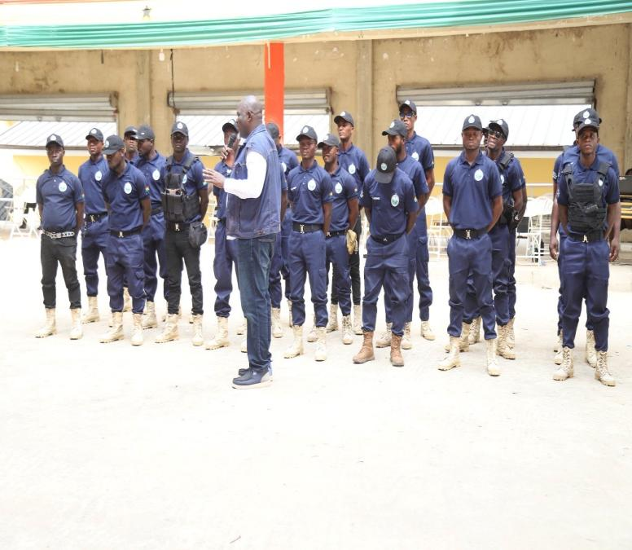
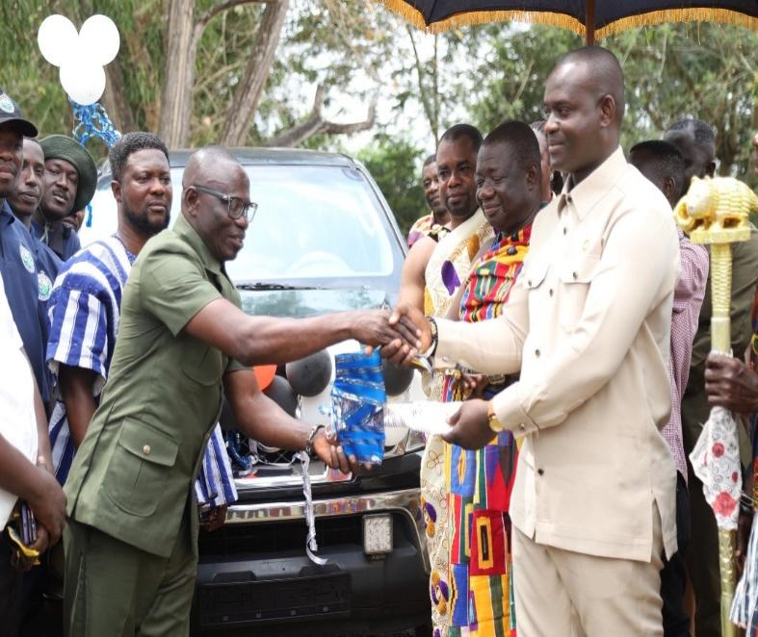
To further enhance the operations of the Blue Water Guard initiative, Mr. Isaac Arthur donated a vehicle to support operational activities of the taskforce within the District. The vehicle is expected to improve mobility, monitoring efficiency, rapid response, and operational coordination in combating illegal mining activities and protecting water bodies across affected communities.
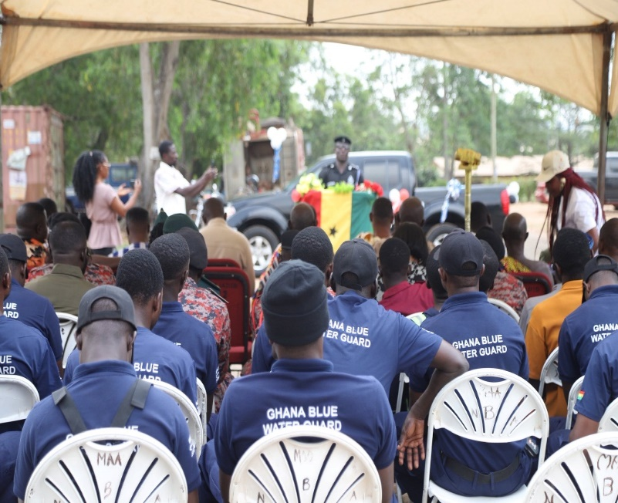
Figure 30: DONATION OF VEHICLE IN SUPPORT OF BLUE WATER GUARD OPERATIONS
The National Apprenticeship Programme (NAP)
The National Apprenticeship Programme (NAP) was also implemented during the quarter with the distribution of apprenticeship learning kits to beneficiaries within the District. The initiative forms part of Government’s efforts to equip young people with employable vocational and technical skills to improve self-employment opportunities and reduce youth unemployment. Beneficiaries received various tools and equipment to support practical training and business start-ups in their respective trades.
Figure 31: DISTRIBUTION OF LEARNING KITS UNDER THE NATIONAL APPRENTICESHIP PROGRAM (NAP)
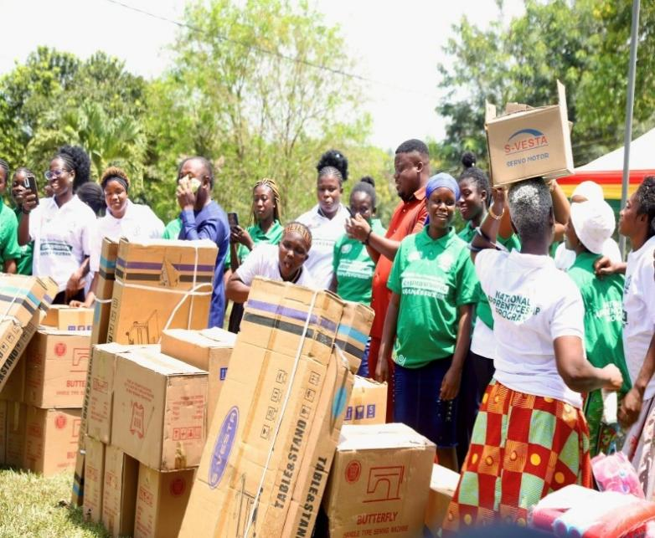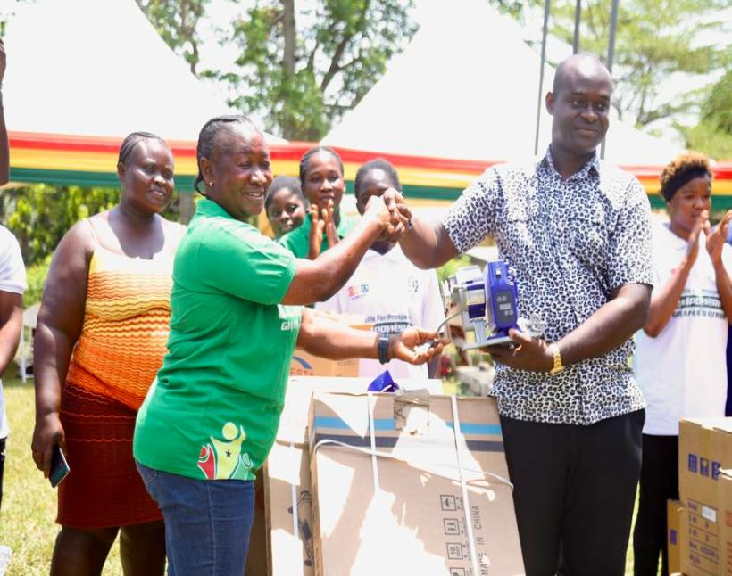
Nkoko Nkitinkiti Programme
In addition, the District benefited from the implementation of the Nkoko Nkitinkiti Programme, under which chicks were distributed to beneficiaries to promote poultry production and household economic empowerment. The programme is aimed at improving food security, increasing local poultry production, creating employment opportunities, and supporting household income generation, particularly among vulnerable groups and small-scale farmers.
Figure 32: DISTRIBUTION OF CHICKS UNDER THE NKOKO NKITINKITI PROGRAMME
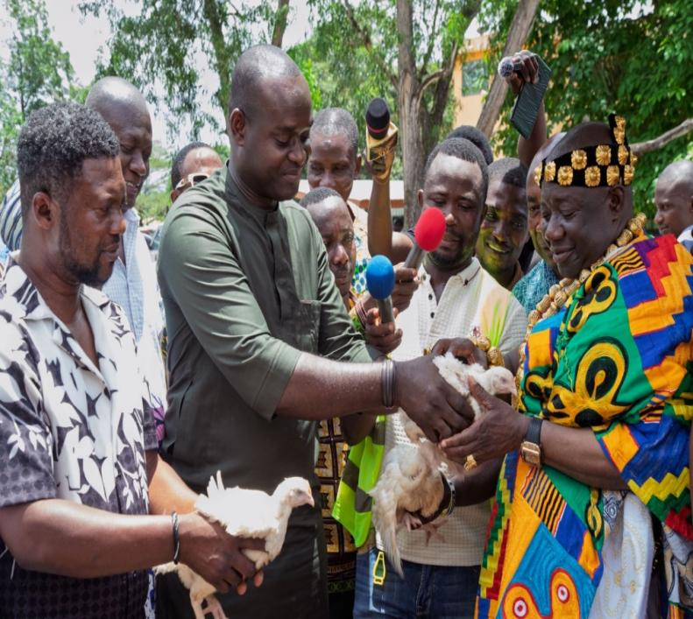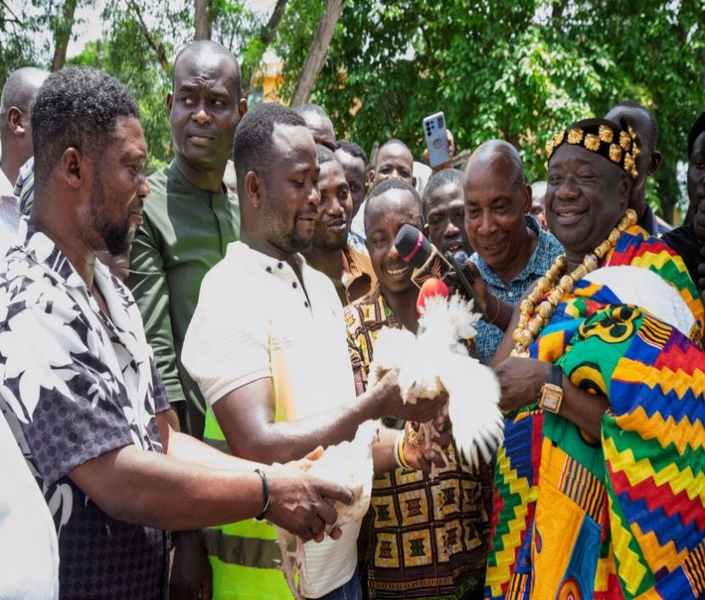
These flagship programmes contributed positively towards environmental protection, skills development, youth empowerment, and agricultural productivity within the Birim North District during the First Quarter of 2026.

2.7 Update on District Specific Indicators for First Quarter 2026
District Specific Indicators are key performance measures developed to assess the progress and effectiveness of programmes, projects, and interventions implemented within the district. These indicators provide valuable information on the Assembly’s performance across various development dimensions, including social welfare, health, water and sanitation, child protection, education, and social intervention programmes.
The indicators serve as an important monitoring and evaluation tool for tracking the implementation of activities under the Birim North District Assembly 2026–2029 Medium-Term Development Plan (MTDP) and the 2026 Annual Action Plan. They help measure achievements against set targets, identify implementation gaps, and support evidence-based decision-making for improved service delivery and resource allocation.
The First Quarter 2026 assessment of the District Specific Indicators provides insight into the extent of progress made during the initial phase of implementing the new Medium-Term Development Plan. The analysis highlights areas of strong performance as well as sectors requiring additional attention, funding, and institutional support to ensure the successful achievement of the Assembly’s development objectives and improved living conditions for the people within the district.

Table 9 : District Specific Indicators for First Quarter 2026
S/N | Indicator (Categorised by Development Dimension | Disaggregation | BASE LINE 2022 | Actual2023 | Actual 2024 | Actual 2025 | TARGET 2026 | ACTUAL 1ST QTR 2026
1 | Number of trainings conducted on ISSOPs | 0 | 0 | 0 | 0 | 0 | 0 | 0
2 | Proportion of case workers trained in child protection and family welfare | 0 | 0 | 0 | 0 | 0 | 0 | 0
3 | Number of child violence cases benefitting from social welfare/social services | 0 | 0 | 0 | 0 | 0 | 0 | 0
4 | Number of children reached by social work/social services | Total | 0 | 0 | 0 | 0 | 0 | 9
4 | Number of children reached by social work/social services | Male | 0 | 0 | 0 | 0 | 3 | 7
4 | Number of children reached by social work/social services | female | 0 | 0 | 0 | 0 | 2 | 2
5 | Number of people reached with child protection and SGBV information | Total | 0 | 0 | 0 | 0 | 30 | 0
5 |  | Male | 0 | 0 | 0 | 0 | 10 | 0
5 |  | female | 0 | 0 | 0 | 0 | 20 | 0
6 | Number of LEAP household members on NHIS | Total | 60 | 12 | 50 | 37 | 833 | 833
6 | Number of LEAP household members on NHIS | Male | 959 | 1,315 | 1,500 | 536 | 366 | 366
6 | Number of LEAP household members on NHIS | female | 641 | 641 | 641 | 641 | 467 | 467
7 | Number of households with adolescent girls benefiting from LEAP |  | 15 | 66 | 68 | 69 | 70 | 68
8 | Number of outreach visits to communities with LEAP households | Total | 2 | 1 | 22 | 12 | 15 | 9
8 |  | Male | 1 | 0 | 10 | 3 | 5 | 0
8 |  | female | 1 | 1 | 12 | 9 | 10 | 9
9 | Number of referrals received from GHS | Total | 2 | 11 | 2 | 2 | 2 | 0
9 | Number of referrals received from GHS | Male | 1 | 0 | 0 | 1 | 1 | 0
9 | Number of referrals received from GHS | female | 1 | 11 | 2 | 1 | 1 | 0
10 | Proportion of referrals receiving adequate follow-up |  | 100% | 100% | 0% | N/A | 100% | 100%
11 | Number of DSWCD’s that have shared their MMDA’s LEAP Household data with both NHIS and GHS | N/A | N/A | N/A | N/A | N/A | N/A | N/A
12 | Number of regional intersectoral monitoring visits conducted | N/A | N/A | N/A | N/A | N/A | N/A | N/A
13 | Number of meetings organised to discuss integrated services | N/A | N/A | N/A | N/A | N/A | N/A | N/A
14 | Number of girls reached by prevention and care services | N/A | 0 | 0 | 0 | N/A | 0 | 0
15 | Number of CP/SGBV cases referred to other services and followed up | N/A | 0 | 1 | 2 | N/A | 1 | 0
16 | Number of NGOs, including RHCs, trained | N/A | 0 | 0 | 0 | N/A | 0 | 0
17 | Number of children in RHCs profiled and reunified | N/A | 0 | 0 | 0 | N/A | 0 | 0
18 | Proportion of sub-standard RHCs closed | N/A | 0 | 0 | 0 | N/A | 0 | 0
19 | Number of children placed in foster care | N/A | 0 | 0 | 0 | N/A | 0 | 0
20 | Proportion of population with access to basic drinking water sources | N/A | 88% | 88% | 88% | 89.96% | 100% | 89.96%
21 | Proportion of population with access to improved sanitation services | N/A | 95.2% | 29.58% | 95.2% | 3.45% | 100% | 84%
22 | Doctor to patient ratio | N/A | 1:12,057 | 1:12,311 | 1:10,703 | 1:14,475 | 1:15,000 | 1:6,204
23 | Nurse to population ratio | N/A | 1:275 | 1:335 | 1:337 | 1:302 | 1:450 | 1:311
24 | Number of reported cases of new HIV infection  Total | N/A | 134 | 54 | 40 | 274 | 0 | 29
 | Male | N/A | 106 | 37 | 27 | 100 | 0 | 10
 | Female | N/A | 28 | 17 | 13 | 174 | 0 | 19

2.7.1Analysis on District Specific Indicators and Targets for First Quarter 2026
The district specific indicators for the First Quarter of 2026 reflect mixed performance across the areas of social welfare, child protection, healthcare delivery, water and sanitation, and LEAP-related interventions within the Birim North District Assembly. The quarter marked the commencement of the implementation of the 2026–2029 Medium-Term Development Plan (MTDP), and efforts were made toward achieving the planned targets under the various development dimensions. While some indicators recorded encouraging performance, others remained stagnant due to operational, financial, and logistical constraints.
In the area of child protection and social welfare services, no trainings were conducted on the Integrated Social Services Operating Procedures (ISSOPs) during the quarter, and consequently no case workers were trained in child protection and family welfare. Similarly, no child violence cases benefitted from social welfare or social services during the period under review. This lack of activity is to be attributed to inadequate funding, limited logistical support, and the absence of planned training programmes during the quarter.
Despite these challenges, some progress was recorded under child social services. A total of nine (9) children benefitted from social work and social services during the quarter, comprising seven (7) males and two (2) females. This performance indicates some level of engagement by the Department of Social Welfare and Community Development in responding to child welfare issues within the district. However, no individuals were reached with child protection and Sexual and Gender-Based Violence (SGBV) information during the quarter against a target of 30 persons. This may be due to the non-implementation of planned sensitization programmes and inadequate operational resources during the reporting period.
Performance under the Livelihood Empowerment Against Poverty (LEAP) programme was relatively encouraging during the quarter. The number of LEAP household members enrolled on the National Health Insurance Scheme (NHIS) reached 833 beneficiaries, made up of 366 males and 467 females, thereby achieving the annual target within the first quarter. This strong performance reflects sustained collaboration between the Department of Social Welfare, NHIS, and other stakeholders in ensuring that vulnerable households continue to access healthcare services. In addition, the number of households with adolescent girls benefiting from LEAP stood at 68 against a target of 70, representing near achievement of the annual target.
Community outreach activities to LEAP households also recorded moderate performance during the quarter. A total of nine (9) outreach visits were conducted, all involving female beneficiaries. Although this performance falls short of the annual target of 15 outreach visits, it demonstrates continued field engagement and monitoring activities by officers despite logistical and financial challenges.
With respect to referral systems, no referrals were received from the Ghana Health Service during the quarter. However, the proportion of referrals receiving adequate follow-up remained at 100 percent, indicating that existing referral cases were properly monitored and managed. This demonstrates the Assembly’s commitment to effective case management and coordination among service providers.
Indicators relating to institutional strengthening and child care services, including the number of NGOs and Residential Homes for Children (RHCs) trained, children placed in foster care, closure of sub-standard RHCs, and children reunified with families, recorded no progress during the quarter. The absence of activities under these indicators may be linked to inadequate funding, limited technical support, and competing operational priorities during the commencement of the new Medium-Term Development Plan.
In the area of water and sanitation, the district recorded relatively high performance. Access to basic drinking water sources increased to 99 percent against the annual target of 100 percent, indicating continued improvement in water service delivery and access to potable water within the district. This achievement may be attributed to ongoing investments in water infrastructure and community water systems. Similarly, access to improved sanitation services stood at 84 percent during the quarter. Although this performance remains below the annual target of 100 percent, it reflects considerable progress compared to previous years and may be linked to intensified sanitation campaigns and household sanitation improvements.
Health indicators also recorded notable performance during the quarter. The doctor-to-patient ratio improved significantly from 1:14,475 in 2025 to 1:6,204 in the first quarter of 2026, surpassing the annual target of 1:15,000. This improvement may be attributed to increased posting of medical officers and improved staffing levels within health facilities in the district. The nurse-to-population ratio also remained relatively stable at 1:311, performing better than the annual target of 1:450. This indicates improved access to healthcare personnel and strengthened healthcare delivery services within the district.
However, the district recorded twenty-nine (29) new HIV infections during the quarter, comprising ten (10) males and nineteen (19) females. Although the annual target was zero new infections, the recorded cases suggest the need for intensified public education, awareness creation, testing, and preventive interventions, particularly among vulnerable populations and high-risk groups within the district.
Overall, the district specific indicators for the First Quarter of 2026 reveal encouraging performance in areas such as LEAP-NHIS enrolment, access to potable water, healthcare staffing ratios, and social outreach services. However, performance under child protection training, SGBV sensitization, institutional strengthening, and HIV prevention requires significant improvement. Going forward, the Assembly should strengthen inter-sectoral collaboration, improve logistical and financial support for field operations, intensify public sensitization programmes, and ensure timely implementation of planned activities under the 2026–2029 Medium-Term Development Plan to enhance service delivery and achieve the set targets.

2.9 Participatory Monitoring and Evaluation Undertaken
Participatory monitoring and evaluation activities were carried out by the District Monitoring and Evaluation Team, coordinated by the District Planning Coordinating Unit (DPCU). These activities involved routine field visits, interactive discussions with key stakeholders, and review sessions with contractors, consultants, and beneficiary communities. The process provided an opportunity to collectively examine the status of ongoing projects, assess compliance with approved plans, and identify operational challenges affecting implementation.
Issues identified during the monitoring exercises were discussed with stakeholders, and practical measures were agreed upon to address observed deficiencies. Relevant stakeholders have since taken steps to implement the agreed actions to improve project outcomes. This participatory approach has strengthened stakeholder involvement, enhanced openness in project implementation, and reinforced accountability, ultimately contributing to more effective and sustainable delivery of development interventions within the District.
Table 10: Evaluations Conducted, Findings and Recommendations
NAME OF EVALUATION | PROJECTS/PROGRAMMES INVOLVED | CONSULTANT /RESOURCE PERSON | METHODOLOGY | FINDINGS | RECOMMENDATIONS
MIDTERM | Construction of 1No. CHPs Compound, Mpintimpi | DPCU | Field Indicators Checklist (agreed by DPCU) | 1. Project is nearing completion.  2. Approximately 90% of work is completed | 1. Assembly should ensure regular maintenance  of the building. road.  2. Conduct participatory monitoring during the final  stages.
MIDTERM | Construction of 1No. 16-seater W/C toilet with 4 No. bathrooms, New Abirem | DPCU | Field indicators check list agreed on by DPCU | 1.Work on the project is due completion  2.the project is 90% completed | 1. The Assembly should ensure regular maintenance  of the road.  2. Participatory Monitoring is advised.
MIDTERM | Construction of 1No. 16-lockable stores, Afosu Phase I & II | DPCU | Interview/focus group discussion. | 1. Some community members were unaware that the project is an Assembly initiative.  2. Project progress has been steady due to committed funding. | 1. Contractor should install project signage at the site.  2. Encourage community participation in project implementation.  3. Form a committee to ensure proper maintenance  of the facilities
Table 10: Participatory Monitoring and Evaluation and Their Results
Name of The PM & E Tool | Policy/Programme/Project Involved | Consultant/Resource Persons Involved | Methodology Used | Findings | Recommendations
Participatory Rural Appraisal | Developments projects | DPCU | Observation  Focus group discussions, interviews | Delay in the completion of some projects especially DACF projects. | Regular monitoring  and inspection needs  to carried out to  ensure value for  money.
 |  |  |  | Inadequate logistics to undertake PME activities. | Adequate resources  should be allocated  and released for  monitoring and  evaluation activities.

CHAPTER THREE

THE WAY FORWARD

3.0 Introduction
This chapter presents a summary of the key issues that emerged during the reporting period, highlighting both the progress made in the implementation of planned programmes and the challenges that affected overall performance. It provides an overview of the operational environment within which the District implemented its development interventions, with particular emphasis on factors that influenced service delivery and project execution.
Although the District recorded notable achievements across various sectors, including improvements in service delivery, revenue mobilisation, and implementation of development projects, a number of institutional and operational challenges were also observed. These challenges include resource constraints, delays in the release of statutory funds, logistical limitations, and capacity gaps in some implementing departments.
Addressing these challenges is critical to improving efficiency, strengthening accountability systems, and enhancing the overall effectiveness of public service delivery. It is therefore important that appropriate corrective measures are put in place to sustain the gains made and address identified gaps in implementation.
This Section of the report provides the basis for informed decision-making and sets the stage for targeted interventions aimed at improving performance. By responding strategically to the issues identified, the District will be better positioned to achieve sustainable development outcomes and ensure that development interventions deliver meaningful and lasting benefits to the communities it serves.

3.1 Key Issues Addressed
During the review period, a number of critical issues were identified and successfully addressed through timely interventions and stakeholder collaboration.

3.1.1 Disaster Issues Resolved
The interventions led to the restoration of industrial harmony, improved stakeholder confidence, and strengthened

3.2 Key Issues Yet To Be Addressed
Notwithstanding the gains recorded during the reporting period, a number of critical issues remain unresolved and require sustained attention to ensure social stability, effective service delivery, and improved governance outcomes.
- Timely Release of Funds: From an institutional and financial perspective, the erratic release of funds from central government continues to impede the effective implementation of planned programmes and projects. Although Internally Generated Funds (IGF) performance showed marginal improvement, the lack of predictable and timely central government disbursements remains a major constraint to service delivery and the continuity of development interventions.
- Non-Compliance with Deadlines: Furthermore, persistent non-compliance with reporting and operational deadlines by some departments has adversely affected the Monitoring and Evaluation (M&E) cycle, thereby limiting the Assembly’s ability to track progress, assess outcomes, and make evidence-based decisions.
- Functionality of Sub-Structures: Lastly, the functionality of several sub-district structures remains weak. Their limited operational capacity continues to undermine revenue mobilization, grassroots participation, and the effectiveness of decentralized governance. Strengthening these sub-structures is therefore critical to improving local administration, accountability, and stakeholder engagement in the district’s development processes.
3.3 Recommendations
In view of the challenges identified during the reporting period and to strengthen the District’s Monitoring and Evaluation (M&E) system as well as overall development performance, the following recommendations are proposed for consideration and implementation:
- Enhance DPCU Logistics: The operational capacity of the District Planning Coordinating Unit (DPCU) should be strengthened through the provision of adequate logistics and working tools. This includes reliable means of transportation, communication equipment, and essential office facilities such as computers, printers, and stationery. Strengthening these logistical resources will improve coordination, supervision of projects, data collection, and timely reporting on development interventions.
- Diversify Funding Sources: To address persistent funding constraints, the Assembly should intensify efforts to broaden its funding base. This should include strengthening partnerships with private sector actors, non-governmental organizations (NGOs), civil society organizations, and development partners, alongside improved Internally Generated Fund (IGF) mobilization. Diversification of funding will enhance financial sustainability and ensure smooth implementation of the Medium-Term Development Plan (MTDP).
- Prioritize Monitoring and Evaluation: The Assembly should prioritize Monitoring and Evaluation by ensuring the timely release and dedicated allocation of funds for M&E activities. Adequate resourcing will improve tracking of project implementation, enhance data quality, support performance reporting, and promote evidence-based decision-making for improved development outcomes.
- Strengthen Public Engagement and Visibility: A comprehensive communication and public engagement strategy should be developed and implemented to enhance transparency, accountability, and stakeholder participation. Improved dissemination of information on programmes and projects will build public trust, encourage community ownership of development interventions, and strengthen feedback mechanisms between the Assembly and citizens.
- Improve Revenue Mobilization Systems: The Assembly should strengthen its revenue collection systems through digitization, improved monitoring of revenue collectors, and regular stakeholder sensitization. This will reduce leakages, increase compliance, and boost Internally Generated Funds to support development activities.
- Strengthen Capacity Building for Staff: Continuous training and capacity-building programmes should be organized for staff, particularly those involved in planning, budgeting, monitoring, and social services delivery. This will enhance technical competence, improve service delivery, and ensure efficient implementation of development programmes.
- Ensure Timely Release of Statutory Funds: Management should intensify engagement with central government institutions to ensure the timely release of statutory funds such as the District Assemblies Common Fund (DACF) and DACF-RFG. Predictable fund flows will improve project implementation efficiency and reduce delays in development activities.
- Strengthen Inter-Departmental Coordination: There should be improved coordination among departments and units within the Assembly to ensure harmonized planning, implementation, and reporting. Regular coordination meetings and shared reporting frameworks will reduce duplication and improve efficiency.
- Improve Data Management and Reporting Systems: The Assembly should strengthen its data collection, storage, and reporting systems to ensure accuracy and reliability of performance data. Digital tools and standardized reporting templates should be adopted to improve the quality of M&E information.
The implementation of these recommendations is expected to significantly improve project delivery, enhance service provision, strengthen institutional efficiency, and support the achievement of the District’s development objectives in a sustainable and effective manner.

